-- -- Importing the csv files

-- --

-- LOAD DATA INFILE 'C:/ProgramData/MySQL/MySQL Server 8.0/Uploads/DSAI_T_Sales.csv'

-- INTO TABLE sales

-- FIELDS TERMINATED BY ',' ENCLOSED BY '"'

-- LINES TERMINATED BY '\n'

-- IGNORE 1 ROWS;

-- --

-- LOAD DATA INFILE 'C:/ProgramData/MySQL/MySQL Server 8.0/Uploads/DSAI_M_Discount_1.csv'

-- INTO TABLE discount

-- FIELDS TERMINATED BY ',' ENCLOSED BY '"'

-- LINES TERMINATED BY '\n'

-- IGNORE 1 ROWS;

CREATE DATABASE IF NOT EXISTS `sales_v1` /*!40100 DEFAULT CHARACTER SET utf8mb4 COLLATE utf8mb4_0900_ai_ci */ /*!80016 DEFAULT ENCRYPTION='N' */;

USE `sales_v1`;

-- MySQL dump 10.13 Distrib 8.0.34, for Win64 (x86_64)

--

-- Host: localhost Database: sales_v1

-- ------------------------------------------------------

-- Server version 8.0.35

/*!40101 SET @OLD_CHARACTER_SET_CLIENT=@@CHARACTER_SET_CLIENT */;

/*!40101 SET @OLD_CHARACTER_SET_RESULTS=@@CHARACTER_SET_RESULTS */;

/*!40101 SET @OLD_COLLATION_CONNECTION=@@COLLATION_CONNECTION */;

/*!50503 SET NAMES utf8 */;

/*!40103 SET @OLD_TIME_ZONE=@@TIME_ZONE */;

/*!40103 SET TIME_ZONE='+00:00' */;

/*!40014 SET @OLD_UNIQUE_CHECKS=@@UNIQUE_CHECKS, UNIQUE_CHECKS=0 */;

/*!40014 SET @OLD_FOREIGN_KEY_CHECKS=@@FOREIGN_KEY_CHECKS, FOREIGN_KEY_CHECKS=0 */;

/*!40101 SET @OLD_SQL_MODE=@@SQL_MODE, SQL_MODE='NO_AUTO_VALUE_ON_ZERO' */;

/*!40111 SET @OLD_SQL_NOTES=@@SQL_NOTES, SQL_NOTES=0 */;

--

-- Table structure for table `dsai_d_country`

--

DROP TABLE IF EXISTS `dsai_d_country`;

/*!40101 SET @saved_cs_client = @@character_set_client */;

/*!50503 SET character_set_client = utf8mb4 */;

CREATE TABLE `dsai_d_country` (

`Country_Code` varchar(3) DEFAULT NULL,

`Country_Name` varchar(22) DEFAULT NULL,

`Updated_DT` datetime DEFAULT NULL,

UNIQUE KEY `Country_Name` (`Country_Name`)

) ENGINE=InnoDB DEFAULT CHARSET=utf8mb4 COLLATE=utf8mb4_0900_ai_ci;

/*!40101 SET character_set_client = @saved_cs_client */;

--

-- Dumping data for table `dsai_d_country`

--

LOCK TABLES `dsai_d_country` WRITE;

/*!40000 ALTER TABLE `dsai_d_country` DISABLE KEYS */;

/*!40000 ALTER TABLE `dsai_d_country` ENABLE KEYS */;

UNLOCK TABLES;

--

-- Table structure for table `dsai_d_currency_duplicate1`

--

DROP TABLE IF EXISTS `dsai_d_currency_duplicate1`;

/*!40101 SET @saved_cs_client = @@character_set_client */;

/*!50503 SET character_set_client = utf8mb4 */;

CREATE TABLE `dsai_d_currency_duplicate1` (

`Currency_Code` varchar(3) CHARACTER SET utf8mb3 DEFAULT NULL,

`Currency_Name` varchar(20) CHARACTER SET utf8mb3 DEFAULT NULL,

`Created_DT` datetime DEFAULT NULL,

`Created_User` varchar(15) CHARACTER SET utf8mb3 DEFAULT NULL,

`Updated_DT` datetime DEFAULT NULL,

`Updated_User` varchar(15) CHARACTER SET utf8mb3 DEFAULT NULL

) ENGINE=InnoDB DEFAULT CHARSET=utf8mb4 COLLATE=utf8mb4_0900_ai_ci;

/*!40101 SET character_set_client = @saved_cs_client */;

--

-- Dumping data for table `dsai_d_currency_duplicate1`

--

LOCK TABLES `dsai_d_currency_duplicate1` WRITE;

/*!40000 ALTER TABLE `dsai_d_currency_duplicate1` DISABLE KEYS */;

/*!40000 ALTER TABLE `dsai_d_currency_duplicate1` ENABLE KEYS */;

UNLOCK TABLES;

--

-- Table structure for table `dsai_d_customer`

--

DROP TABLE IF EXISTS `dsai_d_customer`;

/*!40101 SET @saved_cs_client = @@character_set_client */;

/*!50503 SET character_set_client = utf8mb4 */;

CREATE TABLE `dsai_d_customer` (

`Customer_ID` varchar(3) NOT NULL,

`Customer_Name` varchar(22) NOT NULL DEFAULT '',

`Created_User` varchar(10) NOT NULL DEFAULT '',

`Created_DT` datetime NOT NULL DEFAULT '0000-00-00 00:00:00',

`Updated_User` varchar(10) NOT NULL DEFAULT '',

`Updated_DT` datetime NOT NULL DEFAULT '0000-00-00 00:00:00',

PRIMARY KEY (`Customer_ID`)

) ENGINE=InnoDB DEFAULT CHARSET=utf8mb4 COLLATE=utf8mb4_0900_ai_ci;

/*!40101 SET character_set_client = @saved_cs_client */;

--

-- Dumping data for table `dsai_d_customer`

--

LOCK TABLES `dsai_d_customer` WRITE;

/*!40000 ALTER TABLE `dsai_d_customer` DISABLE KEYS */;

/*!40000 ALTER TABLE `dsai_d_customer` ENABLE KEYS */;

UNLOCK TABLES;

--

-- Table structure for table `dsai_d_discount`

--

DROP TABLE IF EXISTS `dsai_d_discount`;

/*!40101 SET @saved_cs_client = @@character_set_client */;

/*!50503 SET character_set_client = utf8mb4 */;

CREATE TABLE `dsai_d_discount` (

`Discount_Code` varchar(5) CHARACTER SET utf8mb3 DEFAULT NULL,

`Discount_Name` varchar(15) CHARACTER SET utf8mb3 DEFAULT NULL,

`Created_DT` datetime DEFAULT NULL,

`Created_User` varchar(15) CHARACTER SET utf8mb3 DEFAULT NULL,

`Updated_DT` datetime DEFAULT NULL,

`Updated_User` varchar(15) CHARACTER SET utf8mb3 DEFAULT NULL

) ENGINE=InnoDB DEFAULT CHARSET=utf8mb4 COLLATE=utf8mb4_0900_ai_ci;

/*!40101 SET character_set_client = @saved_cs_client */;

--

-- Dumping data for table `dsai_d_discount`

--

LOCK TABLES `dsai_d_discount` WRITE;

/*!40000 ALTER TABLE `dsai_d_discount` DISABLE KEYS */;

INSERT INTO `dsai_d_discount` VALUES ('DC001','Discount Sale 1','2024-01-23 10:00:00','DSAI User','2024-01-23 10:00:00','DSAI User\r'),('DC002','Discount Sale 2','2024-01-23 10:00:00','DSAI User','2024-01-23 10:00:00','DSAI User\r'),('DC003','Discount Sale 3','2024-01-23 10:00:00','DSAI User','2024-01-23 10:00:00','DSAI User\r'),('DC004','Discount Sale 4','2024-01-23 10:00:00','DSAI User','2024-01-23 10:00:00','DSAI User\r'),('DC005','Discount Sale 5','2024-01-23 10:00:00','DSAI User','2024-01-23 10:00:00','DSAI User'),('DC001','Discount Sale 1',NULL,NULL,NULL,NULL),('DC002','Discount Sale 2',NULL,NULL,NULL,NULL),('DC003','Discount Sale 3',NULL,NULL,NULL,NULL),('DC004','Discount Sale 4',NULL,NULL,NULL,NULL),('DC005','Discount Sale 5',NULL,NULL,NULL,NULL),('DC001','Discount Sale 1',NULL,NULL,NULL,NULL),('DC002','Discount Sale 2',NULL,NULL,NULL,NULL),('DC003','Discount Sale 3',NULL,NULL,NULL,NULL),('DC004','Discount Sale 4',NULL,NULL,NULL,NULL),('DC005','Discount Sale 5',NULL,NULL,NULL,NULL);

/*!40000 ALTER TABLE `dsai_d_discount` ENABLE KEYS */;

UNLOCK TABLES;

--

-- Table structure for table `dsai_d_product`

--

DROP TABLE IF EXISTS `dsai_d_product`;

/*!40101 SET @saved_cs_client = @@character_set_client */;

/*!50503 SET character_set_client = utf8mb4 */;

CREATE TABLE `dsai_d_product` (

`Product_Group_Code` varchar(4) NOT NULL,

`Product_Code` varchar(4) NOT NULL,

`Product_Name` varchar(25) NOT NULL DEFAULT '',

PRIMARY KEY (`Product_Group_Code`,`Product_Code`)

) ENGINE=InnoDB DEFAULT CHARSET=utf8mb4 COLLATE=utf8mb4_0900_ai_ci;

/*!40101 SET character_set_client = @saved_cs_client */;

--

-- Dumping data for table `dsai_d_product`

--

LOCK TABLES `dsai_d_product` WRITE;

/*!40000 ALTER TABLE `dsai_d_product` DISABLE KEYS */;

/*!40000 ALTER TABLE `dsai_d_product` ENABLE KEYS */;

UNLOCK TABLES;

--

-- Table structure for table `dsai_d_user`

--

DROP TABLE IF EXISTS `dsai_d_user`;

/*!40101 SET @saved_cs_client = @@character_set_client */;

/*!50503 SET character_set_client = utf8mb4 */;

CREATE TABLE `dsai_d_user` (

`Id` int NOT NULL AUTO_INCREMENT,

`User_ID` varchar(25) NOT NULL DEFAULT '',

`User_Name` varchar(50) NOT NULL,

PRIMARY KEY (`Id`)

) ENGINE=InnoDB AUTO_INCREMENT=3 DEFAULT CHARSET=utf8mb4 COLLATE=utf8mb4_0900_ai_ci;

/*!40101 SET character_set_client = @saved_cs_client */;

--

-- Dumping data for table `dsai_d_user`

--

LOCK TABLES `dsai_d_user` WRITE;

/*!40000 ALTER TABLE `dsai_d_user` DISABLE KEYS */;

INSERT INTO `dsai_d_user` VALUES (1,'E001','Sunil'),(2,'E002','Suresh');

/*!40000 ALTER TABLE `dsai_d_user` ENABLE KEYS */;

UNLOCK TABLES;

--

-- Table structure for table `dsai_d_user_copy1`

--

DROP TABLE IF EXISTS `dsai_d_user_copy1`;

/*!40101 SET @saved_cs_client = @@character_set_client */;

/*!50503 SET character_set_client = utf8mb4 */;

CREATE TABLE `dsai_d_user_copy1` (

`Id` int NOT NULL DEFAULT '0',

`User_ID` varchar(25) NOT NULL DEFAULT '',

`User_Name` varchar(50) NOT NULL

) ENGINE=InnoDB DEFAULT CHARSET=utf8mb4 COLLATE=utf8mb4_0900_ai_ci;

/*!40101 SET character_set_client = @saved_cs_client */;

--

-- Dumping data for table `dsai_d_user_copy1`

--

LOCK TABLES `dsai_d_user_copy1` WRITE;

/*!40000 ALTER TABLE `dsai_d_user_copy1` DISABLE KEYS */;

/*!40000 ALTER TABLE `dsai_d_user_copy1` ENABLE KEYS */;

UNLOCK TABLES;

--

-- Table structure for table `dsai_d_user_copy2`

--

DROP TABLE IF EXISTS `dsai_d_user_copy2`;

/*!40101 SET @saved_cs_client = @@character_set_client */;

/*!50503 SET character_set_client = utf8mb4 */;

CREATE TABLE `dsai_d_user_copy2` (

`Id` int NOT NULL DEFAULT '0',

`User_ID` varchar(25) NOT NULL DEFAULT '',

`User_Name` varchar(50) NOT NULL

) ENGINE=InnoDB DEFAULT CHARSET=utf8mb4 COLLATE=utf8mb4_0900_ai_ci;

/*!40101 SET character_set_client = @saved_cs_client */;

--

-- Dumping data for table `dsai_d_user_copy2`

--

LOCK TABLES `dsai_d_user_copy2` WRITE;

/*!40000 ALTER TABLE `dsai_d_user_copy2` DISABLE KEYS */;

INSERT INTO `dsai_d_user_copy2` VALUES (1,'E001','Sunil'),(2,'E002','Suresh');

/*!40000 ALTER TABLE `dsai_d_user_copy2` ENABLE KEYS */;

UNLOCK TABLES;

--

-- Table structure for table `dsai_m_currency`

--

DROP TABLE IF EXISTS `dsai_m_currency`;

/*!40101 SET @saved_cs_client = @@character_set_client */;

/*!50503 SET character_set_client = utf8mb4 */;

CREATE TABLE `dsai_m_currency` (

`Currency_Code` varchar(3) DEFAULT NULL,

`Currency_Name` varchar(20) DEFAULT NULL,

`Created_DT` datetime DEFAULT NULL,

`Created_User` varchar(15) DEFAULT NULL,

`Updated_DT` datetime DEFAULT NULL,

`Updated_User` varchar(15) DEFAULT NULL

) ENGINE=InnoDB DEFAULT CHARSET=utf8mb3;

/*!40101 SET character_set_client = @saved_cs_client */;

--

-- Dumping data for table `dsai_m_currency`

--

LOCK TABLES `dsai_m_currency` WRITE;

/*!40000 ALTER TABLE `dsai_m_currency` DISABLE KEYS */;

INSERT INTO `dsai_m_currency` VALUES ('INR','Indian Ruppes','2024-01-23 10:00:00','DSAI User','2024-01-23 10:00:00','DSAI User'),('USD','American Dollar','2024-01-23 10:00:00','DSAI User','2024-01-23 10:00:00','DSAI User'),('SDG','Singapore Dollar','2024-01-23 10:00:00','DSAI User','2024-01-23 10:00:00','DSAI User');

/*!40000 ALTER TABLE `dsai_m_currency` ENABLE KEYS */;

UNLOCK TABLES;

--

-- Table structure for table `dsai_m_customer`

--

DROP TABLE IF EXISTS `dsai_m_customer`;

/*!40101 SET @saved_cs_client = @@character_set_client */;

/*!50503 SET character_set_client = utf8mb4 */;

CREATE TABLE `dsai_m_customer` (

`Customer_ID` varchar(7) NOT NULL,

`Customer_Name` varchar(11) DEFAULT NULL,

`Address` varchar(24) DEFAULT NULL,

`Location_Code` varchar(4) DEFAULT NULL,

`Phone` varchar(14) DEFAULT NULL,

`Email` varchar(20) DEFAULT NULL,

`Created_DT` datetime DEFAULT NULL,

`Created_User` varchar(15) DEFAULT NULL,

`Updated_DT` datetime DEFAULT NULL,

`Updated_User` varchar(15) DEFAULT NULL,

PRIMARY KEY (`Customer_ID`)

) ENGINE=InnoDB DEFAULT CHARSET=utf8mb3;

/*!40101 SET character_set_client = @saved_cs_client */;

--

-- Dumping data for table `dsai_m_customer`

--

LOCK TABLES `dsai_m_customer` WRITE;

/*!40000 ALTER TABLE `dsai_m_customer` DISABLE KEYS */;

INSERT INTO `dsai_m_customer` VALUES ('C000001','Sunil Raj','9 cross street.','L001','91 99789889933','sunilraj@gmail.com','2024-01-23 10:00:00','DSAI User','2024-01-23 10:00:00','DSAI User'),('C000002','Aaditya Jha','15, Cherry Road','L002','91 9978044335','aaditya@gmail.com','2024-01-23 10:00:00','DSAI User','2024-01-23 10:00:00','DSAI User'),('C000003','Akhil Metha','12, Prince Street','L003','91 9843577889','Akhil@gmail.com','2024-01-23 10:00:00','DSAI User','2024-01-23 10:00:00','DSAI User'),('C000004','Rishi Yadav','11, Car street','L004','91 8765669087','rishiya@gmail.com','2024-01-23 10:00:00','DSAI User','2024-01-23 10:00:00','DSAI User'),('C000005','Anil Menon','74, Gandhi road','L005','91 8767543423','anilmenon @gmail.com','2024-01-23 10:00:00','DSAI User','2024-01-23 10:00:00','DSAI User'),('C000006','Rishikesh ','34, New bus stand','L006','91 8909456576','kesh@gmail.com','2024-01-23 10:00:00','DSAI User','2024-01-23 10:00:00','DSAI User'),('C000007','Anjana','35, Shivaji Steet','L007','91 8967453423','anj@rediffmail.com','2024-01-23 10:00:00','DSAI User','2024-01-23 10:00:00','DSAI User'),('C000008','Babita','14, Cauveri road','L008','918070605040','Babi123@gmail.com','2024-01-23 10:00:00','DSAI User','2024-01-23 10:00:00','DSAI User'),('C000009','Barka','34, dritya road, ','L009','916754897654','Barka@gmail,com','2024-01-23 10:00:00','DSAI User','2024-01-23 10:00:00','DSAI User'),('C000010','Moulya','1, Aravind road','L010','914534231345','Moulya@gmail.com','2024-01-23 10:00:00','DSAI User','2024-01-23 10:00:00','DSAI User'),('C000011','Diya','34, fountainhas','L011','917656463626','diya@yahoo.com','2024-01-23 10:00:00','DSAI User','2024-01-23 10:00:00','DSAI User'),('C000012','Trishika','4, Sardar Market','L012','918010203040','Trishi@yahoo.com','2024-01-23 10:00:00','DSAI User','2024-01-23 10:00:00','DSAI User'),('C000013','Deepika','9, Chowrasta, ','L013','918767777777','Deepi@gmail.com','2024-01-23 10:00:00','DSAI User','2024-01-23 10:00:00','DSAI User'),('C000014','Katrina','67, Band Stand Promenede','L014','914232526272','Katrina@gmail.com','2024-01-23 10:00:00','DSAI User','2024-01-23 10:00:00','DSAI User'),('C000015','Hruthik','45, Park strreet','L015','914555568888','Hruthik@gmail.com','2024-01-23 10:00:00','DSAI User','2024-01-23 10:00:00','DSAI User'),('C000016','Naveen','76, Connaught Place','L016','917890679088','Naveen@yahoo.com','2024-01-23 10:00:00','DSAI User','2024-01-23 10:00:00','DSAI User'),('C000017','ksh Patel','67, Hazratkanj','L017','919888888888','Aakash@gmail.com','2024-01-23 10:00:00','DSAI User','2024-01-23 10:00:00','DSAI User'),('C000018','Adheeran','98, mall road','L018','919090949592','Adheeran@gmail.com','2024-01-23 10:00:00','DSAI User','2024-01-23 10:00:00','DSAI User'),('C000019','Deeshithan','90, Rajpath','L019','919080706666','Deesh@gmail.com','2024-01-23 10:00:00','DSAI User','2024-01-23 10:00:00','DSAI User'),('C000020','Rachel','45, Tripolia Bazaar','L020','916756453768','Rachel@gmail.com','2024-01-23 10:00:00','DSAI User','2024-01-23 10:00:00','DSAI User');

/*!40000 ALTER TABLE `dsai_m_customer` ENABLE KEYS */;

UNLOCK TABLES;

--

-- Table structure for table `dsai_m_discount`

--

DROP TABLE IF EXISTS `dsai_m_discount`;

/*!40101 SET @saved_cs_client = @@character_set_client */;

/*!50503 SET character_set_client = utf8mb4 */;

CREATE TABLE `dsai_m_discount` (

`Discount_Code` varchar(5) DEFAULT NULL,

`Discount_Name` varchar(15) DEFAULT NULL,

`Created_DT` datetime DEFAULT NULL,

`Created_User` varchar(15) DEFAULT NULL,

`Updated_DT` datetime DEFAULT NULL,

`Updated_User` varchar(15) DEFAULT NULL

) ENGINE=InnoDB DEFAULT CHARSET=utf8mb3;

/*!40101 SET character_set_client = @saved_cs_client */;

--

-- Dumping data for table `dsai_m_discount`

--

LOCK TABLES `dsai_m_discount` WRITE;

/*!40000 ALTER TABLE `dsai_m_discount` DISABLE KEYS */;

INSERT INTO `dsai_m_discount` VALUES ('DC001','Discount Sale 1','2024-01-23 10:00:00','DSAI User','2024-01-23 10:00:00','DSAI User'),('DC002','Discount Sale 2','2024-01-23 10:00:00','DSAI User','2024-01-23 10:00:00','DSAI User'),('DC003','Discount Sale 3','2024-01-23 10:00:00','DSAI User','2024-01-23 10:00:00','DSAI User'),('DC004','Discount Sale 4','2024-01-23 10:00:00','DSAI User','2024-01-23 10:00:00','DSAI User'),('DC005','Discount Sale 5','2024-01-23 10:00:00','DSAI User','2024-01-23 10:00:00','DSAI User'),('DC001','Discount Sale 1',NULL,NULL,NULL,NULL),('DC002','Discount Sale 2',NULL,NULL,NULL,NULL),('DC003','Discount Sale 3',NULL,NULL,NULL,NULL),('DC004','Discount Sale 4',NULL,NULL,NULL,NULL),('DC005','Discount Sale 5',NULL,NULL,NULL,NULL);

/*!40000 ALTER TABLE `dsai_m_discount` ENABLE KEYS */;

UNLOCK TABLES;

--

-- Table structure for table `dsai_m_location`

--

DROP TABLE IF EXISTS `dsai_m_location`;

/*!40101 SET @saved_cs_client = @@character_set_client */;

/*!50503 SET character_set_client = utf8mb4 */;

CREATE TABLE `dsai_m_location` (

`Location_Code` varchar(4) DEFAULT NULL,

`Location_Name` varchar(16) DEFAULT NULL,

`Postal_Code` int DEFAULT NULL,

`State_Code` int DEFAULT NULL,

`Created_DT` datetime DEFAULT NULL,

`Created_User` varchar(15) DEFAULT NULL,

`Updated_DT` datetime DEFAULT NULL,

`Updated_User` varchar(15) DEFAULT NULL

) ENGINE=InnoDB DEFAULT CHARSET=utf8mb3;

/*!40101 SET character_set_client = @saved_cs_client */;

--

-- Dumping data for table `dsai_m_location`

--

LOCK TABLES `dsai_m_location` WRITE;

/*!40000 ALTER TABLE `dsai_m_location` DISABLE KEYS */;

INSERT INTO `dsai_m_location` VALUES ('L001','T Nagar',600056,100890,'2024-01-23 10:00:00','DSAI User','2024-01-23 10:00:00','DSAI User'),('L002','Seidapet',600057,100456,'2024-01-23 10:00:00','DSAI User','2024-01-23 10:00:00','DSAI User'),('L003','West Mambalam',600058,100789,'2024-01-23 10:00:00','DSAI User','2024-01-23 10:00:00','DSAI User'),('L004','Ambathur',600059,100231,'2024-01-23 10:00:00','DSAI User','2024-01-23 10:00:00','DSAI User'),('L005','Thirumullaivoyal',600060,100542,'2024-01-23 10:00:00','DSAI User','2024-01-23 10:00:00','DSAI User'),('L006','Guindy',600061,100876,'2024-01-23 10:00:00','DSAI User','2024-01-23 10:00:00','DSAI User'),('L007','Thambaram',600062,100123,'2024-01-23 10:00:00','DSAI User','2024-01-23 10:00:00','DSAI User'),('L008','Muggapair',600063,100654,'2024-01-23 10:00:00','DSAI User','2024-01-23 10:00:00','DSAI User'),('L009','Nolambur',600064,100987,'2024-01-23 10:00:00','DSAI User','2024-01-23 10:00:00','DSAI User'),('L010','City Center II',600065,100345,'2024-01-23 10:00:00','DSAI User','2024-01-23 10:00:00','DSAI User'),('L011','Poonamallee',600066,100678,'2024-01-23 10:00:00','DSAI User','2024-01-23 10:00:00','DSAI User'),('L012','Patabiram',600067,100890,'2024-01-23 10:00:00','DSAI User','2024-01-23 10:00:00','DSAI User'),('L013','Avadi',600068,100234,'2024-01-23 10:00:00','DSAI User','2024-01-23 10:00:00','DSAI User'),('L014','Redhills',600069,100567,'2024-01-23 10:00:00','DSAI User','2024-01-23 10:00:00','DSAI User'),('L015','Kolathur',600070,100321,'2024-01-23 10:00:00','DSAI User','2024-01-23 10:00:00','DSAI User'),('L016','Korattur',600071,100432,'2024-01-23 10:00:00','DSAI User','2024-01-23 10:00:00','DSAI User'),('L017','Annanagar West',600072,100765,'2024-01-23 10:00:00','DSAI User','2024-01-23 10:00:00','DSAI User'),('L018','Annanagar East',600073,100109,'2024-01-23 10:00:00','DSAI User','2024-01-23 10:00:00','DSAI User'),('L019','Padi',600074,100876,'2024-01-23 10:00:00','DSAI User','2024-01-23 10:00:00','DSAI User'),('L020','Velachery',600075,100543,'2024-01-23 10:00:00','DSAI User','2024-01-23 10:00:00','DSAI User');

/*!40000 ALTER TABLE `dsai_m_location` ENABLE KEYS */;

UNLOCK TABLES;

--

-- Table structure for table `dsai_m_loyalty_program`

--

DROP TABLE IF EXISTS `dsai_m_loyalty_program`;

/*!40101 SET @saved_cs_client = @@character_set_client */;

/*!50503 SET character_set_client = utf8mb4 */;

CREATE TABLE `dsai_m_loyalty_program` (

`Loyalty_Program_Code` varchar(6) NOT NULL DEFAULT '',

`Loyalty_Program_Name` varchar(10) DEFAULT NULL,

`Created_DT` datetime DEFAULT NULL,

`Created_User` varchar(15) DEFAULT NULL,

`Updated_DT` datetime DEFAULT NULL,

`Updated_User` varchar(15) DEFAULT NULL,

PRIMARY KEY (`Loyalty_Program_Code`)

) ENGINE=InnoDB DEFAULT CHARSET=utf8mb3;

/*!40101 SET character_set_client = @saved_cs_client */;

--

-- Dumping data for table `dsai_m_loyalty_program`

--

LOCK TABLES `dsai_m_loyalty_program` WRITE;

/*!40000 ALTER TABLE `dsai_m_loyalty_program` DISABLE KEYS */;

INSERT INTO `dsai_m_loyalty_program` VALUES ('LP001','Program 1','2024-01-23 10:00:00','DSAI User','2024-01-23 10:00:00','DSAI User'),('LP002','Program 2','2024-01-23 10:00:00','DSAI User','2024-01-23 10:00:00','DSAI User'),('LP003','Program 3','2024-01-23 10:00:00','DSAI User','2024-01-23 10:00:00','DSAI User'),('LP004','Program 4','2024-01-23 10:00:00','DSAI User','2024-01-23 10:00:00','DSAI User'),('LP005','Program 5','2024-01-23 10:00:00','DSAI User','2024-01-23 10:00:00','DSAI User'),('LP006','Program 6','2024-01-23 10:00:00','DSAI User','2024-01-23 10:00:00','DSAI User'),('LP007','Program 7','2024-01-23 10:00:00','DSAI User','2024-01-23 10:00:00','DSAI User'),('LP008','Program 8','2024-01-23 10:00:00','DSAI User','2024-01-23 10:00:00','DSAI User'),('LP009','Program 9','2024-01-23 10:00:00','DSAI User','2024-01-23 10:00:00','DSAI User'),('LP010','Program 10','2024-01-23 10:00:00','DSAI User','2024-01-23 10:00:00','DSAI User');

/*!40000 ALTER TABLE `dsai_m_loyalty_program` ENABLE KEYS */;

UNLOCK TABLES;

--

-- Table structure for table `dsai_m_product`

--

DROP TABLE IF EXISTS `dsai_m_product`;

/*!40101 SET @saved_cs_client = @@character_set_client */;

/*!50503 SET character_set_client = utf8mb4 */;

CREATE TABLE `dsai_m_product` (

`Product_Code` varchar(5) NOT NULL,

`Product_Group_Code` varchar(5) DEFAULT NULL,

`Product_Name` varchar(20) DEFAULT NULL,

`Created_DT` datetime DEFAULT NULL,

`Created_User` varchar(15) DEFAULT NULL,

`Updated_DT` datetime DEFAULT NULL,

`Updated_User` varchar(15) DEFAULT NULL,

PRIMARY KEY (`Product_Code`)

) ENGINE=InnoDB DEFAULT CHARSET=utf8mb3;

/*!40101 SET character_set_client = @saved_cs_client */;

--

-- Dumping data for table `dsai_m_product`

--

LOCK TABLES `dsai_m_product` WRITE;

/*!40000 ALTER TABLE `dsai_m_product` DISABLE KEYS */;

INSERT INTO `dsai_m_product` VALUES ('PC001','PG001','Milk','2024-01-23 10:00:00','DSAI User','2024-01-23 10:00:00','DSAI User'),('PC002','PG002','Fat Milk','2024-01-23 10:00:00','DSAI User','2024-01-23 10:00:00','DSAI User'),('PC003','PG003','Slim Milk','2024-01-23 10:00:00','DSAI User','2024-01-23 10:00:00','DSAI User'),('PC004','PG004','Butter Milk','2024-01-23 10:00:00','DSAI User','2024-01-23 10:00:00','DSAI User'),('PC005','PG005','Curd','2024-01-23 10:00:00','DSAI User','2024-01-23 10:00:00','DSAI User'),('PC006','PG006','Panner','2024-01-23 10:00:00','DSAI User','2024-01-23 10:00:00','DSAI User'),('PC007','PG007','Yogurt','2024-01-23 10:00:00','DSAI User','2024-01-23 10:00:00','DSAI User'),('PC008','PG002','Olive oil','2024-01-23 10:00:00','DSAI User','2024-01-23 10:00:00','DSAI User'),('PC009','PG002','Sun flower oil','2024-01-23 10:00:00','DSAI User','2024-01-23 10:00:00','DSAI User'),('PC010','PG002','Rice Bran oil','2024-01-23 10:00:00','DSAI User','2024-01-23 10:00:00','DSAI User'),('PC011','PG002','Sesame oil','2024-01-23 10:00:00','DSAI User','2024-01-23 10:00:00','DSAI User'),('PC012','PG002','Peanut oil','2024-01-23 10:00:00','DSAI User','2024-01-23 10:00:00','DSAI User'),('PC013','PG002','Avocado oil','2024-01-23 10:00:00','DSAI User','2024-01-23 10:00:00','DSAI User'),('PC014','PG003','Powders','2024-01-23 10:00:00','DSAI User','2024-01-23 10:00:00','DSAI User'),('PC015','PG003','Lotions','2024-01-23 10:00:00','DSAI User','2024-01-23 10:00:00','DSAI User'),('PC016','PG003','Nail Polish','2024-01-23 10:00:00','DSAI User','2024-01-23 10:00:00','DSAI User'),('PC017','PG003','Lipstick','2024-01-23 10:00:00','DSAI User','2024-01-23 10:00:00','DSAI User'),('PC018','PG003','Foundation','2024-01-23 10:00:00','DSAI User','2024-01-23 10:00:00','DSAI User'),('PC019','PG003','Eye Shadow','2024-01-23 10:00:00','DSAI User','2024-01-23 10:00:00','DSAI User'),('PC020','PG003','Concealer','2024-01-23 10:00:00','DSAI User','2024-01-23 10:00:00','DSAI User'),('PC021','PG003','Mascara','2024-01-23 10:00:00','DSAI User','2024-01-23 10:00:00','DSAI User'),('PC022','PG004','Black Gram','2024-01-23 10:00:00','DSAI User','2024-01-23 10:00:00','DSAI User'),('PC023','PG004','Bengal Gram','2024-01-23 10:00:00','DSAI User','2024-01-23 10:00:00','DSAI User'),('PC024','PG004','Green Gram','2024-01-23 10:00:00','DSAI User','2024-01-23 10:00:00','DSAI User'),('PC025','PG004','Horse Gram','2024-01-23 10:00:00','DSAI User','2024-01-23 10:00:00','DSAI User'),('PC026','PG005','Wheat','2024-01-23 10:00:00','DSAI User','2024-01-23 10:00:00','DSAI User'),('PC027','PG005','Sorghum','2024-01-23 10:00:00','DSAI User','2024-01-23 10:00:00','DSAI User'),('PC028','PG005','Oats','2024-01-23 10:00:00','DSAI User','2024-01-23 10:00:00','DSAI User'),('PC029','PG005','Maize','2024-01-23 10:00:00','DSAI User','2024-01-23 10:00:00','DSAI User'),('PC030','PG005','Quinoa','2024-01-23 10:00:00','DSAI User','2024-01-23 10:00:00','DSAI User'),('PC031','PG006','Dark Chocolate','2024-01-23 10:00:00','DSAI User','2024-01-23 10:00:00','DSAI User'),('PC032','PG006','Millk Chocolate','2024-01-23 10:00:00','DSAI User','2024-01-23 10:00:00','DSAI User'),('PC033','PG006','White chocolate','2024-01-23 10:00:00','DSAI User','2024-01-23 10:00:00','DSAI User'),('PC034','PG006','Hershey','2024-01-23 10:00:00','DSAI User','2024-01-23 10:00:00','DSAI User'),('PC035','PG007','Red Bull','2024-01-23 10:00:00','DSAI User','2024-01-23 10:00:00','DSAI User'),('PC036','PG007','Boston cooler','2024-01-23 10:00:00','DSAI User','2024-01-23 10:00:00','DSAI User'),('PC037','PG007','Cheer wine','2024-01-23 10:00:00','DSAI User','2024-01-23 10:00:00','DSAI User'),('PC038','PG008','Brown rice','2024-01-23 10:00:00','DSAI User','2024-01-23 10:00:00','DSAI User'),('PC039','PG008','Basmati Rice','2024-01-23 10:00:00','DSAI User','2024-01-23 10:00:00','DSAI User'),('PC040','PG008','Raw rice','2024-01-23 10:00:00','DSAI User','2024-01-23 10:00:00','DSAI User'),('PC041','PG009','Wheat','2024-01-23 10:00:00','DSAI User','2024-01-23 10:00:00','DSAI User'),('PC042','PG009','Ragi','2024-01-23 10:00:00','DSAI User','2024-01-23 10:00:00','DSAI User'),('PC043','PG009','Maida','2024-01-23 10:00:00','DSAI User','2024-01-23 10:00:00','DSAI User'),('PC044','PG010','Wheat Rava','2024-01-23 10:00:00','DSAI User','2024-01-23 10:00:00','DSAI User'),('PC045','PG010','White rava','2024-01-23 10:00:00','DSAI User','2024-01-23 10:00:00','DSAI User'),('PC046','PG011','Almond','2024-01-23 10:00:00','DSAI User','2024-01-23 10:00:00','DSAI User'),('PC047','PG011','Walnut','2024-01-23 10:00:00','DSAI User','2024-01-23 10:00:00','DSAI User'),('PC048','PG011','Cashew nut','2024-01-23 10:00:00','DSAI User','2024-01-23 10:00:00','DSAI User'),('PC049','PG011','Raisin','2024-01-23 10:00:00','DSAI User','2024-01-23 10:00:00','DSAI User'),('PC050','PG012','Rin','2024-01-23 10:00:00','DSAI User','2024-01-23 10:00:00','DSAI User'),('PC051','PG012','Ariel','2024-01-23 10:00:00','DSAI User','2024-01-23 10:00:00','DSAI User'),('PC052','PG012','Surf','2024-01-23 10:00:00','DSAI User','2024-01-23 10:00:00','DSAI User'),('PC053','PG012','A one','2024-01-23 10:00:00','DSAI User','2024-01-23 10:00:00','DSAI User'),('PC054','PG013','Sunsilk','2024-01-23 10:00:00','DSAI User','2024-01-23 10:00:00','DSAI User'),('PC055','PG013','Dove','2024-01-23 10:00:00','DSAI User','2024-01-23 10:00:00','DSAI User'),('PC056','PG013','Pantene','2024-01-23 10:00:00','DSAI User','2024-01-23 10:00:00','DSAI User'),('PC057','PG013','Meera','2024-01-23 10:00:00','DSAI User','2024-01-23 10:00:00','DSAI User'),('PC058','PG014','Pepsodeent','2024-01-23 10:00:00','DSAI User','2024-01-23 10:00:00','DSAI User'),('PC059','PG014','Colgate','2024-01-23 10:00:00','DSAI User','2024-01-23 10:00:00','DSAI User'),('PC060','PG014','Sensodyne','2024-01-23 10:00:00','DSAI User','2024-01-23 10:00:00','DSAI User'),('PC061','PG014','Vantej','2024-01-23 10:00:00','DSAI User','2024-01-23 10:00:00','DSAI User'),('PC062','PG015','Park Avenue','2024-01-23 10:00:00','DSAI User','2024-01-23 10:00:00','DSAI User'),('PC063','PG015','First Love','2024-01-23 10:00:00','DSAI User','2024-01-23 10:00:00','DSAI User'),('PC064','PG015','Z Talc Powder','2024-01-23 10:00:00','DSAI User','2024-01-23 10:00:00','DSAI User'),('PC065','PG015','Dove','2024-01-23 10:00:00','DSAI User','2024-01-23 10:00:00','DSAI User'),('PC066','PG016','Brocolli','2024-01-23 10:00:00','DSAI User','2024-01-23 10:00:00','DSAI User'),('PC067','PG016','Carrot','2024-01-23 10:00:00','DSAI User','2024-01-23 10:00:00','DSAI User'),('PC068','PG016','French Beans','2024-01-23 10:00:00','DSAI User','2024-01-23 10:00:00','DSAI User'),('PC069','PG017','Apple','2024-01-23 10:00:00','DSAI User','2024-01-23 10:00:00','DSAI User'),('PC070','PG017','Orange','2024-01-23 10:00:00','DSAI User','2024-01-23 10:00:00','DSAI User'),('PC071','PG017','Kiwi','2024-01-23 10:00:00','DSAI User','2024-01-23 10:00:00','DSAI User'),('PC072','PG017','Pomegranate','2024-01-23 10:00:00','DSAI User','2024-01-23 10:00:00','DSAI User'),('PC073','PG018','Vennila','2024-01-23 10:00:00','DSAI User','2024-01-23 10:00:00','DSAI User'),('PC074','PG018','Black Current','2024-01-23 10:00:00','DSAI User','2024-01-23 10:00:00','DSAI User'),('PC075','PG018','Death by chocolate','2024-01-23 10:00:00','DSAI User','2024-01-23 10:00:00','DSAI User'),('PC076','PG018','Brownie','2024-01-23 10:00:00','DSAI User','2024-01-23 10:00:00','DSAI User'),('PC077','PG018','Pista','2024-01-23 10:00:00','DSAI User','2024-01-23 10:00:00','DSAI User');

/*!40000 ALTER TABLE `dsai_m_product` ENABLE KEYS */;

UNLOCK TABLES;

--

-- Table structure for table `dsai_m_product_group`

--

DROP TABLE IF EXISTS `dsai_m_product_group`;

/*!40101 SET @saved_cs_client = @@character_set_client */;

/*!50503 SET character_set_client = utf8mb4 */;

CREATE TABLE `dsai_m_product_group` (

`Product_Group_code` varchar(5) DEFAULT NULL,

`Product_Group_Name` varchar(10) DEFAULT NULL,

`Created_DT` datetime DEFAULT NULL,

`Created_User` varchar(15) DEFAULT NULL,

`Updated_DT` datetime DEFAULT NULL,

`Updated_User` varchar(15) DEFAULT NULL

) ENGINE=InnoDB DEFAULT CHARSET=utf8mb3;

/*!40101 SET character_set_client = @saved_cs_client */;

--

-- Dumping data for table `dsai_m_product_group`

--

LOCK TABLES `dsai_m_product_group` WRITE;

/*!40000 ALTER TABLE `dsai_m_product_group` DISABLE KEYS */;

INSERT INTO `dsai_m_product_group` VALUES ('PG001','Diary','2024-01-23 10:00:00','DSAI User','2024-01-23 10:00:00','DSAI User'),('PG002','Oil','2024-01-23 10:00:00','DSAI User','2024-01-23 10:00:00','DSAI User'),('PG003','Cosmetics','2024-01-23 10:00:00','DSAI User','2024-01-23 10:00:00','DSAI User'),('PG004','Pulses','2024-01-23 10:00:00','DSAI User','2024-01-23 10:00:00','DSAI User'),('PG005','Cereals','2024-01-23 10:00:00','DSAI User','2024-01-23 10:00:00','DSAI User'),('PG006','Choclates','2024-01-23 10:00:00','DSAI User','2024-01-23 10:00:00','DSAI User'),('PG007','Beverages','2024-01-23 10:00:00','DSAI User','2024-01-23 10:00:00','DSAI User'),('PG008','Rice','2024-01-23 10:00:00','DSAI User','2024-01-23 10:00:00','DSAI User'),('PG009','Flour','2024-01-23 10:00:00','DSAI User','2024-01-23 10:00:00','DSAI User'),('PG010','Rava','2024-01-23 10:00:00','DSAI User','2024-01-23 10:00:00','DSAI User'),('PG011','Nuts','2024-01-23 10:00:00','DSAI User','2024-01-23 10:00:00','DSAI User'),('PG012','Detergents','2024-01-23 10:00:00','DSAI User','2024-01-23 10:00:00','DSAI User'),('PG013','Shampoo','2024-01-23 10:00:00','DSAI User','2024-01-23 10:00:00','DSAI User'),('PG014','ToothPaste','2024-01-23 10:00:00','DSAI User','2024-01-23 10:00:00','DSAI User'),('PG015','Perfume','2024-01-23 10:00:00','DSAI User','2024-01-23 10:00:00','DSAI User'),('PG016','Vegetables','2024-01-23 10:00:00','DSAI User','2024-01-23 10:00:00','DSAI User'),('PG017','Fruits','2024-01-23 10:00:00','DSAI User','2024-01-23 10:00:00','DSAI User'),('PG018','Ice cream','2024-01-23 10:00:00','DSAI User','2024-01-23 10:00:00','DSAI User');

/*!40000 ALTER TABLE `dsai_m_product_group` ENABLE KEYS */;

UNLOCK TABLES;

--

-- Table structure for table `dsai_m_promoton`

--

DROP TABLE IF EXISTS `dsai_m_promoton`;

/*!40101 SET @saved_cs_client = @@character_set_client */;

/*!50503 SET character_set_client = utf8mb4 */;

CREATE TABLE `dsai_m_promoton` (

`Promotion_Code` varchar(7) DEFAULT NULL,

`Promotion_Name` varchar(11) DEFAULT NULL,

`Created_DT` datetime DEFAULT NULL,

`Created_User` varchar(15) DEFAULT NULL,

`Updated_DT` datetime DEFAULT NULL,

`Updated_User` varchar(15) DEFAULT NULL

) ENGINE=InnoDB DEFAULT CHARSET=utf8mb3;

/*!40101 SET character_set_client = @saved_cs_client */;

--

-- Dumping data for table `dsai_m_promoton`

--

LOCK TABLES `dsai_m_promoton` WRITE;

/*!40000 ALTER TABLE `dsai_m_promoton` DISABLE KEYS */;

INSERT INTO `dsai_m_promoton` VALUES ('PRO0001','Promotion 1','2024-01-23 10:00:00','DSAI User','2024-01-23 10:00:00','DSAI User'),('PRO0002','Promotion 2','2024-01-23 10:00:00','DSAI User','2024-01-23 10:00:00','DSAI User'),('PRO0003','Promotion 3','2024-01-23 10:00:00','DSAI User','2024-01-23 10:00:00','DSAI User');

/*!40000 ALTER TABLE `dsai_m_promoton` ENABLE KEYS */;

UNLOCK TABLES;

--

-- Table structure for table `dsai_m_sales_period`

--

DROP TABLE IF EXISTS `dsai_m_sales_period`;

/*!40101 SET @saved_cs_client = @@character_set_client */;

/*!50503 SET character_set_client = utf8mb4 */;

CREATE TABLE `dsai_m_sales_period` (

`Sales_Period` int DEFAULT NULL,

`Year` int DEFAULT NULL,

`Month` varchar(10) DEFAULT NULL,

`Quarter` int DEFAULT NULL,

`Date` varchar(10) DEFAULT NULL,

`Created_DT` datetime DEFAULT NULL,

`Created_User` varchar(15) DEFAULT NULL,

`Updated_DT` datetime DEFAULT NULL,

`Updated_User` varchar(15) DEFAULT NULL

) ENGINE=InnoDB DEFAULT CHARSET=utf8mb3;

/*!40101 SET character_set_client = @saved_cs_client */;

--

-- Dumping data for table `dsai_m_sales_period`

--

LOCK TABLES `dsai_m_sales_period` WRITE;

/*!40000 ALTER TABLE `dsai_m_sales_period` DISABLE KEYS */;

INSERT INTO `dsai_m_sales_period` VALUES (1,2010,'Jan',1,'2010-01-01','2024-01-23 10:00:00','DSAI User','2024-01-23 10:00:00','DSAI User'),(1,2010,'Jan',1,'2010-01-02','2024-01-23 10:00:00','DSAI User','2024-01-23 10:00:00','DSAI User'),(1,2010,'Jan',1,'2010-01-03','2024-01-23 10:00:00','DSAI User','2024-01-23 10:00:00','DSAI User'),(1,2010,'Jan',1,'2010-01-04','2024-01-23 10:00:00','DSAI User','2024-01-23 10:00:00','DSAI User'),(1,2010,'Jan',1,'2010-01-05','2024-01-23 10:00:00','DSAI User','2024-01-23 10:00:00','DSAI User'),(1,2010,'Jan',1,'2010-01-06','2024-01-23 10:00:00','DSAI User','2024-01-23 10:00:00','DSAI User'),(1,2010,'Jan',1,'2010-01-07','2024-01-23 10:00:00','DSAI User','2024-01-23 10:00:00','DSAI User'),(1,2010,'Jan',1,'2010-01-08','2024-01-23 10:00:00','DSAI User','2024-01-23 10:00:00','DSAI User'),(1,2010,'Jan',1,'2010-01-09','2024-01-23 10:00:00','DSAI User','2024-01-23 10:00:00','DSAI User'),(1,2010,'Jan',1,'2010-01-10','2024-01-23 10:00:00','DSAI User','2024-01-23 10:00:00','DSAI User'),(1,2010,'Jan',1,'2010-01-11','2024-01-23 10:00:00','DSAI User','2024-01-23 10:00:00','DSAI User'),(1,2010,'Jan',1,'2010-01-12','2024-01-23 10:00:00','DSAI User','2024-01-23 10:00:00','DSAI User'),(1,2010,'Jan',1,'2010-01-13','2024-01-23 10:00:00','DSAI User','2024-01-23 10:00:00','DSAI User'),(1,2010,'Jan',1,'2010-01-14','2024-01-23 10:00:00','DSAI User','2024-01-23 10:00:00','DSAI User'),(1,2010,'Jan',1,'2010-01-15','2024-01-23 10:00:00','DSAI User','2024-01-23 10:00:00','DSAI User'),(1,2010,'Jan',1,'2010-01-16','2024-01-23 10:00:00','DSAI User','2024-01-23 10:00:00','DSAI User'),(1,2010,'Jan',1,'2010-01-17','2024-01-23 10:00:00','DSAI User','2024-01-23 10:00:00','DSAI User'),(1,2010,'Jan',1,'2010-01-18','2024-01-23 10:00:00','DSAI User','2024-01-23 10:00:00','DSAI User'),(1,2010,'Jan',1,'2010-01-19','2024-01-23 10:00:00','DSAI User','2024-01-23 10:00:00','DSAI User'),(1,2010,'Jan',1,'2010-01-20','2024-01-23 10:00:00','DSAI User','2024-01-23 10:00:00','DSAI User'),(1,2010,'Jan',1,'2010-01-21','2024-01-23 10:00:00','DSAI User','2024-01-23 10:00:00','DSAI User'),(1,2010,'Jan',1,'2010-01-22','2024-01-23 10:00:00','DSAI User','2024-01-23 10:00:00','DSAI User'),(1,2010,'Jan',1,'2010-01-23','2024-01-23 10:00:00','DSAI User','2024-01-23 10:00:00','DSAI User'),(1,2010,'Jan',1,'2010-01-24','2024-01-23 10:00:00','DSAI User','2024-01-23 10:00:00','DSAI User'),(1,2010,'Jan',1,'2010-01-25','2024-01-23 10:00:00','DSAI User','2024-01-23 10:00:00','DSAI User'),(1,2010,'Jan',1,'2010-01-26','2024-01-23 10:00:00','DSAI User','2024-01-23 10:00:00','DSAI User'),(1,2010,'Jan',1,'2010-01-27','2024-01-23 10:00:00','DSAI User','2024-01-23 10:00:00','DSAI User'),(1,2010,'Jan',1,'2010-01-28','2024-01-23 10:00:00','DSAI User','2024-01-23 10:00:00','DSAI User'),(1,2010,'Jan',1,'2010-01-29','2024-01-23 10:00:00','DSAI User','2024-01-23 10:00:00','DSAI User'),(1,2010,'Jan',1,'2010-01-30','2024-01-23 10:00:00','DSAI User','2024-01-23 10:00:00','DSAI User'),(1,2010,'Jan',1,'2010-01-31','2024-01-23 10:00:00','DSAI User','2024-01-23 10:00:00','DSAI User'),(2,2010,'Feb',1,'2010-02-01','2024-01-23 10:00:00','DSAI User','2024-01-23 10:00:00','DSAI User'),(2,2010,'Feb',1,'2010-02-02','2024-01-23 10:00:00','DSAI User','2024-01-23 10:00:00','DSAI User'),(2,2010,'Feb',1,'2010-02-03','2024-01-23 10:00:00','DSAI User','2024-01-23 10:00:00','DSAI User'),(2,2010,'Feb',1,'2010-02-04','2024-01-23 10:00:00','DSAI User','2024-01-23 10:00:00','DSAI User'),(2,2010,'Feb',1,'2010-02-05','2024-01-23 10:00:00','DSAI User','2024-01-23 10:00:00','DSAI User'),(2,2010,'Feb',1,'2010-02-06','2024-01-23 10:00:00','DSAI User','2024-01-23 10:00:00','DSAI User'),(2,2010,'Feb',1,'2010-02-07','2024-01-23 10:00:00','DSAI User','2024-01-23 10:00:00','DSAI User'),(2,2010,'Feb',1,'2010-02-08','2024-01-23 10:00:00','DSAI User','2024-01-23 10:00:00','DSAI User'),(2,2010,'Feb',1,'2010-02-09','2024-01-23 10:00:00','DSAI User','2024-01-23 10:00:00','DSAI User'),(2,2010,'Feb',1,'2010-02-10','2024-01-23 10:00:00','DSAI User','2024-01-23 10:00:00','DSAI User'),(2,2010,'Feb',1,'2010-02-11','2024-01-23 10:00:00','DSAI User','2024-01-23 10:00:00','DSAI User'),(2,2010,'Feb',1,'2010-02-12','2024-01-23 10:00:00','DSAI User','2024-01-23 10:00:00','DSAI User'),(2,2010,'Feb',1,'2010-02-13','2024-01-23 10:00:00','DSAI User','2024-01-23 10:00:00','DSAI User'),(2,2010,'Feb',1,'2010-02-14','2024-01-23 10:00:00','DSAI User','2024-01-23 10:00:00','DSAI User'),(2,2010,'Feb',1,'2010-02-15','2024-01-23 10:00:00','DSAI User','2024-01-23 10:00:00','DSAI User'),(2,2010,'Feb',1,'2010-02-16','2024-01-23 10:00:00','DSAI User','2024-01-23 10:00:00','DSAI User'),(2,2010,'Feb',1,'2010-02-17','2024-01-23 10:00:00','DSAI User','2024-01-23 10:00:00','DSAI User'),(2,2010,'Feb',1,'2010-02-18','2024-01-23 10:00:00','DSAI User','2024-01-23 10:00:00','DSAI User'),(2,2010,'Feb',1,'2010-02-19','2024-01-23 10:00:00','DSAI User','2024-01-23 10:00:00','DSAI User'),(2,2010,'Feb',1,'2010-02-20','2024-01-23 10:00:00','DSAI User','2024-01-23 10:00:00','DSAI User'),(2,2010,'Feb',1,'2010-02-21','2024-01-23 10:00:00','DSAI User','2024-01-23 10:00:00','DSAI User'),(2,2010,'Feb',1,'2010-02-22','2024-01-23 10:00:00','DSAI User','2024-01-23 10:00:00','DSAI User'),(2,2010,'Feb',1,'2010-02-23','2024-01-23 10:00:00','DSAI User','2024-01-23 10:00:00','DSAI User'),(2,2010,'Feb',1,'2010-02-24','2024-01-23 10:00:00','DSAI User','2024-01-23 10:00:00','DSAI User'),(2,2010,'Feb',1,'2010-02-25','2024-01-23 10:00:00','DSAI User','2024-01-23 10:00:00','DSAI User'),(2,2010,'Feb',1,'2010-02-26','2024-01-23 10:00:00','DSAI User','2024-01-23 10:00:00','DSAI User'),(2,2010,'Feb',1,'2010-02-27','2024-01-23 10:00:00','DSAI User','2024-01-23 10:00:00','DSAI User'),(2,2010,'Feb',1,'2010-02-28','2024-01-23 10:00:00','DSAI User','2024-01-23 10:00:00','DSAI User'),(3,2010,'Mar',1,'2010-03-01','2024-01-23 10:00:00','DSAI User','2024-01-23 10:00:00','DSAI User'),(3,2010,'Mar',1,'2010-03-02','2024-01-23 10:00:00','DSAI User','2024-01-23 10:00:00','DSAI User'),(3,2010,'Mar',1,'2010-03-03','2024-01-23 10:00:00','DSAI User','2024-01-23 10:00:00','DSAI User'),(3,2010,'Mar',1,'2010-03-04','2024-01-23 10:00:00','DSAI User','2024-01-23 10:00:00','DSAI User'),(3,2010,'Mar',1,'2010-03-05','2024-01-23 10:00:00','DSAI User','2024-01-23 10:00:00','DSAI User'),(3,2010,'Mar',1,'2010-03-06','2024-01-23 10:00:00','DSAI User','2024-01-23 10:00:00','DSAI User'),(3,2010,'Mar',1,'2010-03-07','2024-01-23 10:00:00','DSAI User','2024-01-23 10:00:00','DSAI User'),(3,2010,'Mar',1,'2010-03-08','2024-01-23 10:00:00','DSAI User','2024-01-23 10:00:00','DSAI User'),(3,2010,'Mar',1,'2010-03-09','2024-01-23 10:00:00','DSAI User','2024-01-23 10:00:00','DSAI User'),(3,2010,'Mar',1,'2010-03-10','2024-01-23 10:00:00','DSAI User','2024-01-23 10:00:00','DSAI User'),(3,2010,'Mar',1,'2010-03-11','2024-01-23 10:00:00','DSAI User','2024-01-23 10:00:00','DSAI User'),(3,2010,'Mar',1,'2010-03-12','2024-01-23 10:00:00','DSAI User','2024-01-23 10:00:00','DSAI User'),(3,2010,'Mar',1,'2010-03-13','2024-01-23 10:00:00','DSAI User','2024-01-23 10:00:00','DSAI User'),(3,2010,'Mar',1,'2010-03-14','2024-01-23 10:00:00','DSAI User','2024-01-23 10:00:00','DSAI User'),(3,2010,'Mar',1,'2010-03-15','2024-01-23 10:00:00','DSAI User','2024-01-23 10:00:00','DSAI User'),(3,2010,'Mar',1,'2010-03-16','2024-01-23 10:00:00','DSAI User','2024-01-23 10:00:00','DSAI User'),(3,2010,'Mar',1,'2010-03-17','2024-01-23 10:00:00','DSAI User','2024-01-23 10:00:00','DSAI User'),(3,2010,'Mar',1,'2010-03-18','2024-01-23 10:00:00','DSAI User','2024-01-23 10:00:00','DSAI User'),(3,2010,'Mar',1,'2010-03-19','2024-01-23 10:00:00','DSAI User','2024-01-23 10:00:00','DSAI User'),(3,2010,'Mar',1,'2010-03-20','2024-01-23 10:00:00','DSAI User','2024-01-23 10:00:00','DSAI User'),(3,2010,'Mar',1,'2010-03-21','2024-01-23 10:00:00','DSAI User','2024-01-23 10:00:00','DSAI User'),(3,2010,'Mar',1,'2010-03-22','2024-01-23 10:00:00','DSAI User','2024-01-23 10:00:00','DSAI User'),(3,2010,'Mar',1,'2010-03-23','2024-01-23 10:00:00','DSAI User','2024-01-23 10:00:00','DSAI User'),(3,2010,'Mar',1,'2010-03-24','2024-01-23 10:00:00','DSAI User','2024-01-23 10:00:00','DSAI User'),(3,2010,'Mar',1,'2010-03-25','2024-01-23 10:00:00','DSAI User','2024-01-23 10:00:00','DSAI User'),(3,2010,'Mar',1,'2010-03-26','2024-01-23 10:00:00','DSAI User','2024-01-23 10:00:00','DSAI User'),(3,2010,'Mar',1,'2010-03-27','2024-01-23 10:00:00','DSAI User','2024-01-23 10:00:00','DSAI User'),(3,2010,'Mar',1,'2010-03-28','2024-01-23 10:00:00','DSAI User','2024-01-23 10:00:00','DSAI User'),(3,2010,'Mar',1,'2010-03-29','2024-01-23 10:00:00','DSAI User','2024-01-23 10:00:00','DSAI User'),(3,2010,'Mar',1,'2010-03-30','2024-01-23 10:00:00','DSAI User','2024-01-23 10:00:00','DSAI User'),(3,2010,'Mar',1,'2010-03-31','2024-01-23 10:00:00','DSAI User','2024-01-23 10:00:00','DSAI User'),(4,2010,'Apr',2,'2010-04-01','2024-01-23 10:00:00','DSAI User','2024-01-23 10:00:00','DSAI User'),(4,2010,'Apr',2,'2010-04-02','2024-01-23 10:00:00','DSAI User','2024-01-23 10:00:00','DSAI User'),(4,2010,'Apr',2,'2010-04-03','2024-01-23 10:00:00','DSAI User','2024-01-23 10:00:00','DSAI User'),(4,2010,'Apr',2,'2010-04-04','2024-01-23 10:00:00','DSAI User','2024-01-23 10:00:00','DSAI User'),(4,2010,'Apr',2,'2010-04-05','2024-01-23 10:00:00','DSAI User','2024-01-23 10:00:00','DSAI User'),(4,2010,'Apr',2,'2010-04-06','2024-01-23 10:00:00','DSAI User','2024-01-23 10:00:00','DSAI User'),(4,2010,'Apr',2,'2010-04-07','2024-01-23 10:00:00','DSAI User','2024-01-23 10:00:00','DSAI User'),(4,2010,'Apr',2,'2010-04-08','2024-01-23 10:00:00','DSAI User','2024-01-23 10:00:00','DSAI User'),(4,2010,'Apr',2,'2010-04-09','2024-01-23 10:00:00','DSAI User','2024-01-23 10:00:00','DSAI User'),(4,2010,'Apr',2,'2010-04-10','2024-01-23 10:00:00','DSAI User','2024-01-23 10:00:00','DSAI User'),(4,2010,'Apr',2,'2010-04-11','2024-01-23 10:00:00','DSAI User','2024-01-23 10:00:00','DSAI User'),(4,2010,'Apr',2,'2010-04-12','2024-01-23 10:00:00','DSAI User','2024-01-23 10:00:00','DSAI User'),(4,2010,'Apr',2,'2010-04-13','2024-01-23 10:00:00','DSAI User','2024-01-23 10:00:00','DSAI User'),(4,2010,'Apr',2,'2010-04-14','2024-01-23 10:00:00','DSAI User','2024-01-23 10:00:00','DSAI User'),(4,2010,'Apr',2,'2010-04-15','2024-01-23 10:00:00','DSAI User','2024-01-23 10:00:00','DSAI User'),(4,2010,'Apr',2,'2010-04-16','2024-01-23 10:00:00','DSAI User','2024-01-23 10:00:00','DSAI User'),(4,2010,'Apr',2,'2010-04-17','2024-01-23 10:00:00','DSAI User','2024-01-23 10:00:00','DSAI User'),(4,2010,'Apr',2,'2010-04-18','2024-01-23 10:00:00','DSAI User','2024-01-23 10:00:00','DSAI User'),(4,2010,'Apr',2,'2010-04-19','2024-01-23 10:00:00','DSAI User','2024-01-23 10:00:00','DSAI User'),(4,2010,'Apr',2,'2010-04-20','2024-01-23 10:00:00','DSAI User','2024-01-23 10:00:00','DSAI User'),(4,2010,'Apr',2,'2010-04-21','2024-01-23 10:00:00','DSAI User','2024-01-23 10:00:00','DSAI User'),(4,2010,'Apr',2,'2010-04-22','2024-01-23 10:00:00','DSAI User','2024-01-23 10:00:00','DSAI User'),(4,2010,'Apr',2,'2010-04-23','2024-01-23 10:00:00','DSAI User','2024-01-23 10:00:00','DSAI User'),(4,2010,'Apr',2,'2010-04-24','2024-01-23 10:00:00','DSAI User','2024-01-23 10:00:00','DSAI User'),(4,2010,'Apr',2,'2010-04-25','2024-01-23 10:00:00','DSAI User','2024-01-23 10:00:00','DSAI User'),(4,2010,'Apr',2,'2010-04-26','2024-01-23 10:00:00','DSAI User','2024-01-23 10:00:00','DSAI User'),(4,2010,'Apr',2,'2010-04-27','2024-01-23 10:00:00','DSAI User','2024-01-23 10:00:00','DSAI User'),(4,2010,'Apr',2,'2010-04-28','2024-01-23 10:00:00','DSAI User','2024-01-23 10:00:00','DSAI User'),(4,2010,'Apr',2,'2010-04-29','2024-01-23 10:00:00','DSAI User','2024-01-23 10:00:00','DSAI User'),(4,2010,'Apr',2,'2010-04-30','2024-01-23 10:00:00','DSAI User','2024-01-23 10:00:00','DSAI User'),(5,2010,'May',2,'2010-05-01','2024-01-23 10:00:00','DSAI User','2024-01-23 10:00:00','DSAI User'),(5,2010,'May',2,'2010-05-02','2024-01-23 10:00:00','DSAI User','2024-01-23 10:00:00','DSAI User'),(5,2010,'May',2,'2010-05-03','2024-01-23 10:00:00','DSAI User','2024-01-23 10:00:00','DSAI User'),(5,2010,'May',2,'2010-05-04','2024-01-23 10:00:00','DSAI User','2024-01-23 10:00:00','DSAI User'),(5,2010,'May',2,'2010-05-05','2024-01-23 10:00:00','DSAI User','2024-01-23 10:00:00','DSAI User'),(5,2010,'May',2,'2010-05-06','2024-01-23 10:00:00','DSAI User','2024-01-23 10:00:00','DSAI User'),(5,2010,'May',2,'2010-05-07','2024-01-23 10:00:00','DSAI User','2024-01-23 10:00:00','DSAI User'),(5,2010,'May',2,'2010-05-08','2024-01-23 10:00:00','DSAI User','2024-01-23 10:00:00','DSAI User'),(5,2010,'May',2,'2010-05-09','2024-01-23 10:00:00','DSAI User','2024-01-23 10:00:00','DSAI User'),(5,2010,'May',2,'2010-05-10','2024-01-23 10:00:00','DSAI User','2024-01-23 10:00:00','DSAI User'),(5,2010,'May',2,'2010-05-11','2024-01-23 10:00:00','DSAI User','2024-01-23 10:00:00','DSAI User'),(5,2010,'May',2,'2010-05-12','2024-01-23 10:00:00','DSAI User','2024-01-23 10:00:00','DSAI User'),(5,2010,'May',2,'2010-05-13','2024-01-23 10:00:00','DSAI User','2024-01-23 10:00:00','DSAI User'),(5,2010,'May',2,'2010-05-14','2024-01-23 10:00:00','DSAI User','2024-01-23 10:00:00','DSAI User'),(5,2010,'May',2,'2010-05-15','2024-01-23 10:00:00','DSAI User','2024-01-23 10:00:00','DSAI User'),(5,2010,'May',2,'2010-05-16','2024-01-23 10:00:00','DSAI User','2024-01-23 10:00:00','DSAI User'),(5,2010,'May',2,'2010-05-17','2024-01-23 10:00:00','DSAI User','2024-01-23 10:00:00','DSAI User'),(5,2010,'May',2,'2010-05-18','2024-01-23 10:00:00','DSAI User','2024-01-23 10:00:00','DSAI User'),(5,2010,'May',2,'2010-05-19','2024-01-23 10:00:00','DSAI User','2024-01-23 10:00:00','DSAI User'),(5,2010,'May',2,'2010-05-20','2024-01-23 10:00:00','DSAI User','2024-01-23 10:00:00','DSAI User'),(5,2010,'May',2,'2010-05-21','2024-01-23 10:00:00','DSAI User','2024-01-23 10:00:00','DSAI User'),(5,2010,'May',2,'2010-05-22','2024-01-23 10:00:00','DSAI User','2024-01-23 10:00:00','DSAI User'),(5,2010,'May',2,'2010-05-23','2024-01-23 10:00:00','DSAI User','2024-01-23 10:00:00','DSAI User'),(5,2010,'May',2,'2010-05-24','2024-01-23 10:00:00','DSAI User','2024-01-23 10:00:00','DSAI User'),(5,2010,'May',2,'2010-05-25','2024-01-23 10:00:00','DSAI User','2024-01-23 10:00:00','DSAI User'),(5,2010,'May',2,'2010-05-26','2024-01-23 10:00:00','DSAI User','2024-01-23 10:00:00','DSAI User'),(5,2010,'May',2,'2010-05-27','2024-01-23 10:00:00','DSAI User','2024-01-23 10:00:00','DSAI User'),(5,2010,'May',2,'2010-05-28','2024-01-23 10:00:00','DSAI User','2024-01-23 10:00:00','DSAI User'),(5,2010,'May',2,'2010-05-29','2024-01-23 10:00:00','DSAI User','2024-01-23 10:00:00','DSAI User'),(5,2010,'May',2,'2010-05-30','2024-01-23 10:00:00','DSAI User','2024-01-23 10:00:00','DSAI User'),(5,2010,'May',2,'2010-05-31','2024-01-23 10:00:00','DSAI User','2024-01-23 10:00:00','DSAI User'),(6,2010,'Jun',2,'2010-06-01','2024-01-23 10:00:00','DSAI User','2024-01-23 10:00:00','DSAI User'),(6,2010,'Jun',2,'2010-06-02','2024-01-23 10:00:00','DSAI User','2024-01-23 10:00:00','DSAI User'),(6,2010,'Jun',2,'2010-06-03','2024-01-23 10:00:00','DSAI User','2024-01-23 10:00:00','DSAI User'),(6,2010,'Jun',2,'2010-06-04','2024-01-23 10:00:00','DSAI User','2024-01-23 10:00:00','DSAI User'),(6,2010,'Jun',2,'2010-06-05','2024-01-23 10:00:00','DSAI User','2024-01-23 10:00:00','DSAI User'),(6,2010,'Jun',2,'2010-06-06','2024-01-23 10:00:00','DSAI User','2024-01-23 10:00:00','DSAI User'),(6,2010,'Jun',2,'2010-06-07','2024-01-23 10:00:00','DSAI User','2024-01-23 10:00:00','DSAI User'),(6,2010,'Jun',2,'2010-06-08','2024-01-23 10:00:00','DSAI User','2024-01-23 10:00:00','DSAI User'),(6,2010,'Jun',2,'2010-06-09','2024-01-23 10:00:00','DSAI User','2024-01-23 10:00:00','DSAI User'),(6,2010,'Jun',2,'2010-06-10','2024-01-23 10:00:00','DSAI User','2024-01-23 10:00:00','DSAI User'),(6,2010,'Jun',2,'2010-06-11','2024-01-23 10:00:00','DSAI User','2024-01-23 10:00:00','DSAI User'),(6,2010,'Jun',2,'2010-06-12','2024-01-23 10:00:00','DSAI User','2024-01-23 10:00:00','DSAI User'),(6,2010,'Jun',2,'2010-06-13','2024-01-23 10:00:00','DSAI User','2024-01-23 10:00:00','DSAI User'),(6,2010,'Jun',2,'2010-06-14','2024-01-23 10:00:00','DSAI User','2024-01-23 10:00:00','DSAI User'),(6,2010,'Jun',2,'2010-06-15','2024-01-23 10:00:00','DSAI User','2024-01-23 10:00:00','DSAI User'),(6,2010,'Jun',2,'2010-06-16','2024-01-23 10:00:00','DSAI User','2024-01-23 10:00:00','DSAI User'),(6,2010,'Jun',2,'2010-06-17','2024-01-23 10:00:00','DSAI User','2024-01-23 10:00:00','DSAI User'),(6,2010,'Jun',2,'2010-06-18','2024-01-23 10:00:00','DSAI User','2024-01-23 10:00:00','DSAI User'),(6,2010,'Jun',2,'2010-06-19','2024-01-23 10:00:00','DSAI User','2024-01-23 10:00:00','DSAI User'),(6,2010,'Jun',2,'2010-06-20','2024-01-23 10:00:00','DSAI User','2024-01-23 10:00:00','DSAI User'),(6,2010,'Jun',2,'2010-06-21','2024-01-23 10:00:00','DSAI User','2024-01-23 10:00:00','DSAI User'),(6,2010,'Jun',2,'2010-06-22','2024-01-23 10:00:00','DSAI User','2024-01-23 10:00:00','DSAI User'),(6,2010,'Jun',2,'2010-06-23','2024-01-23 10:00:00','DSAI User','2024-01-23 10:00:00','DSAI User'),(6,2010,'Jun',2,'2010-06-24','2024-01-23 10:00:00','DSAI User','2024-01-23 10:00:00','DSAI User'),(6,2010,'Jun',2,'2010-06-25','2024-01-23 10:00:00','DSAI User','2024-01-23 10:00:00','DSAI User'),(6,2010,'Jun',2,'2010-06-26','2024-01-23 10:00:00','DSAI User','2024-01-23 10:00:00','DSAI User'),(6,2010,'Jun',2,'2010-06-27','2024-01-23 10:00:00','DSAI User','2024-01-23 10:00:00','DSAI User'),(6,2010,'Jun',2,'2010-06-28','2024-01-23 10:00:00','DSAI User','2024-01-23 10:00:00','DSAI User'),(6,2010,'Jun',2,'2010-06-29','2024-01-23 10:00:00','DSAI User','2024-01-23 10:00:00','DSAI User'),(6,2010,'Jun',2,'2010-06-30','2024-01-23 10:00:00','DSAI User','2024-01-23 10:00:00','DSAI User'),(7,2010,'Jul',3,'2010-07-01','2024-01-23 10:00:00','DSAI User','2024-01-23 10:00:00','DSAI User'),(7,2010,'Jul',3,'2010-07-02','2024-01-23 10:00:00','DSAI User','2024-01-23 10:00:00','DSAI User'),(7,2010,'Jul',3,'2010-07-03','2024-01-23 10:00:00','DSAI User','2024-01-23 10:00:00','DSAI User'),(7,2010,'Jul',3,'2010-07-04','2024-01-23 10:00:00','DSAI User','2024-01-23 10:00:00','DSAI User'),(7,2010,'Jul',3,'2010-07-05','2024-01-23 10:00:00','DSAI User','2024-01-23 10:00:00','DSAI User'),(7,2010,'Jul',3,'2010-07-06','2024-01-23 10:00:00','DSAI User','2024-01-23 10:00:00','DSAI User'),(7,2010,'Jul',3,'2010-07-07','2024-01-23 10:00:00','DSAI User','2024-01-23 10:00:00','DSAI User'),(7,2010,'Jul',3,'2010-07-08','2024-01-23 10:00:00','DSAI User','2024-01-23 10:00:00','DSAI User'),(7,2010,'Jul',3,'2010-07-09','2024-01-23 10:00:00','DSAI User','2024-01-23 10:00:00','DSAI User'),(7,2010,'Jul',3,'2010-07-10','2024-01-23 10:00:00','DSAI User','2024-01-23 10:00:00','DSAI User'),(7,2010,'Jul',3,'2010-07-11','2024-01-23 10:00:00','DSAI User','2024-01-23 10:00:00','DSAI User'),(7,2010,'Jul',3,'2010-07-12','2024-01-23 10:00:00','DSAI User','2024-01-23 10:00:00','DSAI User'),(7,2010,'Jul',3,'2010-07-13','2024-01-23 10:00:00','DSAI User','2024-01-23 10:00:00','DSAI User'),(7,2010,'Jul',3,'2010-07-14','2024-01-23 10:00:00','DSAI User','2024-01-23 10:00:00','DSAI User'),(7,2010,'Jul',3,'2010-07-15','2024-01-23 10:00:00','DSAI User','2024-01-23 10:00:00','DSAI User'),(7,2010,'Jul',3,'2010-07-16','2024-01-23 10:00:00','DSAI User','2024-01-23 10:00:00','DSAI User'),(7,2010,'Jul',3,'2010-07-17','2024-01-23 10:00:00','DSAI User','2024-01-23 10:00:00','DSAI User'),(7,2010,'Jul',3,'2010-07-18','2024-01-23 10:00:00','DSAI User','2024-01-23 10:00:00','DSAI User'),(7,2010,'Jul',3,'2010-07-19','2024-01-23 10:00:00','DSAI User','2024-01-23 10:00:00','DSAI User'),(7,2010,'Jul',3,'2010-07-20','2024-01-23 10:00:00','DSAI User','2024-01-23 10:00:00','DSAI User'),(7,2010,'Jul',3,'2010-07-21','2024-01-23 10:00:00','DSAI User','2024-01-23 10:00:00','DSAI User'),(7,2010,'Jul',3,'2010-07-22','2024-01-23 10:00:00','DSAI User','2024-01-23 10:00:00','DSAI User'),(7,2010,'Jul',3,'2010-07-23','2024-01-23 10:00:00','DSAI User','2024-01-23 10:00:00','DSAI User'),(7,2010,'Jul',3,'2010-07-24','2024-01-23 10:00:00','DSAI User','2024-01-23 10:00:00','DSAI User'),(7,2010,'Jul',3,'2010-07-25','2024-01-23 10:00:00','DSAI User','2024-01-23 10:00:00','DSAI User'),(7,2010,'Jul',3,'2010-07-26','2024-01-23 10:00:00','DSAI User','2024-01-23 10:00:00','DSAI User'),(7,2010,'Jul',3,'2010-07-27','2024-01-23 10:00:00','DSAI User','2024-01-23 10:00:00','DSAI User'),(7,2010,'Jul',3,'2010-07-28','2024-01-23 10:00:00','DSAI User','2024-01-23 10:00:00','DSAI User'),(7,2010,'Jul',3,'2010-07-29','2024-01-23 10:00:00','DSAI User','2024-01-23 10:00:00','DSAI User'),(7,2010,'Jul',3,'2010-07-30','2024-01-23 10:00:00','DSAI User','2024-01-23 10:00:00','DSAI User'),(7,2010,'Jul',3,'2010-07-31','2024-01-23 10:00:00','DSAI User','2024-01-23 10:00:00','DSAI User'),(8,2010,'Aug',3,'2010-08-01','2024-01-23 10:00:00','DSAI User','2024-01-23 10:00:00','DSAI User'),(8,2010,'Aug',3,'2010-08-02','2024-01-23 10:00:00','DSAI User','2024-01-23 10:00:00','DSAI User'),(8,2010,'Aug',3,'2010-08-03','2024-01-23 10:00:00','DSAI User','2024-01-23 10:00:00','DSAI User'),(8,2010,'Aug',3,'2010-08-04','2024-01-23 10:00:00','DSAI User','2024-01-23 10:00:00','DSAI User'),(8,2010,'Aug',3,'2010-08-05','2024-01-23 10:00:00','DSAI User','2024-01-23 10:00:00','DSAI User'),(8,2010,'Aug',3,'2010-08-06','2024-01-23 10:00:00','DSAI User','2024-01-23 10:00:00','DSAI User'),(8,2010,'Aug',3,'2010-08-07','2024-01-23 10:00:00','DSAI User','2024-01-23 10:00:00','DSAI User'),(8,2010,'Aug',3,'2010-08-08','2024-01-23 10:00:00','DSAI User','2024-01-23 10:00:00','DSAI User'),(8,2010,'Aug',3,'2010-08-09','2024-01-23 10:00:00','DSAI User','2024-01-23 10:00:00','DSAI User'),(8,2010,'Aug',3,'2010-08-10','2024-01-23 10:00:00','DSAI User','2024-01-23 10:00:00','DSAI User'),(8,2010,'Aug',3,'2010-08-11','2024-01-23 10:00:00','DSAI User','2024-01-23 10:00:00','DSAI User'),(8,2010,'Aug',3,'2010-08-12','2024-01-23 10:00:00','DSAI User','2024-01-23 10:00:00','DSAI User'),(8,2010,'Aug',3,'2010-08-13','2024-01-23 10:00:00','DSAI User','2024-01-23 10:00:00','DSAI User'),(8,2010,'Aug',3,'2010-08-14','2024-01-23 10:00:00','DSAI User','2024-01-23 10:00:00','DSAI User'),(8,2010,'Aug',3,'2010-08-15','2024-01-23 10:00:00','DSAI User','2024-01-23 10:00:00','DSAI User'),(8,2010,'Aug',3,'2010-08-16','2024-01-23 10:00:00','DSAI User','2024-01-23 10:00:00','DSAI User'),(8,2010,'Aug',3,'2010-08-17','2024-01-23 10:00:00','DSAI User','2024-01-23 10:00:00','DSAI User'),(8,2010,'Aug',3,'2010-08-18','2024-01-23 10:00:00','DSAI User','2024-01-23 10:00:00','DSAI User'),(8,2010,'Aug',3,'2010-08-19','2024-01-23 10:00:00','DSAI User','2024-01-23 10:00:00','DSAI User'),(8,2010,'Aug',3,'2010-08-20','2024-01-23 10:00:00','DSAI User','2024-01-23 10:00:00','DSAI User'),(8,2010,'Aug',3,'2010-08-21','2024-01-23 10:00:00','DSAI User','2024-01-23 10:00:00','DSAI User'),(8,2010,'Aug',3,'2010-08-22','2024-01-23 10:00:00','DSAI User','2024-01-23 10:00:00','DSAI User'),(8,2010,'Aug',3,'2010-08-23','2024-01-23 10:00:00','DSAI User','2024-01-23 10:00:00','DSAI User'),(8,2010,'Aug',3,'2010-08-24','2024-01-23 10:00:00','DSAI User','2024-01-23 10:00:00','DSAI User'),(8,2010,'Aug',3,'2010-08-25','2024-01-23 10:00:00','DSAI User','2024-01-23 10:00:00','DSAI User'),(8,2010,'Aug',3,'2010-08-26','2024-01-23 10:00:00','DSAI User','2024-01-23 10:00:00','DSAI User'),(8,2010,'Aug',3,'2010-08-27','2024-01-23 10:00:00','DSAI User','2024-01-23 10:00:00','DSAI User'),(8,2010,'Aug',3,'2010-08-28','2024-01-23 10:00:00','DSAI User','2024-01-23 10:00:00','DSAI User'),(8,2010,'Aug',3,'2010-08-29','2024-01-23 10:00:00','DSAI User','2024-01-23 10:00:00','DSAI User'),(8,2010,'Aug',3,'2010-08-30','2024-01-23 10:00:00','DSAI User','2024-01-23 10:00:00','DSAI User'),(8,2010,'Aug',3,'2010-08-31','2024-01-23 10:00:00','DSAI User','2024-01-23 10:00:00','DSAI User'),(9,2010,'Sep',3,'2010-09-01','2024-01-23 10:00:00','DSAI User','2024-01-23 10:00:00','DSAI User'),(9,2010,'Sep',3,'2010-09-02','2024-01-23 10:00:00','DSAI User','2024-01-23 10:00:00','DSAI User'),(9,2010,'Sep',3,'2010-09-03','2024-01-23 10:00:00','DSAI User','2024-01-23 10:00:00','DSAI User'),(9,2010,'Sep',3,'2010-09-04','2024-01-23 10:00:00','DSAI User','2024-01-23 10:00:00','DSAI User'),(9,2010,'Sep',3,'2010-09-05','2024-01-23 10:00:00','DSAI User','2024-01-23 10:00:00','DSAI User'),(9,2010,'Sep',3,'2010-09-06','2024-01-23 10:00:00','DSAI User','2024-01-23 10:00:00','DSAI User'),(9,2010,'Sep',3,'2010-09-07','2024-01-23 10:00:00','DSAI User','2024-01-23 10:00:00','DSAI User'),(9,2010,'Sep',3,'2010-09-08','2024-01-23 10:00:00','DSAI User','2024-01-23 10:00:00','DSAI User'),(9,2010,'Sep',3,'2010-09-09','2024-01-23 10:00:00','DSAI User','2024-01-23 10:00:00','DSAI User'),(9,2010,'Sep',3,'2010-09-10','2024-01-23 10:00:00','DSAI User','2024-01-23 10:00:00','DSAI User'),(9,2010,'Sep',3,'2010-09-11','2024-01-23 10:00:00','DSAI User','2024-01-23 10:00:00','DSAI User'),(9,2010,'Sep',3,'2010-09-12','2024-01-23 10:00:00','DSAI User','2024-01-23 10:00:00','DSAI User'),(9,2010,'Sep',3,'2010-09-13','2024-01-23 10:00:00','DSAI User','2024-01-23 10:00:00','DSAI User'),(9,2010,'Sep',3,'2010-09-14','2024-01-23 10:00:00','DSAI User','2024-01-23 10:00:00','DSAI User'),(9,2010,'Sep',3,'2010-09-15','2024-01-23 10:00:00','DSAI User','2024-01-23 10:00:00','DSAI User'),(9,2010,'Sep',3,'2010-09-16','2024-01-23 10:00:00','DSAI User','2024-01-23 10:00:00','DSAI User'),(9,2010,'Sep',3,'2010-09-17','2024-01-23 10:00:00','DSAI User','2024-01-23 10:00:00','DSAI User'),(9,2010,'Sep',3,'2010-09-18','2024-01-23 10:00:00','DSAI User','2024-01-23 10:00:00','DSAI User'),(9,2010,'Sep',3,'2010-09-19','2024-01-23 10:00:00','DSAI User','2024-01-23 10:00:00','DSAI User'),(9,2010,'Sep',3,'2010-09-20','2024-01-23 10:00:00','DSAI User','2024-01-23 10:00:00','DSAI User'),(9,2010,'Sep',3,'2010-09-21','2024-01-23 10:00:00','DSAI User','2024-01-23 10:00:00','DSAI User'),(9,2010,'Sep',3,'2010-09-22','2024-01-23 10:00:00','DSAI User','2024-01-23 10:00:00','DSAI User'),(9,2010,'Sep',3,'2010-09-23','2024-01-23 10:00:00','DSAI User','2024-01-23 10:00:00','DSAI User'),(9,2010,'Sep',3,'2010-09-24','2024-01-23 10:00:00','DSAI User','2024-01-23 10:00:00','DSAI User'),(9,2010,'Sep',3,'2010-09-25','2024-01-23 10:00:00','DSAI User','2024-01-23 10:00:00','DSAI User'),(9,2010,'Sep',3,'2010-09-26','2024-01-23 10:00:00','DSAI User','2024-01-23 10:00:00','DSAI User'),(9,2010,'Sep',3,'2010-09-27','2024-01-23 10:00:00','DSAI User','2024-01-23 10:00:00','DSAI User'),(9,2010,'Sep',3,'2010-09-28','2024-01-23 10:00:00','DSAI User','2024-01-23 10:00:00','DSAI User'),(9,2010,'Sep',3,'2010-09-29','2024-01-23 10:00:00','DSAI User','2024-01-23 10:00:00','DSAI User'),(9,2010,'Sep',3,'2010-09-30','2024-01-23 10:00:00','DSAI User','2024-01-23 10:00:00','DSAI User'),(10,2010,'Oct',4,'2010-10-01','2024-01-23 10:00:00','DSAI User','2024-01-23 10:00:00','DSAI User'),(10,2010,'Oct',4,'2010-10-02','2024-01-23 10:00:00','DSAI User','2024-01-23 10:00:00','DSAI User'),(10,2010,'Oct',4,'2010-10-03','2024-01-23 10:00:00','DSAI User','2024-01-23 10:00:00','DSAI User'),(10,2010,'Oct',4,'2010-10-04','2024-01-23 10:00:00','DSAI User','2024-01-23 10:00:00','DSAI User'),(10,2010,'Oct',4,'2010-10-05','2024-01-23 10:00:00','DSAI User','2024-01-23 10:00:00','DSAI User'),(10,2010,'Oct',4,'2010-10-06','2024-01-23 10:00:00','DSAI User','2024-01-23 10:00:00','DSAI User'),(10,2010,'Oct',4,'2010-10-07','2024-01-23 10:00:00','DSAI User','2024-01-23 10:00:00','DSAI User'),(10,2010,'Oct',4,'2010-10-08','2024-01-23 10:00:00','DSAI User','2024-01-23 10:00:00','DSAI User'),(10,2010,'Oct',4,'2010-10-09','2024-01-23 10:00:00','DSAI User','2024-01-23 10:00:00','DSAI User'),(10,2010,'Oct',4,'2010-10-10','2024-01-23 10:00:00','DSAI User','2024-01-23 10:00:00','DSAI User'),(10,2010,'Oct',4,'2010-10-11','2024-01-23 10:00:00','DSAI User','2024-01-23 10:00:00','DSAI User'),(10,2010,'Oct',4,'2010-10-12','2024-01-23 10:00:00','DSAI User','2024-01-23 10:00:00','DSAI User'),(10,2010,'Oct',4,'2010-10-13','2024-01-23 10:00:00','DSAI User','2024-01-23 10:00:00','DSAI User'),(10,2010,'Oct',4,'2010-10-14','2024-01-23 10:00:00','DSAI User','2024-01-23 10:00:00','DSAI User'),(10,2010,'Oct',4,'2010-10-15','2024-01-23 10:00:00','DSAI User','2024-01-23 10:00:00','DSAI User'),(10,2010,'Oct',4,'2010-10-16','2024-01-23 10:00:00','DSAI User','2024-01-23 10:00:00','DSAI User'),(10,2010,'Oct',4,'2010-10-17','2024-01-23 10:00:00','DSAI User','2024-01-23 10:00:00','DSAI User'),(10,2010,'Oct',4,'2010-10-18','2024-01-23 10:00:00','DSAI User','2024-01-23 10:00:00','DSAI User'),(10,2010,'Oct',4,'2010-10-19','2024-01-23 10:00:00','DSAI User','2024-01-23 10:00:00','DSAI User'),(10,2010,'Oct',4,'2010-10-20','2024-01-23 10:00:00','DSAI User','2024-01-23 10:00:00','DSAI User'),(10,2010,'Oct',4,'2010-10-21','2024-01-23 10:00:00','DSAI User','2024-01-23 10:00:00','DSAI User'),(10,2010,'Oct',4,'2010-10-22','2024-01-23 10:00:00','DSAI User','2024-01-23 10:00:00','DSAI User'),(10,2010,'Oct',4,'2010-10-23','2024-01-23 10:00:00','DSAI User','2024-01-23 10:00:00','DSAI User'),(10,2010,'Oct',4,'2010-10-24','2024-01-23 10:00:00','DSAI User','2024-01-23 10:00:00','DSAI User'),(10,2010,'Oct',4,'2010-10-25','2024-01-23 10:00:00','DSAI User','2024-01-23 10:00:00','DSAI User'),(10,2010,'Oct',4,'2010-10-26','2024-01-23 10:00:00','DSAI User','2024-01-23 10:00:00','DSAI User'),(10,2010,'Oct',4,'2010-10-27','2024-01-23 10:00:00','DSAI User','2024-01-23 10:00:00','DSAI User'),(10,2010,'Oct',4,'2010-10-28','2024-01-23 10:00:00','DSAI User','2024-01-23 10:00:00','DSAI User'),(10,2010,'Oct',4,'2010-10-29','2024-01-23 10:00:00','DSAI User','2024-01-23 10:00:00','DSAI User'),(10,2010,'Oct',4,'2010-10-30','2024-01-23 10:00:00','DSAI User','2024-01-23 10:00:00','DSAI User'),(10,2010,'Oct',4,'2010-10-31','2024-01-23 10:00:00','DSAI User','2024-01-23 10:00:00','DSAI User'),(11,2010,'Nov',4,'2010-11-01','2024-01-23 10:00:00','DSAI User','2024-01-23 10:00:00','DSAI User'),(11,2010,'Nov',4,'2010-11-02','2024-01-23 10:00:00','DSAI User','2024-01-23 10:00:00','DSAI User'),(11,2010,'Nov',4,'2010-11-03','2024-01-23 10:00:00','DSAI User','2024-01-23 10:00:00','DSAI User'),(11,2010,'Nov',4,'2010-11-04','2024-01-23 10:00:00','DSAI User','2024-01-23 10:00:00','DSAI User'),(11,2010,'Nov',4,'2010-11-05','2024-01-23 10:00:00','DSAI User','2024-01-23 10:00:00','DSAI User'),(11,2010,'Nov',4,'2010-11-06','2024-01-23 10:00:00','DSAI User','2024-01-23 10:00:00','DSAI User'),(11,2010,'Nov',4,'2010-11-07','2024-01-23 10:00:00','DSAI User','2024-01-23 10:00:00','DSAI User'),(11,2010,'Nov',4,'2010-11-08','2024-01-23 10:00:00','DSAI User','2024-01-23 10:00:00','DSAI User'),(11,2010,'Nov',4,'2010-11-09','2024-01-23 10:00:00','DSAI User','2024-01-23 10:00:00','DSAI User'),(11,2010,'Nov',4,'2010-11-10','2024-01-23 10:00:00','DSAI User','2024-01-23 10:00:00','DSAI User'),(11,2010,'Nov',4,'2010-11-11','2024-01-23 10:00:00','DSAI User','2024-01-23 10:00:00','DSAI User'),(11,2010,'Nov',4,'2010-11-12','2024-01-23 10:00:00','DSAI User','2024-01-23 10:00:00','DSAI User'),(11,2010,'Nov',4,'2010-11-13','2024-01-23 10:00:00','DSAI User','2024-01-23 10:00:00','DSAI User'),(11,2010,'Nov',4,'2010-11-14','2024-01-23 10:00:00','DSAI User','2024-01-23 10:00:00','DSAI User'),(11,2010,'Nov',4,'2010-11-15','2024-01-23 10:00:00','DSAI User','2024-01-23 10:00:00','DSAI User'),(11,2010,'Nov',4,'2010-11-16','2024-01-23 10:00:00','DSAI User','2024-01-23 10:00:00','DSAI User'),(11,2010,'Nov',4,'2010-11-17','2024-01-23 10:00:00','DSAI User','2024-01-23 10:00:00','DSAI User'),(11,2010,'Nov',4,'2010-11-18','2024-01-23 10:00:00','DSAI User','2024-01-23 10:00:00','DSAI User'),(11,2010,'Nov',4,'2010-11-19','2024-01-23 10:00:00','DSAI User','2024-01-23 10:00:00','DSAI User'),(11,2010,'Nov',4,'2010-11-20','2024-01-23 10:00:00','DSAI User','2024-01-23 10:00:00','DSAI User'),(11,2010,'Nov',4,'2010-11-21','2024-01-23 10:00:00','DSAI User','2024-01-23 10:00:00','DSAI User'),(11,2010,'Nov',4,'2010-11-22','2024-01-23 10:00:00','DSAI User','2024-01-23 10:00:00','DSAI User'),(11,2010,'Nov',4,'2010-11-23','2024-01-23 10:00:00','DSAI User','2024-01-23 10:00:00','DSAI User'),(11,2010,'Nov',4,'2010-11-24','2024-01-23 10:00:00','DSAI User','2024-01-23 10:00:00','DSAI User'),(11,2010,'Nov',4,'2010-11-25','2024-01-23 10:00:00','DSAI User','2024-01-23 10:00:00','DSAI User'),(11,2010,'Nov',4,'2010-11-26','2024-01-23 10:00:00','DSAI User','2024-01-23 10:00:00','DSAI User'),(11,2010,'Nov',4,'2010-11-27','2024-01-23 10:00:00','DSAI User','2024-01-23 10:00:00','DSAI User'),(11,2010,'Nov',4,'2010-11-28','2024-01-23 10:00:00','DSAI User','2024-01-23 10:00:00','DSAI User'),(11,2010,'Nov',4,'2010-11-29','2024-01-23 10:00:00','DSAI User','2024-01-23 10:00:00','DSAI User'),(11,2010,'Nov',4,'2010-11-30','2024-01-23 10:00:00','DSAI User','2024-01-23 10:00:00','DSAI User'),(12,2010,'Dec',4,'2010-12-01','2024-01-23 10:00:00','DSAI User','2024-01-23 10:00:00','DSAI User'),(12,2010,'Dec',4,'2010-12-02','2024-01-23 10:00:00','DSAI User','2024-01-23 10:00:00','DSAI User'),(12,2010,'Dec',4,'2010-12-03','2024-01-23 10:00:00','DSAI User','2024-01-23 10:00:00','DSAI User'),(12,2010,'Dec',4,'2010-12-04','2024-01-23 10:00:00','DSAI User','2024-01-23 10:00:00','DSAI User'),(12,2010,'Dec',4,'2010-12-05','2024-01-23 10:00:00','DSAI User','2024-01-23 10:00:00','DSAI User'),(12,2010,'Dec',4,'2010-12-06','2024-01-23 10:00:00','DSAI User','2024-01-23 10:00:00','DSAI User'),(12,2010,'Dec',4,'2010-12-07','2024-01-23 10:00:00','DSAI User','2024-01-23 10:00:00','DSAI User'),(12,2010,'Dec',4,'2010-12-08','2024-01-23 10:00:00','DSAI User','2024-01-23 10:00:00','DSAI User'),(12,2010,'Dec',4,'2010-12-09','2024-01-23 10:00:00','DSAI User','2024-01-23 10:00:00','DSAI User'),(12,2010,'Dec',4,'2010-12-10','2024-01-23 10:00:00','DSAI User','2024-01-23 10:00:00','DSAI User'),(12,2010,'Dec',4,'2010-12-11','2024-01-23 10:00:00','DSAI User','2024-01-23 10:00:00','DSAI User'),(12,2010,'Dec',4,'2010-12-12','2024-01-23 10:00:00','DSAI User','2024-01-23 10:00:00','DSAI User'),(12,2010,'Dec',4,'2010-12-13','2024-01-23 10:00:00','DSAI User','2024-01-23 10:00:00','DSAI User'),(12,2010,'Dec',4,'2010-12-14','2024-01-23 10:00:00','DSAI User','2024-01-23 10:00:00','DSAI User'),(12,2010,'Dec',4,'2010-12-15','2024-01-23 10:00:00','DSAI User','2024-01-23 10:00:00','DSAI User'),(12,2010,'Dec',4,'2010-12-16','2024-01-23 10:00:00','DSAI User','2024-01-23 10:00:00','DSAI User'),(12,2010,'Dec',4,'2010-12-17','2024-01-23 10:00:00','DSAI User','2024-01-23 10:00:00','DSAI User'),(12,2010,'Dec',4,'2010-12-18','2024-01-23 10:00:00','DSAI User','2024-01-23 10:00:00','DSAI User'),(12,2010,'Dec',4,'2010-12-19','2024-01-23 10:00:00','DSAI User','2024-01-23 10:00:00','DSAI User'),(12,2010,'Dec',4,'2010-12-20','2024-01-23 10:00:00','DSAI User','2024-01-23 10:00:00','DSAI User'),(12,2010,'Dec',4,'2010-12-21','2024-01-23 10:00:00','DSAI User','2024-01-23 10:00:00','DSAI User'),(12,2010,'Dec',4,'2010-12-22','2024-01-23 10:00:00','DSAI User','2024-01-23 10:00:00','DSAI User'),(12,2010,'Dec',4,'2010-12-23','2024-01-23 10:00:00','DSAI User','2024-01-23 10:00:00','DSAI User'),(12,2010,'Dec',4,'2010-12-24','2024-01-23 10:00:00','DSAI User','2024-01-23 10:00:00','DSAI User'),(12,2010,'Dec',4,'2010-12-25','2024-01-23 10:00:00','DSAI User','2024-01-23 10:00:00','DSAI User'),(12,2010,'Dec',4,'2010-12-26','2024-01-23 10:00:00','DSAI User','2024-01-23 10:00:00','DSAI User'),(12,2010,'Dec',4,'2010-12-27','2024-01-23 10:00:00','DSAI User','2024-01-23 10:00:00','DSAI User'),(12,2010,'Dec',4,'2010-12-28','2024-01-23 10:00:00','DSAI User','2024-01-23 10:00:00','DSAI User'),(12,2010,'Dec',4,'2010-12-29','2024-01-23 10:00:00','DSAI User','2024-01-23 10:00:00','DSAI User'),(12,2010,'Dec',4,'2010-12-30','2024-01-23 10:00:00','DSAI User','2024-01-23 10:00:00','DSAI User'),(12,2010,'Dec',4,'2010-12-31','2024-01-23 10:00:00','DSAI User','2024-01-23 10:00:00','DSAI User');

/*!40000 ALTER TABLE `dsai_m_sales_period` ENABLE KEYS */;

UNLOCK TABLES;

--

-- Table structure for table `dsai_m_unit_price`

--

DROP TABLE IF EXISTS `dsai_m_unit_price`;

/*!40101 SET @saved_cs_client = @@character_set_client */;

/*!50503 SET character_set_client = utf8mb4 */;

CREATE TABLE `dsai_m_unit_price` (

`Product_Code` varchar(5) NOT NULL,

`Unit_Price_Code` varchar(6) NOT NULL,

`Unit_Price` int DEFAULT NULL,

`Measure` int DEFAULT NULL,

`Measure_Code` varchar(8) DEFAULT NULL,

`Created_DT` datetime DEFAULT NULL,

`Created_User` varchar(15) DEFAULT NULL,

`Updated_DT` datetime DEFAULT NULL,

`Updated_User` varchar(15) DEFAULT NULL,

PRIMARY KEY (`Product_Code`,`Unit_Price_Code`)

) ENGINE=InnoDB DEFAULT CHARSET=utf8mb3;

/*!40101 SET character_set_client = @saved_cs_client */;

--

-- Dumping data for table `dsai_m_unit_price`

--

LOCK TABLES `dsai_m_unit_price` WRITE;

/*!40000 ALTER TABLE `dsai_m_unit_price` DISABLE KEYS */;

INSERT INTO `dsai_m_unit_price` VALUES ('PC001','UPC001',60,1,'Liter','2024-01-23 10:00:00','DSAI User','2024-01-23 10:00:00','DSAI User'),('PC002','UPC002',190,1,'Liter','2024-01-23 10:00:00','DSAI User','2024-01-23 10:00:00','DSAI User'),('PC003','UPC003',200,1,'Nos','2024-01-23 10:00:00','DSAI User','2024-01-23 10:00:00','DSAI User'),('PC004','UPC004',100,1,'Kilogram','2024-01-23 10:00:00','DSAI User','2024-01-23 10:00:00','DSAI User'),('PC005','UPC005',60,1,'Kilogram','2024-01-23 10:00:00','DSAI User','2024-01-23 10:00:00','DSAI User'),('PC006','UPC006',50,1,'Nos','2024-01-23 10:00:00','DSAI User','2024-01-23 10:00:00','DSAI User'),('PC007','UPC007',100,1,'Nos','2024-01-23 10:00:00','DSAI User','2024-01-23 10:00:00','DSAI User'),('PC008','UPC008',150,1,'Kilogram','2024-01-23 10:00:00','DSAI User','2024-01-23 10:00:00','DSAI User'),('PC009','UPC009',150,1,'Kilogram','2024-01-23 10:00:00','DSAI User','2024-01-23 10:00:00','DSAI User'),('PC010','UPC010',150,1,'Kilogram','2024-01-23 10:00:00','DSAI User','2024-01-23 10:00:00','DSAI User'),('PC011','UPC011',150,1,'Kilogram','2024-01-23 10:00:00','DSAI User','2024-01-23 10:00:00','DSAI User'),('PC012','UPC012',150,1,'Nos','2024-01-23 10:00:00','DSAI User','2024-01-23 10:00:00','DSAI User'),('PC013','UPC013',150,1,'Nos','2024-01-23 10:00:00','DSAI User','2024-01-23 10:00:00','DSAI User'),('PC014','UPC014',300,1,'Nos','2024-01-23 10:00:00','DSAI User','2024-01-23 10:00:00','DSAI User'),('PC015','UPC015',500,1,'Nos','2024-01-23 10:00:00','DSAI User','2024-01-23 10:00:00','DSAI User'),('PC016','UPC016',200,1,'Kilogram','2024-01-23 10:00:00','DSAI User','2024-01-23 10:00:00','DSAI User'),('PC017','UPC017',300,1,'Kilogram','2024-01-23 10:00:00','DSAI User','2024-01-23 10:00:00','DSAI User'),('PC018','UPC018',200,1,'Nos','2024-01-23 10:00:00','DSAI User','2024-01-23 10:00:00','DSAI User');

/*!40000 ALTER TABLE `dsai_m_unit_price` ENABLE KEYS */;

UNLOCK TABLES;

--

-- Table structure for table `dsai_t_sales`

--

DROP TABLE IF EXISTS `dsai_t_sales`;

/*!40101 SET @saved_cs_client = @@character_set_client */;

/*!50503 SET character_set_client = utf8mb4 */;

CREATE TABLE `dsai_t_sales` (

`Customer_ID` varchar(7) DEFAULT NULL,

`Product_Code` varchar(5) DEFAULT NULL,

`Unit_Price_Code` varchar(6) DEFAULT NULL,

`Location_Code` varchar(4) DEFAULT NULL,

`Currency_Code` varchar(3) DEFAULT NULL,

`Unit_of_Measure` varchar(8) DEFAULT NULL,

`Sales_Quantity` int DEFAULT NULL,

`Sales_Date` varchar(10) DEFAULT NULL,

`Promotion_Code` varchar(7) DEFAULT NULL,

`Discount_Code` varchar(5) DEFAULT NULL,

`Loyalty_Program_Code` varchar(5) DEFAULT NULL,

`History` varchar(2) DEFAULT NULL,

`Created_DT` datetime DEFAULT NULL,

`Created_User` varchar(15) DEFAULT NULL,

`Updated_DT` datetime DEFAULT NULL,

`Updated_User` varchar(15) DEFAULT NULL,

`ORDER_DT1` datetime DEFAULT NULL,

KEY `fk_customer_id` (`Customer_ID`),

CONSTRAINT `fk_customer_id` FOREIGN KEY (`Customer_ID`) REFERENCES `dsai_m_customer` (`Customer_ID`)

) ENGINE=InnoDB DEFAULT CHARSET=utf8mb3;

/*!40101 SET character_set_client = @saved_cs_client */;

--

-- Dumping data for table `dsai_t_sales`

--

LOCK TABLES `dsai_t_sales` WRITE;

/*!40000 ALTER TABLE `dsai_t_sales` DISABLE KEYS */;

INSERT INTO `dsai_t_sales` VALUES ('C000001','PC001','UPC001','L009','USD','Liter',1,'2010-01-01','','','LP001','No','2024-01-23 10:00:00','DSAI User','2024-01-23 10:00:00','DSAI User',NULL),('C000002','PC002','UPC002','L004','USD','Liter',2,'2010-01-01','PRO0001','','LP002','No','2024-01-23 10:00:00','DSAI User','2024-01-23 10:00:00','DSAI User',NULL),('C000003','PC003','UPC003','L002','INR','Nos',1,'2010-01-01','','','LP003','No','2024-01-23 10:00:00','DSAI User','2024-01-23 10:00:00','DSAI User',NULL),('C000004','PC004','UPC004','L008','USD','Kilogram',1,'2010-01-01','','','LP004','No','2024-01-23 10:00:00','DSAI User','2024-01-23 10:00:00','DSAI User',NULL),('C000005','PC002','UPC002','L004','SDG','Liter',3,'2010-01-02','','','LP005','No','2024-01-23 10:00:00','DSAI User','2024-01-23 10:00:00','DSAI User',NULL),('C000006','PC003','UPC003','L008','USD','Nos',1,'2010-01-03','','','LP006','No','2024-01-23 10:00:00','DSAI User','2024-01-23 10:00:00','DSAI User',NULL),('C000007','PC004','UPC004','L008','USD','Kilogram',2,'2010-01-04','','','LP007','No','2024-01-23 10:00:00','DSAI User','2024-01-23 10:00:00','DSAI User',NULL),('C000008','PC005','UPC005','L006','USD','Kilogram',5,'2010-01-05','','DC001','LP008','No','2024-01-23 10:00:00','DSAI User','2024-01-23 10:00:00','DSAI User',NULL),('C000009','PC006','UPC006','L006','SDG','Nos',3,'2010-01-06','','DC002','LP009','No','2024-01-23 10:00:00','DSAI User','2024-01-23 10:00:00','DSAI User',NULL),('C000010','PC007','UPC007','L009','INR','Nos',1,'2010-01-07','PRO0001','DC003','LP010','No','2024-01-23 10:00:00','DSAI User','2024-01-23 10:00:00','DSAI User',NULL),('C000011','PC008','UPC008','L007','SDG','Kilogram',2,'2010-01-08','','DC004','','No','2024-01-23 10:00:00','DSAI User','2024-01-23 10:00:00','DSAI User',NULL),('C000012','PC009','UPC009','L003','USD','Kilogram',1,'2010-01-09','','DC005','','No','2024-01-23 10:00:00','DSAI User','2024-01-23 10:00:00','DSAI User',NULL),('C000013','PC010','UPC010','L001','USD','Kilogram',1,'2010-01-10','','','','No','2024-01-23 10:00:00','DSAI User','2024-01-23 10:00:00','DSAI User',NULL),('C000014','PC011','UPC011','L002','USD','Kilogram',3,'2010-01-11','','','','No','2024-01-23 10:00:00','DSAI User','2024-01-23 10:00:00','DSAI User',NULL),('C000015','PC012','UPC012','L009','SDG','Nos',1,'2010-01-12','','','','No','2024-01-23 10:00:00','DSAI User','2024-01-23 10:00:00','DSAI User',NULL),('C000016','PC013','UPC013','L004','SDG','Nos',2,'2010-01-13','','','','No','2024-01-23 10:00:00','DSAI User','2024-01-23 10:00:00','DSAI User',NULL),('C000017','PC014','UPC014','L008','INR','Nos',5,'2010-01-14','','','','No','2024-01-23 10:00:00','DSAI User','2024-01-23 10:00:00','DSAI User',NULL),('C000018','PC015','UPC015','L007','USD','Nos',3,'2010-01-15','PRO0002','','','No','2024-01-23 10:00:00','DSAI User','2024-01-23 10:00:00','DSAI User',NULL),('C000019','PC016','UPC016','L010','USD','Kilogram',1,'2010-01-16','','DC001','','No','2024-01-23 10:00:00','DSAI User','2024-01-23 10:00:00','DSAI User',NULL),('C000020','PC017','UPC017','L001','USD','Kilogram',2,'2010-01-17','','DC002','','No','2024-01-23 10:00:00','DSAI User','2024-01-23 10:00:00','DSAI User',NULL),('C000001','PC018','UPC018','L005','USD','Nos',1,'2010-01-18','','DC003','','No','2024-01-23 10:00:00','DSAI User','2024-01-23 10:00:00','DSAI User',NULL),('C000002','PC001','UPC001','L007','INR','Liter',1,'2010-01-19','','DC004','','No','2024-01-23 10:00:00','DSAI User','2024-01-23 10:00:00','DSAI User',NULL),('C000003','PC002','UPC002','L008','INR','Liter',3,'2010-01-20','','DC005','','No','2024-01-23 10:00:00','DSAI User','2024-01-23 10:00:00','DSAI User',NULL),('C000004','PC003','UPC003','L006','USD','Nos',1,'2010-01-21','','','','No','2024-01-23 10:00:00','DSAI User','2024-01-23 10:00:00','DSAI User',NULL),('C000005','PC004','UPC004','L004','INR','Kilogram',2,'2010-01-22','','','','No','2024-01-23 10:00:00','DSAI User','2024-01-23 10:00:00','DSAI User',NULL),('C000006','PC002','UPC002','L006','USD','Liter',5,'2010-01-23','','','','No','2024-01-23 10:00:00','DSAI User','2024-01-23 10:00:00','DSAI User',NULL),('C000007','PC003','UPC003','L009','USD','Nos',3,'2010-01-24','','','','No','2024-01-23 10:00:00','DSAI User','2024-01-23 10:00:00','DSAI User',NULL),('C000008','PC004','UPC004','L006','SDG','Kilogram',1,'2010-01-25','','','','No','2024-01-23 10:00:00','DSAI User','2024-01-23 10:00:00','DSAI User',NULL),('C000009','PC005','UPC005','L005','USD','Kilogram',2,'2010-01-26','PRO0003','','','No','2024-01-23 10:00:00','DSAI User','2024-01-23 10:00:00','DSAI User',NULL),('C000010','PC006','UPC006','L008','INR','Nos',1,'2010-01-27','','','LP001','No','2024-01-23 10:00:00','DSAI User','2024-01-23 10:00:00','DSAI User',NULL),('C000011','PC007','UPC007','L002','INR','Nos',1,'2010-01-28','','','LP002','No','2024-01-23 10:00:00','DSAI User','2024-01-23 10:00:00','DSAI User',NULL),('C000012','PC008','UPC008','L005','INR','Kilogram',3,'2010-01-29','','','LP003','No','2024-01-23 10:00:00','DSAI User','2024-01-23 10:00:00','DSAI User',NULL),('C000013','PC009','UPC009','L007','USD','Kilogram',1,'2010-01-30','','','LP004','No','2024-01-23 10:00:00','DSAI User','2024-01-23 10:00:00','DSAI User',NULL),('C000014','PC010','UPC010','L002','INR','Kilogram',2,'2010-01-31','','','LP005','No','2024-01-23 10:00:00','DSAI User','2024-01-23 10:00:00','DSAI User',NULL),('C000015','PC011','UPC011','L007','SDG','Kilogram',5,'2010-02-01','','','LP006','No','2024-01-23 10:00:00','DSAI User','2024-01-23 10:00:00','DSAI User',NULL),('C000016','PC012','UPC012','L002','USD','Nos',3,'2010-02-02','','','LP007','No','2024-01-23 10:00:00','DSAI User','2024-01-23 10:00:00','DSAI User',NULL),('C000017','PC013','UPC013','L008','USD','Nos',1,'2010-02-03','','','LP008','No','2024-01-23 10:00:00','DSAI User','2024-01-23 10:00:00','DSAI User',NULL),('C000018','PC014','UPC014','L010','INR','Nos',2,'2010-02-04','','','LP009','No','2024-01-23 10:00:00','DSAI User','2024-01-23 10:00:00','DSAI User',NULL),('C000019','PC015','UPC015','L007','USD','Nos',1,'2010-02-05','','','LP010','No','2024-01-23 10:00:00','DSAI User','2024-01-23 10:00:00','DSAI User',NULL),('C000020','PC016','UPC016','L003','USD','Kilogram',1,'2010-02-06','','DC001','','No','2024-01-23 10:00:00','DSAI User','2024-01-23 10:00:00','DSAI User',NULL),('C000001','PC017','UPC017','L010','INR','Kilogram',3,'2010-02-07','','DC002','','No','2024-01-23 10:00:00','DSAI User','2024-01-23 10:00:00','DSAI User',NULL),('C000002','PC018','UPC018','L006','SDG','Nos',1,'2010-02-08','','DC003','','No','2024-01-23 10:00:00','DSAI User','2024-01-23 10:00:00','DSAI User',NULL),('C000003','PC001','UPC001','L002','USD','Liter',2,'2010-02-09','','DC004','','No','2024-01-23 10:00:00','DSAI User','2024-01-23 10:00:00','DSAI User',NULL),('C000004','PC002','UPC002','L002','SDG','Liter',5,'2010-02-10','','DC005','','No','2024-01-23 10:00:00','DSAI User','2024-01-23 10:00:00','DSAI User',NULL),('C000005','PC003','UPC003','L001','SDG','Nos',3,'2010-02-11','PRO0001','','','No','2024-01-23 10:00:00','DSAI User','2024-01-23 10:00:00','DSAI User',NULL),('C000006','PC004','UPC004','L010','INR','Kilogram',1,'2010-02-12','','','','No','2024-01-23 10:00:00','DSAI User','2024-01-23 10:00:00','DSAI User',NULL),('C000007','PC002','UPC002','L002','SDG','Liter',2,'2010-02-13','','','','No','2024-01-23 10:00:00','DSAI User','2024-01-23 10:00:00','DSAI User',NULL),('C000008','PC003','UPC003','L003','USD','Nos',1,'2010-02-14','','','','No','2024-01-23 10:00:00','DSAI User','2024-01-23 10:00:00','DSAI User',NULL),('C000009','PC004','UPC004','L007','USD','Kilogram',1,'2010-02-15','','','','No','2024-01-23 10:00:00','DSAI User','2024-01-23 10:00:00','DSAI User',NULL),('C000010','PC005','UPC005','L004','INR','Kilogram',3,'2010-02-16','','','','No','2024-01-23 10:00:00','DSAI User','2024-01-23 10:00:00','DSAI User',NULL),('C000011','PC006','UPC006','L008','INR','Nos',1,'2010-02-17','','','','No','2024-01-23 10:00:00','DSAI User','2024-01-23 10:00:00','DSAI User',NULL),('C000012','PC007','UPC007','L001','SDG','Nos',2,'2010-02-18','','','','No','2024-01-23 10:00:00','DSAI User','2024-01-23 10:00:00','DSAI User',NULL),('C000013','PC008','UPC008','L005','SDG','Kilogram',5,'2010-02-19','PRO0002','','','No','2024-01-23 10:00:00','DSAI User','2024-01-23 10:00:00','DSAI User',NULL),('C000014','PC009','UPC009','L002','SDG','Kilogram',3,'2010-02-20','','','','No','2024-01-23 10:00:00','DSAI User','2024-01-23 10:00:00','DSAI User',NULL),('C000015','PC010','UPC010','L004','USD','Kilogram',1,'2010-02-21','','','','No','2024-01-23 10:00:00','DSAI User','2024-01-23 10:00:00','DSAI User',NULL),('C000016','PC011','UPC011','L008','USD','Kilogram',2,'2010-02-22','','','LP001','No','2024-01-23 10:00:00','DSAI User','2024-01-23 10:00:00','DSAI User',NULL),('C000017','PC012','UPC012','L007','SDG','Nos',1,'2010-02-23','','','LP002','No','2024-01-23 10:00:00','DSAI User','2024-01-23 10:00:00','DSAI User',NULL),('C000018','PC013','UPC013','L009','USD','Nos',1,'2010-02-24','','','LP003','No','2024-01-23 10:00:00','DSAI User','2024-01-23 10:00:00','DSAI User',NULL),('C000019','PC014','UPC014','L009','INR','Nos',3,'2010-02-25','','','LP004','No','2024-01-23 10:00:00','DSAI User','2024-01-23 10:00:00','DSAI User',NULL),('C000020','PC015','UPC015','L002','SDG','Nos',1,'2010-02-26','','','LP005','No','2024-01-23 10:00:00','DSAI User','2024-01-23 10:00:00','DSAI User',NULL),('C000001','PC016','UPC016','L001','SDG','Kilogram',2,'2010-02-27','','','LP006','No','2024-01-23 10:00:00','DSAI User','2024-01-23 10:00:00','DSAI User',NULL),('C000002','PC017','UPC017','L010','INR','Kilogram',5,'2010-02-28','','','LP007','No','2024-01-23 10:00:00','DSAI User','2024-01-23 10:00:00','DSAI User',NULL),('C000003','PC018','UPC018','L003','INR','Nos',3,'2010-03-01','','','LP008','No','2024-01-23 10:00:00','DSAI User','2024-01-23 10:00:00','DSAI User',NULL),('C000004','PC001','UPC001','L006','SDG','Liter',1,'2010-03-02','PRO0003','','LP009','No','2024-01-23 10:00:00','DSAI User','2024-01-23 10:00:00','DSAI User',NULL),('C000005','PC002','UPC002','L002','INR','Liter',2,'2010-03-03','','','LP010','No','2024-01-23 10:00:00','DSAI User','2024-01-23 10:00:00','DSAI User',NULL),('C000006','PC003','UPC003','L010','SDG','Nos',1,'2010-03-04','','','','No','2024-01-23 10:00:00','DSAI User','2024-01-23 10:00:00','DSAI User',NULL),('C000007','PC004','UPC004','L002','SDG','Kilogram',1,'2010-03-05','','DC001','','No','2024-01-23 10:00:00','DSAI User','2024-01-23 10:00:00','DSAI User',NULL),('C000008','PC002','UPC002','L009','SDG','Liter',3,'2010-03-06','','DC002','','No','2024-01-23 10:00:00','DSAI User','2024-01-23 10:00:00','DSAI User',NULL),('C000009','PC003','UPC003','L002','INR','Nos',1,'2010-03-07','','DC003','','No','2024-01-23 10:00:00','DSAI User','2024-01-23 10:00:00','DSAI User',NULL),('C000010','PC004','UPC004','L003','SDG','Kilogram',2,'2010-03-08','','DC004','','No','2024-01-23 10:00:00','DSAI User','2024-01-23 10:00:00','DSAI User',NULL),('C000011','PC005','UPC005','L006','SDG','Kilogram',5,'2010-03-09','','DC005','','No','2024-01-23 10:00:00','DSAI User','2024-01-23 10:00:00','DSAI User',NULL),('C000012','PC006','UPC006','L009','INR','Nos',3,'2010-03-10','','','','No','2024-01-23 10:00:00','DSAI User','2024-01-23 10:00:00','DSAI User',NULL),('C000013','PC007','UPC007','L008','INR','Nos',1,'2010-03-11','','','','No','2024-01-23 10:00:00','DSAI User','2024-01-23 10:00:00','DSAI User',NULL),('C000014','PC008','UPC008','L003','INR','Kilogram',2,'2010-03-12','','','','No','2024-01-23 10:00:00','DSAI User','2024-01-23 10:00:00','DSAI User',NULL),('C000015','PC009','UPC009','L010','USD','Kilogram',1,'2010-03-13','','','','No','2024-01-23 10:00:00','DSAI User','2024-01-23 10:00:00','DSAI User',NULL),('C000016','PC010','UPC010','L003','SDG','Kilogram',1,'2010-03-14','','','','No','2024-01-23 10:00:00','DSAI User','2024-01-23 10:00:00','DSAI User',NULL),('C000017','PC011','UPC011','L007','SDG','Kilogram',3,'2010-03-15','PRO0001','','','No','2024-01-23 10:00:00','DSAI User','2024-01-23 10:00:00','DSAI User',NULL),('C000018','PC012','UPC012','L003','SDG','Nos',1,'2010-03-16','','','','No','2024-01-23 10:00:00','DSAI User','2024-01-23 10:00:00','DSAI User',NULL),('C000019','PC013','UPC013','L002','USD','Nos',2,'2010-03-17','','','','No','2024-01-23 10:00:00','DSAI User','2024-01-23 10:00:00','DSAI User',NULL),('C000020','PC014','UPC014','L009','USD','Nos',5,'2010-03-18','','','','No','2024-01-23 10:00:00','DSAI User','2024-01-23 10:00:00','DSAI User',NULL),('C000001','PC015','UPC015','L001','INR','Nos',3,'2010-03-19','','','','No','2024-01-23 10:00:00','DSAI User','2024-01-23 10:00:00','DSAI User',NULL),('C000002','PC016','UPC016','L001','INR','Kilogram',1,'2010-03-20','','','','No','2024-01-23 10:00:00','DSAI User','2024-01-23 10:00:00','DSAI User',NULL),('C000003','PC017','UPC017','L004','INR','Kilogram',2,'2010-03-21','','DC001','','No','2024-01-23 10:00:00','DSAI User','2024-01-23 10:00:00','DSAI User',NULL),('C000004','PC018','UPC018','L010','INR','Nos',1,'2010-03-22','','DC002','','No','2024-01-23 10:00:00','DSAI User','2024-01-23 10:00:00','DSAI User',NULL),('C000005','PC001','UPC001','L002','INR','Liter',1,'2010-03-23','PRO0002','DC003','','No','2024-01-23 10:00:00','DSAI User','2024-01-23 10:00:00','DSAI User',NULL),('C000006','PC002','UPC002','L008','USD','Liter',3,'2010-03-24','','DC004','','No','2024-01-23 10:00:00','DSAI User','2024-01-23 10:00:00','DSAI User',NULL),('C000007','PC003','UPC003','L010','USD','Nos',1,'2010-03-25','','DC005','','No','2024-01-23 10:00:00','DSAI User','2024-01-23 10:00:00','DSAI User',NULL),('C000008','PC004','UPC004','L005','SDG','Kilogram',2,'2010-03-26','','','','No','2024-01-23 10:00:00','DSAI User','2024-01-23 10:00:00','DSAI User',NULL),('C000009','PC002','UPC002','L008','INR','Liter',5,'2010-03-27','','','','No','2024-01-23 10:00:00','DSAI User','2024-01-23 10:00:00','DSAI User',NULL),('C000010','PC003','UPC003','L003','USD','Nos',3,'2010-03-28','','','','No','2024-01-23 10:00:00','DSAI User','2024-01-23 10:00:00','DSAI User',NULL),('C000011','PC004','UPC004','L009','INR','Kilogram',1,'2010-03-29','','','','No','2024-01-23 10:00:00','DSAI User','2024-01-23 10:00:00','DSAI User',NULL),('C000012','PC005','UPC005','L004','INR','Kilogram',2,'2010-03-30','','','','No','2024-01-23 10:00:00','DSAI User','2024-01-23 10:00:00','DSAI User',NULL),('C000013','PC006','UPC006','L001','USD','Nos',1,'2010-03-31','','','LP001','No','2024-01-23 10:00:00','DSAI User','2024-01-23 10:00:00','DSAI User',NULL),('C000014','PC007','UPC007','L003','INR','Nos',1,'2010-04-01','','','LP002','No','2024-01-23 10:00:00','DSAI User','2024-01-23 10:00:00','DSAI User',NULL),('C000015','PC008','UPC008','L009','SDG','Kilogram',3,'2010-04-02','','','LP003','No','2024-01-23 10:00:00','DSAI User','2024-01-23 10:00:00','DSAI User',NULL),('C000016','PC009','UPC009','L010','USD','Kilogram',1,'2010-04-03','PRO0003','','LP004','No','2024-01-23 10:00:00','DSAI User','2024-01-23 10:00:00','DSAI User',NULL),('C000017','PC010','UPC010','L006','SDG','Kilogram',2,'2010-04-04','','','LP005','No','2024-01-23 10:00:00','DSAI User','2024-01-23 10:00:00','DSAI User',NULL),('C000018','PC011','UPC011','L007','USD','Kilogram',5,'2010-04-05','','','LP006','No','2024-01-23 10:00:00','DSAI User','2024-01-23 10:00:00','DSAI User',NULL),('C000019','PC012','UPC012','L008','INR','Nos',3,'2010-04-06','','','LP007','No','2024-01-23 10:00:00','DSAI User','2024-01-23 10:00:00','DSAI User',NULL),('C000020','PC013','UPC013','L005','USD','Nos',1,'2010-04-07','','','LP008','No','2024-01-23 10:00:00','DSAI User','2024-01-23 10:00:00','DSAI User',NULL),('C000001','PC014','UPC014','L002','SDG','Nos',2,'2010-04-08','','DC001','LP009','No','2024-01-23 10:00:00','DSAI User','2024-01-23 10:00:00','DSAI User',NULL),('C000002','PC015','UPC015','L010','USD','Nos',1,'2010-04-09','','DC002','LP010','No','2024-01-23 10:00:00','DSAI User','2024-01-23 10:00:00','DSAI User',NULL),('C000003','PC016','UPC016','L001','INR','Kilogram',1,'2010-04-10','','DC003','','No','2024-01-23 10:00:00','DSAI User','2024-01-23 10:00:00','DSAI User',NULL),('C000004','PC017','UPC017','L010','INR','Kilogram',3,'2010-04-11','','DC004','','No','2024-01-23 10:00:00','DSAI User','2024-01-23 10:00:00','DSAI User',NULL),('C000005','PC018','UPC018','L007','INR','Nos',1,'2010-04-12','','DC005','','No','2024-01-23 10:00:00','DSAI User','2024-01-23 10:00:00','DSAI User',NULL),('C000006','PC001','UPC001','L010','USD','Liter',2,'2010-04-13','','','','No','2024-01-23 10:00:00','DSAI User','2024-01-23 10:00:00','DSAI User',NULL),('C000007','PC002','UPC002','L006','INR','Liter',5,'2010-04-14','','','','No','2024-01-23 10:00:00','DSAI User','2024-01-23 10:00:00','DSAI User',NULL),('C000008','PC003','UPC003','L007','INR','Nos',3,'2010-04-15','','','','No','2024-01-23 10:00:00','DSAI User','2024-01-23 10:00:00','DSAI User',NULL),('C000009','PC004','UPC004','L010','SDG','Kilogram',1,'2010-04-16','','','','No','2024-01-23 10:00:00','DSAI User','2024-01-23 10:00:00','DSAI User',NULL),('C000010','PC002','UPC002','L004','USD','Liter',2,'2010-04-17','','','','No','2024-01-23 10:00:00','DSAI User','2024-01-23 10:00:00','DSAI User',NULL),('C000011','PC003','UPC003','L006','SDG','Nos',1,'2010-04-18','','','','No','2024-01-23 10:00:00','DSAI User','2024-01-23 10:00:00','DSAI User',NULL),('C000012','PC004','UPC004','L008','SDG','Kilogram',1,'2010-04-19','','','','No','2024-01-23 10:00:00','DSAI User','2024-01-23 10:00:00','DSAI User',NULL),('C000013','PC005','UPC005','L004','USD','Kilogram',3,'2010-04-20','','','','No','2024-01-23 10:00:00','DSAI User','2024-01-23 10:00:00','DSAI User',NULL),('C000014','PC006','UPC006','L008','SDG','Nos',1,'2010-04-21','','','','No','2024-01-23 10:00:00','DSAI User','2024-01-23 10:00:00','DSAI User',NULL),('C000015','PC007','UPC007','L001','SDG','Nos',2,'2010-04-22','','','','No','2024-01-23 10:00:00','DSAI User','2024-01-23 10:00:00','DSAI User',NULL),('C000016','PC008','UPC008','L009','USD','Kilogram',5,'2010-04-23','','','','No','2024-01-23 10:00:00','DSAI User','2024-01-23 10:00:00','DSAI User',NULL),('C000017','PC009','UPC009','L009','SDG','Kilogram',3,'2010-04-24','','','','No','2024-01-23 10:00:00','DSAI User','2024-01-23 10:00:00','DSAI User',NULL),('C000018','PC010','UPC010','L004','SDG','Kilogram',1,'2010-04-25','','','','No','2024-01-23 10:00:00','DSAI User','2024-01-23 10:00:00','DSAI User',NULL),('C000019','PC011','UPC011','L001','INR','Kilogram',2,'2010-04-26','','','','No','2024-01-23 10:00:00','DSAI User','2024-01-23 10:00:00','DSAI User',NULL),('C000020','PC012','UPC012','L007','INR','Nos',1,'2010-04-27','PRO0001','','','No','2024-01-23 10:00:00','DSAI User','2024-01-23 10:00:00','DSAI User',NULL),('C000001','PC013','UPC013','L004','USD','Nos',1,'2010-04-28','','','','No','2024-01-23 10:00:00','DSAI User','2024-01-23 10:00:00','DSAI User',NULL),('C000002','PC014','UPC014','L008','USD','Nos',3,'2010-04-29','','','','No','2024-01-23 10:00:00','DSAI User','2024-01-23 10:00:00','DSAI User',NULL),('C000003','PC015','UPC015','L005','USD','Nos',1,'2010-04-30','','','','No','2024-01-23 10:00:00','DSAI User','2024-01-23 10:00:00','DSAI User',NULL),('C000004','PC016','UPC016','L001','SDG','Kilogram',2,'2010-05-01','','','','No','2024-01-23 10:00:00','DSAI User','2024-01-23 10:00:00','DSAI User',NULL),('C000005','PC017','UPC017','L008','USD','Kilogram',5,'2010-05-02','','','','No','2024-01-23 10:00:00','DSAI User','2024-01-23 10:00:00','DSAI User',NULL),('C000006','PC018','UPC018','L009','USD','Nos',3,'2010-05-03','','','','No','2024-01-23 10:00:00','DSAI User','2024-01-23 10:00:00','DSAI User',NULL),('C000007','PC001','UPC001','L006','SDG','Liter',1,'2010-05-04','','','LP001','No','2024-01-23 10:00:00','DSAI User','2024-01-23 10:00:00','DSAI User',NULL),('C000008','PC002','UPC002','L010','SDG','Liter',2,'2010-05-05','PRO0002','','LP002','No','2024-01-23 10:00:00','DSAI User','2024-01-23 10:00:00','DSAI User',NULL),('C000009','PC003','UPC003','L010','USD','Nos',1,'2010-05-06','','','LP003','No','2024-01-23 10:00:00','DSAI User','2024-01-23 10:00:00','DSAI User',NULL),('C000010','PC004','UPC004','L007','USD','Kilogram',1,'2010-05-07','','','LP004','No','2024-01-23 10:00:00','DSAI User','2024-01-23 10:00:00','DSAI User',NULL),('C000011','PC002','UPC002','L008','USD','Liter',3,'2010-05-08','','DC001','LP005','No','2024-01-23 10:00:00','DSAI User','2024-01-23 10:00:00','DSAI User',NULL),('C000012','PC003','UPC003','L006','SDG','Nos',1,'2010-05-09','','DC002','LP006','No','2024-01-23 10:00:00','DSAI User','2024-01-23 10:00:00','DSAI User',NULL),('C000013','PC004','UPC004','L001','INR','Kilogram',2,'2010-05-10','','DC003','LP007','No','2024-01-23 10:00:00','DSAI User','2024-01-23 10:00:00','DSAI User',NULL),('C000014','PC005','UPC005','L001','INR','Kilogram',5,'2010-05-11','','DC004','LP008','No','2024-01-23 10:00:00','DSAI User','2024-01-23 10:00:00','DSAI User',NULL),('C000015','PC006','UPC006','L005','USD','Nos',3,'2010-05-12','','DC005','LP009','No','2024-01-23 10:00:00','DSAI User','2024-01-23 10:00:00','DSAI User',NULL),('C000016','PC007','UPC007','L008','USD','Nos',1,'2010-05-13','','','LP010','No','2024-01-23 10:00:00','DSAI User','2024-01-23 10:00:00','DSAI User',NULL),('C000017','PC008','UPC008','L003','USD','Kilogram',2,'2010-05-14','','','','No','2024-01-23 10:00:00','DSAI User','2024-01-23 10:00:00','DSAI User',NULL),('C000018','PC009','UPC009','L005','INR','Kilogram',1,'2010-05-15','','','','No','2024-01-23 10:00:00','DSAI User','2024-01-23 10:00:00','DSAI User',NULL),('C000019','PC010','UPC010','L006','INR','Kilogram',1,'2010-05-16','PRO0003','','','No','2024-01-23 10:00:00','DSAI User','2024-01-23 10:00:00','DSAI User',NULL),('C000020','PC011','UPC011','L007','SDG','Kilogram',3,'2010-05-17','','','','No','2024-01-23 10:00:00','DSAI User','2024-01-23 10:00:00','DSAI User',NULL),('C000001','PC012','UPC012','L007','SDG','Nos',1,'2010-05-18','','','','No','2024-01-23 10:00:00','DSAI User','2024-01-23 10:00:00','DSAI User',NULL),('C000002','PC013','UPC013','L007','USD','Nos',2,'2010-05-19','','','','No','2024-01-23 10:00:00','DSAI User','2024-01-23 10:00:00','DSAI User',NULL),('C000003','PC014','UPC014','L004','SDG','Nos',5,'2010-05-20','','','','No','2024-01-23 10:00:00','DSAI User','2024-01-23 10:00:00','DSAI User',NULL),('C000004','PC015','UPC015','L005','USD','Nos',3,'2010-05-21','','','','No','2024-01-23 10:00:00','DSAI User','2024-01-23 10:00:00','DSAI User',NULL),('C000005','PC016','UPC016','L001','USD','Kilogram',1,'2010-05-22','','','','No','2024-01-23 10:00:00','DSAI User','2024-01-23 10:00:00','DSAI User',NULL),('C000006','PC017','UPC017','L005','SDG','Kilogram',2,'2010-05-23','','','','No','2024-01-23 10:00:00','DSAI User','2024-01-23 10:00:00','DSAI User',NULL),('C000007','PC018','UPC018','L008','SDG','Nos',1,'2010-05-24','','','','No','2024-01-23 10:00:00','DSAI User','2024-01-23 10:00:00','DSAI User',NULL),('C000008','PC001','UPC001','L006','USD','Liter',1,'2010-05-25','','','','No','2024-01-23 10:00:00','DSAI User','2024-01-23 10:00:00','DSAI User',NULL),('C000009','PC002','UPC002','L009','USD','Liter',3,'2010-05-26','','','','No','2024-01-23 10:00:00','DSAI User','2024-01-23 10:00:00','DSAI User',NULL),('C000010','PC003','UPC003','L006','INR','Nos',1,'2010-05-27','','DC001','','No','2024-01-23 10:00:00','DSAI User','2024-01-23 10:00:00','DSAI User',NULL),('C000011','PC004','UPC004','L004','SDG','Kilogram',2,'2010-05-28','','DC002','','No','2024-01-23 10:00:00','DSAI User','2024-01-23 10:00:00','DSAI User',NULL),('C000012','PC002','UPC002','L006','INR','Liter',5,'2010-05-29','','DC003','','No','2024-01-23 10:00:00','DSAI User','2024-01-23 10:00:00','DSAI User',NULL),('C000013','PC003','UPC003','L002','USD','Nos',3,'2010-05-30','','DC004','','No','2024-01-23 10:00:00','DSAI User','2024-01-23 10:00:00','DSAI User',NULL),('C000014','PC004','UPC004','L009','USD','Kilogram',1,'2010-05-31','','DC005','','No','2024-01-23 10:00:00','DSAI User','2024-01-23 10:00:00','DSAI User',NULL),('C000015','PC005','UPC005','L009','USD','Kilogram',2,'2010-06-01','','','','No','2024-01-23 10:00:00','DSAI User','2024-01-23 10:00:00','DSAI User',NULL),('C000016','PC006','UPC006','L001','INR','Nos',1,'2010-06-02','','','LP001','No','2024-01-23 10:00:00','DSAI User','2024-01-23 10:00:00','DSAI User',NULL),('C000017','PC007','UPC007','L001','USD','Nos',1,'2010-06-03','','','LP002','No','2024-01-23 10:00:00','DSAI User','2024-01-23 10:00:00','DSAI User',NULL),('C000018','PC008','UPC008','L007','USD','Kilogram',3,'2010-06-04','PRO0001','','LP003','No','2024-01-23 10:00:00','DSAI User','2024-01-23 10:00:00','DSAI User',NULL),('C000019','PC009','UPC009','L002','SDG','Kilogram',1,'2010-06-05','','','LP004','No','2024-01-23 10:00:00','DSAI User','2024-01-23 10:00:00','DSAI User',NULL),('C000020','PC010','UPC010','L001','USD','Kilogram',2,'2010-06-06','','','LP005','No','2024-01-23 10:00:00','DSAI User','2024-01-23 10:00:00','DSAI User',NULL),('C000001','PC011','UPC011','L007','SDG','Kilogram',5,'2010-06-07','','','LP006','No','2024-01-23 10:00:00','DSAI User','2024-01-23 10:00:00','DSAI User',NULL),('C000002','PC012','UPC012','L005','USD','Nos',3,'2010-06-08','','','LP007','No','2024-01-23 10:00:00','DSAI User','2024-01-23 10:00:00','DSAI User',NULL),('C000003','PC013','UPC013','L009','INR','Nos',1,'2010-06-09','','','LP008','No','2024-01-23 10:00:00','DSAI User','2024-01-23 10:00:00','DSAI User',NULL),('C000004','PC014','UPC014','L010','INR','Nos',2,'2010-06-10','','','LP009','No','2024-01-23 10:00:00','DSAI User','2024-01-23 10:00:00','DSAI User',NULL),('C000005','PC015','UPC015','L007','INR','Nos',1,'2010-06-11','','','LP010','No','2024-01-23 10:00:00','DSAI User','2024-01-23 10:00:00','DSAI User',NULL),('C000006','PC016','UPC016','L001','SDG','Kilogram',1,'2010-06-12','PRO0002','','','No','2024-01-23 10:00:00','DSAI User','2024-01-23 10:00:00','DSAI User',NULL),('C000007','PC017','UPC017','L001','SDG','Kilogram',3,'2010-06-13','','','','No','2024-01-23 10:00:00','DSAI User','2024-01-23 10:00:00','DSAI User',NULL),('C000008','PC018','UPC018','L005','USD','Nos',1,'2010-06-14','','','','No','2024-01-23 10:00:00','DSAI User','2024-01-23 10:00:00','DSAI User',NULL),('C000009','PC001','UPC001','L004','SDG','Liter',2,'2010-06-15','','','','No','2024-01-23 10:00:00','DSAI User','2024-01-23 10:00:00','DSAI User',NULL),('C000010','PC002','UPC002','L003','INR','Liter',5,'2010-06-16','','DC001','','No','2024-01-23 10:00:00','DSAI User','2024-01-23 10:00:00','DSAI User',NULL),('C000011','PC003','UPC003','L006','USD','Nos',3,'2010-06-17','','DC002','','No','2024-01-23 10:00:00','DSAI User','2024-01-23 10:00:00','DSAI User',NULL),('C000012','PC004','UPC004','L009','INR','Kilogram',1,'2010-06-18','','DC003','','No','2024-01-23 10:00:00','DSAI User','2024-01-23 10:00:00','DSAI User',NULL),('C000013','PC002','UPC002','L009','INR','Liter',2,'2010-06-19','','DC004','','No','2024-01-23 10:00:00','DSAI User','2024-01-23 10:00:00','DSAI User',NULL),('C000014','PC003','UPC003','L004','USD','Nos',1,'2010-06-20','','DC005','','No','2024-01-23 10:00:00','DSAI User','2024-01-23 10:00:00','DSAI User',NULL),('C000015','PC004','UPC004','L004','USD','Kilogram',1,'2010-06-21','','','','No','2024-01-23 10:00:00','DSAI User','2024-01-23 10:00:00','DSAI User',NULL),('C000016','PC005','UPC005','L004','USD','Kilogram',3,'2010-06-22','','','','No','2024-01-23 10:00:00','DSAI User','2024-01-23 10:00:00','DSAI User',NULL),('C000017','PC006','UPC006','L003','INR','Nos',1,'2010-06-23','PRO0003','','','No','2024-01-23 10:00:00','DSAI User','2024-01-23 10:00:00','DSAI User',NULL),('C000018','PC007','UPC007','L001','SDG','Nos',2,'2010-06-24','','','','No','2024-01-23 10:00:00','DSAI User','2024-01-23 10:00:00','DSAI User',NULL),('C000019','PC008','UPC008','L007','USD','Kilogram',5,'2010-06-25','','','','No','2024-01-23 10:00:00','DSAI User','2024-01-23 10:00:00','DSAI User',NULL),('C000020','PC009','UPC009','L009','INR','Kilogram',3,'2010-06-26','','','','No','2024-01-23 10:00:00','DSAI User','2024-01-23 10:00:00','DSAI User',NULL),('C000001','PC010','UPC010','L006','USD','Kilogram',1,'2010-06-27','','','','No','2024-01-23 10:00:00','DSAI User','2024-01-23 10:00:00','DSAI User',NULL),('C000002','PC011','UPC011','L002','SDG','Kilogram',2,'2010-06-28','','','','No','2024-01-23 10:00:00','DSAI User','2024-01-23 10:00:00','DSAI User',NULL),('C000003','PC012','UPC012','L002','USD','Nos',1,'2010-06-29','','','LP001','No','2024-01-23 10:00:00','DSAI User','2024-01-23 10:00:00','DSAI User',NULL),('C000004','PC013','UPC013','L006','SDG','Nos',1,'2010-06-30','','','LP002','No','2024-01-23 10:00:00','DSAI User','2024-01-23 10:00:00','DSAI User',NULL),('C000005','PC014','UPC014','L002','SDG','Nos',3,'2010-07-01','','','LP003','No','2024-01-23 10:00:00','DSAI User','2024-01-23 10:00:00','DSAI User',NULL),('C000006','PC015','UPC015','L010','USD','Nos',1,'2010-07-02','','','LP004','No','2024-01-23 10:00:00','DSAI User','2024-01-23 10:00:00','DSAI User',NULL),('C000007','PC016','UPC016','L001','SDG','Kilogram',2,'2010-07-03','','','LP005','No','2024-01-23 10:00:00','DSAI User','2024-01-23 10:00:00','DSAI User',NULL),('C000008','PC017','UPC017','L004','USD','Kilogram',5,'2010-07-04','','','LP006','No','2024-01-23 10:00:00','DSAI User','2024-01-23 10:00:00','DSAI User',NULL),('C000009','PC018','UPC018','L010','SDG','Nos',3,'2010-07-05','','','LP007','No','2024-01-23 10:00:00','DSAI User','2024-01-23 10:00:00','DSAI User',NULL),('C000010','PC001','UPC001','L001','INR','Liter',1,'2010-07-06','','','LP008','No','2024-01-23 10:00:00','DSAI User','2024-01-23 10:00:00','DSAI User',NULL),('C000011','PC002','UPC002','L006','SDG','Liter',2,'2010-07-07','','','LP009','No','2024-01-23 10:00:00','DSAI User','2024-01-23 10:00:00','DSAI User',NULL),('C000012','PC003','UPC003','L010','SDG','Nos',1,'2010-07-08','','','LP010','No','2024-01-23 10:00:00','DSAI User','2024-01-23 10:00:00','DSAI User',NULL),('C000013','PC004','UPC004','L002','USD','Kilogram',1,'2010-07-09','','','','No','2024-01-23 10:00:00','DSAI User','2024-01-23 10:00:00','DSAI User',NULL),('C000014','PC002','UPC002','L009','SDG','Liter',3,'2010-07-10','','','','No','2024-01-23 10:00:00','DSAI User','2024-01-23 10:00:00','DSAI User',NULL),('C000015','PC003','UPC003','L004','SDG','Nos',1,'2010-07-11','','','','No','2024-01-23 10:00:00','DSAI User','2024-01-23 10:00:00','DSAI User',NULL),('C000016','PC004','UPC004','L002','USD','Kilogram',2,'2010-07-12','','','','No','2024-01-23 10:00:00','DSAI User','2024-01-23 10:00:00','DSAI User',NULL),('C000017','PC005','UPC005','L008','USD','Kilogram',5,'2010-07-13','','DC001','','No','2024-01-23 10:00:00','DSAI User','2024-01-23 10:00:00','DSAI User',NULL),('C000018','PC006','UPC006','L007','INR','Nos',3,'2010-07-14','','DC002','','No','2024-01-23 10:00:00','DSAI User','2024-01-23 10:00:00','DSAI User',NULL),('C000019','PC007','UPC007','L003','USD','Nos',1,'2010-07-15','PRO0001','DC003','','No','2024-01-23 10:00:00','DSAI User','2024-01-23 10:00:00','DSAI User',NULL),('C000020','PC008','UPC008','L005','SDG','Kilogram',2,'2010-07-16','','DC004','','No','2024-01-23 10:00:00','DSAI User','2024-01-23 10:00:00','DSAI User',NULL),('C000001','PC009','UPC009','L001','SDG','Kilogram',1,'2010-07-17','','DC005','','No','2024-01-23 10:00:00','DSAI User','2024-01-23 10:00:00','DSAI User',NULL),('C000002','PC010','UPC010','L001','SDG','Kilogram',1,'2010-07-18','','','','No','2024-01-23 10:00:00','DSAI User','2024-01-23 10:00:00','DSAI User',NULL),('C000003','PC011','UPC011','L010','USD','Kilogram',3,'2010-07-19','','','','No','2024-01-23 10:00:00','DSAI User','2024-01-23 10:00:00','DSAI User',NULL),('C000004','PC012','UPC012','L002','USD','Nos',1,'2010-07-20','','','','No','2024-01-23 10:00:00','DSAI User','2024-01-23 10:00:00','DSAI User',NULL),('C000005','PC013','UPC013','L002','INR','Nos',2,'2010-07-21','','','','No','2024-01-23 10:00:00','DSAI User','2024-01-23 10:00:00','DSAI User',NULL),('C000006','PC014','UPC014','L005','SDG','Nos',5,'2010-07-22','','','','No','2024-01-23 10:00:00','DSAI User','2024-01-23 10:00:00','DSAI User',NULL),('C000007','PC015','UPC015','L001','USD','Nos',3,'2010-07-23','PRO0002','','','No','2024-01-23 10:00:00','DSAI User','2024-01-23 10:00:00','DSAI User',NULL),('C000008','PC016','UPC016','L009','USD','Kilogram',1,'2010-07-24','','','','No','2024-01-23 10:00:00','DSAI User','2024-01-23 10:00:00','DSAI User',NULL),('C000009','PC017','UPC017','L010','INR','Kilogram',2,'2010-07-25','','','','No','2024-01-23 10:00:00','DSAI User','2024-01-23 10:00:00','DSAI User',NULL),('C000010','PC018','UPC018','L001','USD','Nos',1,'2010-07-26','','','','No','2024-01-23 10:00:00','DSAI User','2024-01-23 10:00:00','DSAI User',NULL),('C000011','PC001','UPC001','L003','SDG','Liter',1,'2010-07-27','','','','No','2024-01-23 10:00:00','DSAI User','2024-01-23 10:00:00','DSAI User',NULL),('C000012','PC002','UPC002','L005','USD','Liter',3,'2010-07-28','','','LP001','No','2024-01-23 10:00:00','DSAI User','2024-01-23 10:00:00','DSAI User',NULL),('C000013','PC003','UPC003','L002','USD','Nos',1,'2010-07-29','','','LP002','No','2024-01-23 10:00:00','DSAI User','2024-01-23 10:00:00','DSAI User',NULL),('C000014','PC004','UPC004','L002','INR','Kilogram',2,'2010-07-30','','','LP003','No','2024-01-23 10:00:00','DSAI User','2024-01-23 10:00:00','DSAI User',NULL),('C000015','PC002','UPC002','L007','SDG','Liter',5,'2010-07-31','','','LP004','No','2024-01-23 10:00:00','DSAI User','2024-01-23 10:00:00','DSAI User',NULL),('C000016','PC003','UPC003','L010','INR','Nos',3,'2010-08-01','','','LP005','No','2024-01-23 10:00:00','DSAI User','2024-01-23 10:00:00','DSAI User',NULL),('C000017','PC004','UPC004','L007','INR','Kilogram',1,'2010-08-02','','','LP006','No','2024-01-23 10:00:00','DSAI User','2024-01-23 10:00:00','DSAI User',NULL),('C000018','PC005','UPC005','L003','USD','Kilogram',2,'2010-08-03','PRO0003','','LP007','No','2024-01-23 10:00:00','DSAI User','2024-01-23 10:00:00','DSAI User',NULL),('C000019','PC006','UPC006','L006','SDG','Nos',1,'2010-08-04','','','LP008','No','2024-01-23 10:00:00','DSAI User','2024-01-23 10:00:00','DSAI User',NULL),('C000020','PC007','UPC007','L002','USD','Nos',1,'2010-08-05','','','LP009','No','2024-01-23 10:00:00','DSAI User','2024-01-23 10:00:00','DSAI User',NULL),('C000001','PC008','UPC008','L006','USD','Kilogram',3,'2010-08-06','','','LP010','No','2024-01-23 10:00:00','DSAI User','2024-01-23 10:00:00','DSAI User',NULL),('C000002','PC009','UPC009','L006','SDG','Kilogram',1,'2010-08-07','','','','No','2024-01-23 10:00:00','DSAI User','2024-01-23 10:00:00','DSAI User',NULL),('C000003','PC010','UPC010','L009','SDG','Kilogram',2,'2010-08-08','','','','No','2024-01-23 10:00:00','DSAI User','2024-01-23 10:00:00','DSAI User',NULL),('C000004','PC011','UPC011','L008','USD','Kilogram',5,'2010-08-09','','','','No','2024-01-23 10:00:00','DSAI User','2024-01-23 10:00:00','DSAI User',NULL),('C000005','PC012','UPC012','L007','INR','Nos',3,'2010-08-10','','DC001','','No','2024-01-23 10:00:00','DSAI User','2024-01-23 10:00:00','DSAI User',NULL),('C000006','PC013','UPC013','L007','USD','Nos',1,'2010-08-11','','DC002','','No','2024-01-23 10:00:00','DSAI User','2024-01-23 10:00:00','DSAI User',NULL),('C000007','PC014','UPC014','L002','SDG','Nos',2,'2010-08-12','','DC003','','No','2024-01-23 10:00:00','DSAI User','2024-01-23 10:00:00','DSAI User',NULL),('C000008','PC015','UPC015','L004','SDG','Nos',1,'2010-08-13','','DC004','','No','2024-01-23 10:00:00','DSAI User','2024-01-23 10:00:00','DSAI User',NULL),('C000009','PC016','UPC016','L003','USD','Kilogram',1,'2010-08-14','','DC005','','No','2024-01-23 10:00:00','DSAI User','2024-01-23 10:00:00','DSAI User',NULL),('C000010','PC017','UPC017','L007','INR','Kilogram',3,'2010-08-15','PRO0001','','','No','2024-01-23 10:00:00','DSAI User','2024-01-23 10:00:00','DSAI User',NULL),('C000011','PC018','UPC018','L006','INR','Nos',1,'2010-08-16','','','','No','2024-01-23 10:00:00','DSAI User','2024-01-23 10:00:00','DSAI User',NULL),('C000012','PC001','UPC001','L002','USD','Liter',2,'2010-08-17','','','','No','2024-01-23 10:00:00','DSAI User','2024-01-23 10:00:00','DSAI User',NULL),('C000013','PC002','UPC002','L002','SDG','Liter',5,'2010-08-18','','','','No','2024-01-23 10:00:00','DSAI User','2024-01-23 10:00:00','DSAI User',NULL),('C000014','PC003','UPC003','L008','INR','Nos',3,'2010-08-19','','','','No','2024-01-23 10:00:00','DSAI User','2024-01-23 10:00:00','DSAI User',NULL),('C000015','PC004','UPC004','L006','INR','Kilogram',1,'2010-08-20','','','','No','2024-01-23 10:00:00','DSAI User','2024-01-23 10:00:00','DSAI User',NULL),('C000016','PC002','UPC002','L002','SDG','Liter',2,'2010-08-21','','','','No','2024-01-23 10:00:00','DSAI User','2024-01-23 10:00:00','DSAI User',NULL),('C000017','PC003','UPC003','L004','USD','Nos',1,'2010-08-22','','','','No','2024-01-23 10:00:00','DSAI User','2024-01-23 10:00:00','DSAI User',NULL),('C000018','PC004','UPC004','L001','USD','Kilogram',1,'2010-08-23','PRO0002','','','No','2024-01-23 10:00:00','DSAI User','2024-01-23 10:00:00','DSAI User',NULL),('C000019','PC005','UPC005','L002','INR','Kilogram',3,'2010-08-24','','','','No','2024-01-23 10:00:00','DSAI User','2024-01-23 10:00:00','DSAI User',NULL),('C000020','PC006','UPC006','L005','USD','Nos',1,'2010-08-25','','','','No','2024-01-23 10:00:00','DSAI User','2024-01-23 10:00:00','DSAI User',NULL),('C000001','PC007','UPC007','L002','SDG','Nos',2,'2010-08-26','','','LP001','No','2024-01-23 10:00:00','DSAI User','2024-01-23 10:00:00','DSAI User',NULL),('C000002','PC008','UPC008','L003','SDG','Kilogram',5,'2010-08-27','','','LP002','No','2024-01-23 10:00:00','DSAI User','2024-01-23 10:00:00','DSAI User',NULL),('C000003','PC009','UPC009','L006','USD','Kilogram',3,'2010-08-28','','','LP003','No','2024-01-23 10:00:00','DSAI User','2024-01-23 10:00:00','DSAI User',NULL),('C000004','PC010','UPC010','L003','SDG','Kilogram',1,'2010-08-29','','','LP004','No','2024-01-23 10:00:00','DSAI User','2024-01-23 10:00:00','DSAI User',NULL),('C000005','PC011','UPC011','L004','SDG','Kilogram',2,'2010-08-30','','DC001','LP005','No','2024-01-23 10:00:00','DSAI User','2024-01-23 10:00:00','DSAI User',NULL),('C000006','PC012','UPC012','L010','INR','Nos',1,'2010-08-31','','DC002','LP006','No','2024-01-23 10:00:00','DSAI User','2024-01-23 10:00:00','DSAI User',NULL),('C000007','PC013','UPC013','L004','USD','Nos',1,'2010-09-01','','DC003','LP007','No','2024-01-23 10:00:00','DSAI User','2024-01-23 10:00:00','DSAI User',NULL),('C000008','PC014','UPC014','L003','SDG','Nos',3,'2010-09-02','','DC004','LP008','No','2024-01-23 10:00:00','DSAI User','2024-01-23 10:00:00','DSAI User',NULL),('C000009','PC015','UPC015','L003','USD','Nos',1,'2010-09-03','PRO0003','DC005','LP009','No','2024-01-23 10:00:00','DSAI User','2024-01-23 10:00:00','DSAI User',NULL),('C000010','PC016','UPC016','L006','SDG','Kilogram',2,'2010-09-04','','','LP010','No','2024-01-23 10:00:00','DSAI User','2024-01-23 10:00:00','DSAI User',NULL),('C000011','PC017','UPC017','L003','INR','Kilogram',5,'2010-09-05','','','','No','2024-01-23 10:00:00','DSAI User','2024-01-23 10:00:00','DSAI User',NULL),('C000012','PC018','UPC018','L006','INR','Nos',3,'2010-09-06','','','','No','2024-01-23 10:00:00','DSAI User','2024-01-23 10:00:00','DSAI User',NULL),('C000013','PC001','UPC001','L002','INR','Liter',1,'2010-09-07','','','','No','2024-01-23 10:00:00','DSAI User','2024-01-23 10:00:00','DSAI User',NULL),('C000014','PC002','UPC002','L010','SDG','Liter',2,'2010-09-08','','','','No','2024-01-23 10:00:00','DSAI User','2024-01-23 10:00:00','DSAI User',NULL),('C000015','PC003','UPC003','L010','SDG','Nos',1,'2010-09-09','','','','No','2024-01-23 10:00:00','DSAI User','2024-01-23 10:00:00','DSAI User',NULL),('C000016','PC004','UPC004','L004','INR','Kilogram',1,'2010-09-10','','','','No','2024-01-23 10:00:00','DSAI User','2024-01-23 10:00:00','DSAI User',NULL),('C000017','PC002','UPC002','L010','SDG','Liter',3,'2010-09-11','','','','No','2024-01-23 10:00:00','DSAI User','2024-01-23 10:00:00','DSAI User',NULL),('C000018','PC003','UPC003','L008','USD','Nos',1,'2010-09-12','','','','No','2024-01-23 10:00:00','DSAI User','2024-01-23 10:00:00','DSAI User',NULL),('C000019','PC004','UPC004','L005','INR','Kilogram',2,'2010-09-13','','','','No','2024-01-23 10:00:00','DSAI User','2024-01-23 10:00:00','DSAI User',NULL),('C000020','PC005','UPC005','L010','INR','Kilogram',5,'2010-09-14','','','','No','2024-01-23 10:00:00','DSAI User','2024-01-23 10:00:00','DSAI User',NULL),('C000001','PC006','UPC006','L002','SDG','Nos',3,'2010-09-15','','','','No','2024-01-23 10:00:00','DSAI User','2024-01-23 10:00:00','DSAI User',NULL),('C000002','PC007','UPC007','L002','INR','Nos',1,'2010-09-16','','','','No','2024-01-23 10:00:00','DSAI User','2024-01-23 10:00:00','DSAI User',NULL),('C000003','PC008','UPC008','L009','USD','Kilogram',2,'2010-09-17','','','','No','2024-01-23 10:00:00','DSAI User','2024-01-23 10:00:00','DSAI User',NULL),('C000004','PC009','UPC009','L007','USD','Kilogram',1,'2010-09-18','','','','No','2024-01-23 10:00:00','DSAI User','2024-01-23 10:00:00','DSAI User',NULL),('C000005','PC010','UPC010','L006','USD','Kilogram',1,'2010-09-19','','','','No','2024-01-23 10:00:00','DSAI User','2024-01-23 10:00:00','DSAI User',NULL),('C000006','PC011','UPC011','L010','INR','Kilogram',3,'2010-09-20','','','','No','2024-01-23 10:00:00','DSAI User','2024-01-23 10:00:00','DSAI User',NULL),('C000007','PC012','UPC012','L008','SDG','Nos',1,'2010-09-21','','','','No','2024-01-23 10:00:00','DSAI User','2024-01-23 10:00:00','DSAI User',NULL),('C000008','PC013','UPC013','L002','USD','Nos',2,'2010-09-22','','','','No','2024-01-23 10:00:00','DSAI User','2024-01-23 10:00:00','DSAI User',NULL),('C000009','PC014','UPC014','L005','INR','Nos',5,'2010-09-23','','','','No','2024-01-23 10:00:00','DSAI User','2024-01-23 10:00:00','DSAI User',NULL),('C000010','PC015','UPC015','L007','INR','Nos',3,'2010-09-23','','','','No','2024-01-23 10:00:00','DSAI User','2024-01-23 10:00:00','DSAI User',NULL),('C000011','PC016','UPC016','L007','INR','Kilogram',1,'2010-09-23','','','','No','2024-01-23 10:00:00','DSAI User','2024-01-23 10:00:00','DSAI User',NULL),('C000012','PC017','UPC017','L007','USD','Kilogram',2,'2010-09-23','','DC001','','No','2024-01-23 10:00:00','DSAI User','2024-01-23 10:00:00','DSAI User',NULL),('C000013','PC018','UPC018','L006','INR','Nos',1,'2010-09-23','','DC002','','No','2024-01-23 10:00:00','DSAI User','2024-01-23 10:00:00','DSAI User',NULL),('C000014','PC001','UPC001','L002','SDG','Liter',1,'2010-09-23','PRO0001','DC003','','No','2024-01-23 10:00:00','DSAI User','2024-01-23 10:00:00','DSAI User',NULL),('C000015','PC002','UPC002','L005','USD','Liter',3,'2010-09-23','','DC004','','No','2024-01-23 10:00:00','DSAI User','2024-01-23 10:00:00','DSAI User',NULL),('C000016','PC003','UPC003','L007','SDG','Nos',1,'2010-09-23','','DC005','','No','2024-01-23 10:00:00','DSAI User','2024-01-23 10:00:00','DSAI User',NULL),('C000017','PC004','UPC004','L010','INR','Kilogram',2,'2010-09-23','','','','No','2024-01-23 10:00:00','DSAI User','2024-01-23 10:00:00','DSAI User',NULL),('C000018','PC002','UPC002','L006','INR','Liter',5,'2010-09-23','','','','No','2024-01-23 10:00:00','DSAI User','2024-01-23 10:00:00','DSAI User',NULL),('C000019','PC003','UPC003','L003','INR','Nos',3,'2010-09-23','','','','No','2024-01-23 10:00:00','DSAI User','2024-01-23 10:00:00','DSAI User',NULL),('C000020','PC004','UPC004','L006','SDG','Kilogram',1,'2010-09-23','','','','No','2024-01-23 10:00:00','DSAI User','2024-01-23 10:00:00','DSAI User',NULL),('C000001','PC005','UPC005','L008','INR','Kilogram',2,'2010-09-23','','','LP001','No','2024-01-23 10:00:00','DSAI User','2024-01-23 10:00:00','DSAI User',NULL),('C000002','PC006','UPC006','L004','USD','Nos',1,'2010-09-23','PRO0002','','LP002','No','2024-01-23 10:00:00','DSAI User','2024-01-23 10:00:00','DSAI User',NULL),('C000003','PC007','UPC007','L008','SDG','Nos',1,'2010-09-23','','','LP003','No','2024-01-23 10:00:00','DSAI User','2024-01-23 10:00:00','DSAI User',NULL),('C000004','PC008','UPC008','L007','USD','Kilogram',3,'2010-09-23','','','LP004','No','2024-01-23 10:00:00','DSAI User','2024-01-23 10:00:00','DSAI User',NULL),('C000005','PC009','UPC009','L005','USD','Kilogram',1,'2010-09-24','','','LP005','No','2024-01-23 10:00:00','DSAI User','2024-01-23 10:00:00','DSAI User',NULL),('C000006','PC010','UPC010','L007','SDG','Kilogram',2,'2010-09-24','','','LP006','No','2024-01-23 10:00:00','DSAI User','2024-01-23 10:00:00','DSAI User',NULL),('C000007','PC011','UPC011','L003','USD','Kilogram',5,'2010-09-24','','','LP007','No','2024-01-23 10:00:00','DSAI User','2024-01-23 10:00:00','DSAI User',NULL),('C000008','PC012','UPC012','L003','SDG','Nos',3,'2010-09-25','','','LP008','No','2024-01-23 10:00:00','DSAI User','2024-01-23 10:00:00','DSAI User',NULL),('C000009','PC013','UPC013','L010','USD','Nos',1,'2010-09-26','','','LP009','No','2024-01-23 10:00:00','DSAI User','2024-01-23 10:00:00','DSAI User',NULL),('C000010','PC014','UPC014','L001','SDG','Nos',2,'2010-09-27','','','LP010','No','2024-01-23 10:00:00','DSAI User','2024-01-23 10:00:00','DSAI User',NULL),('C000011','PC015','UPC015','L006','USD','Nos',1,'2010-09-28','','','','No','2024-01-23 10:00:00','DSAI User','2024-01-23 10:00:00','DSAI User',NULL),('C000012','PC016','UPC016','L007','INR','Kilogram',1,'2010-09-29','','','','No','2024-01-23 10:00:00','DSAI User','2024-01-23 10:00:00','DSAI User',NULL),('C000013','PC017','UPC017','L001','INR','Kilogram',3,'2010-09-30','PRO0003','','','No','2024-01-23 10:00:00','DSAI User','2024-01-23 10:00:00','DSAI User',NULL),('C000014','PC018','UPC018','L007','USD','Nos',1,'2010-10-01','','','','No','2024-01-23 10:00:00','DSAI User','2024-01-23 10:00:00','DSAI User',NULL),('C000015','PC001','UPC001','L008','INR','Liter',2,'2010-10-02','','','','No','2024-01-23 10:00:00','DSAI User','2024-01-23 10:00:00','DSAI User',NULL),('C000016','PC002','UPC002','L006','INR','Liter',5,'2010-10-03','','','','No','2024-01-23 10:00:00','DSAI User','2024-01-23 10:00:00','DSAI User',NULL),('C000017','PC003','UPC003','L001','SDG','Nos',3,'2010-10-04','','','','No','2024-01-23 10:00:00','DSAI User','2024-01-23 10:00:00','DSAI User',NULL),('C000018','PC004','UPC004','L004','USD','Kilogram',1,'2010-10-05','','','','No','2024-01-23 10:00:00','DSAI User','2024-01-23 10:00:00','DSAI User',NULL),('C000019','PC002','UPC002','L002','INR','Liter',2,'2010-10-06','','','','No','2024-01-23 10:00:00','DSAI User','2024-01-23 10:00:00','DSAI User',NULL),('C000020','PC003','UPC003','L005','SDG','Nos',1,'2010-10-07','','','','No','2024-01-23 10:00:00','DSAI User','2024-01-23 10:00:00','DSAI User',NULL),('C000001','PC004','UPC004','L010','SDG','Kilogram',1,'2010-10-08','','','','No','2024-01-23 10:00:00','DSAI User','2024-01-23 10:00:00','DSAI User',NULL),('C000002','PC005','UPC005','L002','INR','Kilogram',3,'2010-10-09','','','','No','2024-01-23 10:00:00','DSAI User','2024-01-23 10:00:00','DSAI User',NULL),('C000003','PC006','UPC006','L008','USD','Nos',1,'2010-10-10','','','','No','2024-01-23 10:00:00','DSAI User','2024-01-23 10:00:00','DSAI User',NULL),('C000004','PC007','UPC007','L003','INR','Nos',2,'2010-10-11','','','','No','2024-01-23 10:00:00','DSAI User','2024-01-23 10:00:00','DSAI User',NULL),('C000005','PC008','UPC008','L007','USD','Kilogram',5,'2010-10-12','','','','No','2024-01-23 10:00:00','DSAI User','2024-01-23 10:00:00','DSAI User',NULL),('C000006','PC009','UPC009','L008','SDG','Kilogram',3,'2010-10-13','','','','No','2024-01-23 10:00:00','DSAI User','2024-01-23 10:00:00','DSAI User',NULL),('C000007','PC010','UPC010','L001','SDG','Kilogram',1,'2010-10-14','','','','No','2024-01-23 10:00:00','DSAI User','2024-01-23 10:00:00','DSAI User',NULL),('C000008','PC011','UPC011','L007','INR','Kilogram',1,'2010-10-15','','','','No','2024-01-23 10:00:00','DSAI User','2024-01-23 10:00:00','DSAI User',NULL),('C000009','PC012','UPC012','L004','USD','Nos',3,'2010-10-16','','','','No','2024-01-23 10:00:00','DSAI User','2024-01-23 10:00:00','DSAI User',NULL),('C000010','PC013','UPC013','L003','INR','Nos',1,'2010-10-17','','','','No','2024-01-23 10:00:00','DSAI User','2024-01-23 10:00:00','DSAI User',NULL),('C000011','PC014','UPC014','L001','SDG','Nos',2,'2010-10-18','','','','No','2024-01-23 10:00:00','DSAI User','2024-01-23 10:00:00','DSAI User',NULL),('C000012','PC015','UPC015','L002','USD','Nos',5,'2010-10-19','','','','No','2024-01-23 10:00:00','DSAI User','2024-01-23 10:00:00','DSAI User',NULL),('C000013','PC016','UPC016','L002','SDG','Kilogram',3,'2010-10-15','','','LP001','No','2024-01-23 10:00:00','DSAI User','2024-01-23 10:00:00','DSAI User',NULL),('C000014','PC017','UPC017','L003','INR','Kilogram',1,'2010-10-16','','','LP002','No','2024-01-23 10:00:00','DSAI User','2024-01-23 10:00:00','DSAI User',NULL),('C000015','PC018','UPC018','L007','SDG','Nos',2,'2010-10-17','PRO0001','','LP003','No','2024-01-23 10:00:00','DSAI User','2024-01-23 10:00:00','DSAI User',NULL),('C000016','PC001','UPC001','L001','SDG','Liter',1,'2010-10-18','','','LP004','No','2024-01-23 10:00:00','DSAI User','2024-01-23 10:00:00','DSAI User',NULL),('C000017','PC002','UPC002','L005','USD','Liter',1,'2010-10-19','','','LP005','No','2024-01-23 10:00:00','DSAI User','2024-01-23 10:00:00','DSAI User',NULL),('C000018','PC003','UPC003','L006','USD','Nos',3,'2010-10-15','','','LP006','No','2024-01-23 10:00:00','DSAI User','2024-01-23 10:00:00','DSAI User',NULL),('C000019','PC004','UPC004','L003','USD','Kilogram',1,'2010-10-16','','','LP007','No','2024-01-23 10:00:00','DSAI User','2024-01-23 10:00:00','DSAI User',NULL),('C000020','PC002','UPC002','L007','USD','Liter',2,'2010-10-17','','','LP008','No','2024-01-23 10:00:00','DSAI User','2024-01-23 10:00:00','DSAI User',NULL),('C000001','PC003','UPC003','L006','INR','Nos',5,'2010-10-18','','','LP009','No','2024-01-23 10:00:00','DSAI User','2024-01-23 10:00:00','DSAI User',NULL),('C000002','PC004','UPC004','L010','SDG','Kilogram',3,'2010-10-19','','','LP010','No','2024-01-23 10:00:00','DSAI User','2024-01-23 10:00:00','DSAI User',NULL),('C000003','PC005','UPC005','L007','SDG','Kilogram',1,'2010-10-15','PRO0002','','','No','2024-01-23 10:00:00','DSAI User','2024-01-23 10:00:00','DSAI User',NULL),('C000004','PC006','UPC006','L007','USD','Nos',2,'2010-10-16','','','','No','2024-01-23 10:00:00','DSAI User','2024-01-23 10:00:00','DSAI User',NULL),('C000005','PC007','UPC007','L004','USD','Nos',1,'2010-10-17','','','','No','2024-01-23 10:00:00','DSAI User','2024-01-23 10:00:00','DSAI User',NULL),('C000006','PC008','UPC008','L003','USD','Kilogram',1,'2010-10-18','','','','No','2024-01-23 10:00:00','DSAI User','2024-01-23 10:00:00','DSAI User',NULL),('C000007','PC009','UPC009','L009','INR','Kilogram',3,'2010-10-19','','DC001','','No','2024-01-23 10:00:00','DSAI User','2024-01-23 10:00:00','DSAI User',NULL),('C000008','PC010','UPC010','L004','SDG','Kilogram',1,'2010-10-15','','DC002','','No','2024-01-23 10:00:00','DSAI User','2024-01-23 10:00:00','DSAI User',NULL),('C000009','PC011','UPC011','L002','USD','Kilogram',2,'2010-10-16','','DC003','','No','2024-01-23 10:00:00','DSAI User','2024-01-23 10:00:00','DSAI User',NULL),('C000010','PC012','UPC012','L004','INR','Nos',5,'2010-10-17','','DC004','','No','2024-01-23 10:00:00','DSAI User','2024-01-23 10:00:00','DSAI User',NULL),('C000011','PC013','UPC013','L005','INR','Nos',3,'2010-10-18','','DC005','','No','2024-01-23 10:00:00','DSAI User','2024-01-23 10:00:00','DSAI User',NULL),('C000012','PC014','UPC014','L004','INR','Nos',1,'2010-10-19','','','','No','2024-01-23 10:00:00','DSAI User','2024-01-23 10:00:00','DSAI User',NULL),('C000013','PC015','UPC015','L007','INR','Nos',2,'2010-10-15','','','','No','2024-01-23 10:00:00','DSAI User','2024-01-23 10:00:00','DSAI User',NULL),('C000014','PC016','UPC016','L004','SDG','Kilogram',1,'2010-10-16','PRO0003','','','No','2024-01-23 10:00:00','DSAI User','2024-01-23 10:00:00','DSAI User',NULL),('C000015','PC017','UPC017','L005','USD','Kilogram',1,'2010-10-17','','','','No','2024-01-23 10:00:00','DSAI User','2024-01-23 10:00:00','DSAI User',NULL),('C000016','PC001','UPC001','L001','SDG','Nos',3,'2010-10-18','','','','No','2024-01-23 10:00:00','DSAI User','2024-01-23 10:00:00','DSAI User',NULL),('C000017','PC002','UPC002','L004','USD','Liter',1,'2010-10-19','','','','No','2024-01-23 10:00:00','DSAI User','2024-01-23 10:00:00','DSAI User',NULL),('C000018','PC003','UPC003','L003','SDG','Liter',2,'2010-10-15','','','','No','2024-01-23 10:00:00','DSAI User','2024-01-23 10:00:00','DSAI User',NULL),('C000019','PC004','UPC004','L002','USD','Nos',5,'2010-10-16','','','LP001','No','2024-01-23 10:00:00','DSAI User','2024-01-23 10:00:00','DSAI User',NULL),('C000020','PC002','UPC002','L002','USD','Kilogram',3,'2010-10-17','','','LP002','No','2024-01-23 10:00:00','DSAI User','2024-01-23 10:00:00','DSAI User',NULL),('C000001','PC003','UPC003','L007','USD','Liter',1,'2010-10-18','','','LP003','No','2024-01-23 10:00:00','DSAI User','2024-01-23 10:00:00','DSAI User',NULL),('C000002','PC004','UPC004','L008','INR','Nos',2,'2010-10-19','','','LP004','No','2024-01-23 10:00:00','DSAI User','2024-01-23 10:00:00','DSAI User',NULL),('C000003','PC005','UPC005','L001','USD','Kilogram',1,'2010-10-20','','','LP005','No','2024-01-23 10:00:00','DSAI User','2024-01-23 10:00:00','DSAI User',NULL),('C000004','PC006','UPC006','L009','USD','Kilogram',1,'2010-10-21','','','LP006','No','2024-01-23 10:00:00','DSAI User','2024-01-23 10:00:00','DSAI User',NULL),('C000005','PC007','UPC007','L008','SDG','Nos',3,'2010-10-22','','','LP007','No','2024-01-23 10:00:00','DSAI User','2024-01-23 10:00:00','DSAI User',NULL),('C000006','PC008','UPC008','L010','INR','Nos',1,'2010-10-23','','','LP008','No','2024-01-23 10:00:00','DSAI User','2024-01-23 10:00:00','DSAI User',NULL),('C000007','PC009','UPC009','L010','SDG','Kilogram',2,'2010-10-24','','','LP009','No','2024-01-23 10:00:00','DSAI User','2024-01-23 10:00:00','DSAI User',NULL),('C000008','PC010','UPC010','L009','SDG','Kilogram',5,'2010-10-25','','','LP010','No','2024-01-23 10:00:00','DSAI User','2024-01-23 10:00:00','DSAI User',NULL),('C000009','PC011','UPC011','L006','INR','Kilogram',3,'2010-10-26','','','','No','2024-01-23 10:00:00','DSAI User','2024-01-23 10:00:00','DSAI User',NULL),('C000010','PC012','UPC012','L009','USD','Kilogram',1,'2010-10-27','','','','No','2024-01-23 10:00:00','DSAI User','2024-01-23 10:00:00','DSAI User',NULL),('C000011','PC013','UPC013','L008','SDG','Nos',2,'2010-10-28','','','','No','2024-01-23 10:00:00','DSAI User','2024-01-23 10:00:00','DSAI User',NULL),('C000012','PC014','UPC014','L005','INR','Nos',1,'2010-10-29','PRO0001','','','No','2024-01-23 10:00:00','DSAI User','2024-01-23 10:00:00','DSAI User',NULL),('C000013','PC015','UPC015','L005','USD','Nos',1,'2010-10-30','','','','No','2024-01-23 10:00:00','DSAI User','2024-01-23 10:00:00','DSAI User',NULL),('C000014','PC016','UPC016','L008','USD','Nos',3,'2010-10-31','','','','No','2024-01-23 10:00:00','DSAI User','2024-01-23 10:00:00','DSAI User',NULL),('C000015','PC017','UPC017','L002','USD','Kilogram',1,'2010-11-01','','','','No','2024-01-23 10:00:00','DSAI User','2024-01-23 10:00:00','DSAI User',NULL),('C000016','PC018','UPC018','L002','SDG','Kilogram',2,'2010-11-02','','','','No','2024-01-23 10:00:00','DSAI User','2024-01-23 10:00:00','DSAI User',NULL),('C000017','PC001','UPC001','L002','USD','Nos',5,'2010-11-03','','','','No','2024-01-23 10:00:00','DSAI User','2024-01-23 10:00:00','DSAI User',NULL),('C000018','PC002','UPC002','L003','USD','Liter',3,'2010-11-04','','','','No','2024-01-23 10:00:00','DSAI User','2024-01-23 10:00:00','DSAI User',NULL),('C000019','PC003','UPC003','L008','USD','Liter',1,'2010-11-05','','','','No','2024-01-23 10:00:00','DSAI User','2024-01-23 10:00:00','DSAI User',NULL),('C000020','PC004','UPC004','L001','SDG','Nos',1,'2010-11-06','PRO0002','','','No','2024-01-23 10:00:00','DSAI User','2024-01-23 10:00:00','DSAI User',NULL),('C000001','PC002','UPC002','L003','SDG','Kilogram',3,'2010-11-07','','','','No','2024-01-23 10:00:00','DSAI User','2024-01-23 10:00:00','DSAI User',NULL),('C000002','PC003','UPC003','L010','INR','Liter',1,'2010-11-08','','','','No','2024-01-23 10:00:00','DSAI User','2024-01-23 10:00:00','DSAI User',NULL),('C000003','PC004','UPC004','L006','INR','Nos',2,'2010-11-09','','','','No','2024-01-23 10:00:00','DSAI User','2024-01-23 10:00:00','DSAI User',NULL),('C000004','PC005','UPC005','L001','INR','Kilogram',5,'2010-11-10','','','','No','2024-01-23 10:00:00','DSAI User','2024-01-23 10:00:00','DSAI User',NULL),('C000005','PC006','UPC006','L007','USD','Kilogram',3,'2010-11-11','','','','No','2024-01-23 10:00:00','DSAI User','2024-01-23 10:00:00','DSAI User',NULL),('C000006','PC007','UPC007','L009','INR','Nos',1,'2010-11-12','','','','No','2024-01-23 10:00:00','DSAI User','2024-01-23 10:00:00','DSAI User',NULL),('C000007','PC008','UPC008','L002','SDG','Nos',2,'2010-11-13','','','LP001','No','2024-01-23 10:00:00','DSAI User','2024-01-23 10:00:00','DSAI User',NULL),('C000008','PC009','UPC009','L002','SDG','Kilogram',1,'2010-11-14','','','LP002','No','2024-01-23 10:00:00','DSAI User','2024-01-23 10:00:00','DSAI User',NULL),('C000009','PC010','UPC010','L004','USD','Kilogram',1,'2010-11-15','','','LP003','No','2024-01-23 10:00:00','DSAI User','2024-01-23 10:00:00','DSAI User',NULL),('C000010','PC011','UPC011','L004','SDG','Kilogram',3,'2010-11-16','','','LP004','No','2024-01-23 10:00:00','DSAI User','2024-01-23 10:00:00','DSAI User',NULL),('C000011','PC012','UPC012','L005','USD','Kilogram',1,'2010-11-17','PRO0003','','LP005','No','2024-01-23 10:00:00','DSAI User','2024-01-23 10:00:00','DSAI User',NULL),('C000012','PC013','UPC013','L003','SDG','Nos',2,'2010-11-18','','','LP006','No','2024-01-23 10:00:00','DSAI User','2024-01-23 10:00:00','DSAI User',NULL),('C000013','PC014','UPC014','L005','SDG','Nos',5,'2010-11-19','','','LP007','No','2024-01-23 10:00:00','DSAI User','2024-01-23 10:00:00','DSAI User',NULL),('C000014','PC015','UPC015','L005','USD','Nos',3,'2010-11-20','','','LP008','No','2024-01-23 10:00:00','DSAI User','2024-01-23 10:00:00','DSAI User',NULL),('C000015','PC016','UPC016','L008','SDG','Nos',1,'2010-11-21','','','LP009','No','2024-01-23 10:00:00','DSAI User','2024-01-23 10:00:00','DSAI User',NULL),('C000016','PC017','UPC017','L001','INR','Kilogram',2,'2010-11-22','','','LP010','No','2024-01-23 10:00:00','DSAI User','2024-01-23 10:00:00','DSAI User',NULL),('C000017','PC018','UPC018','L007','INR','Kilogram',1,'2010-11-23','','','','No','2024-01-23 10:00:00','DSAI User','2024-01-23 10:00:00','DSAI User',NULL),('C000018','PC001','UPC001','L002','USD','Nos',1,'2010-11-24','','','','No','2024-01-23 10:00:00','DSAI User','2024-01-23 10:00:00','DSAI User',NULL),('C000019','PC002','UPC002','L003','USD','Liter',3,'2010-11-20','','','','No','2024-01-23 10:00:00','DSAI User','2024-01-23 10:00:00','DSAI User',NULL),('C000020','PC003','UPC003','L004','USD','Liter',1,'2010-11-21','','','','No','2024-01-23 10:00:00','DSAI User','2024-01-23 10:00:00','DSAI User',NULL),('C000001','PC004','UPC004','L009','USD','Nos',2,'2010-11-22','','','','No','2024-01-23 10:00:00','DSAI User','2024-01-23 10:00:00','DSAI User',NULL),('C000002','PC002','UPC002','L007','INR','Kilogram',5,'2010-11-23','','','','No','2024-01-23 10:00:00','DSAI User','2024-01-23 10:00:00','DSAI User',NULL),('C000003','PC003','UPC003','L003','USD','Liter',3,'2010-11-24','','','','No','2024-01-23 10:00:00','DSAI User','2024-01-23 10:00:00','DSAI User',NULL),('C000004','PC004','UPC004','L010','SDG','Nos',1,'2010-11-19','','','','No','2024-01-23 10:00:00','DSAI User','2024-01-23 10:00:00','DSAI User',NULL),('C000005','PC005','UPC005','L002','USD','Kilogram',2,'2010-11-20','','','','No','2024-01-23 10:00:00','DSAI User','2024-01-23 10:00:00','DSAI User',NULL),('C000006','PC006','UPC006','L002','USD','Kilogram',1,'2010-11-21','','','','No','2024-01-23 10:00:00','DSAI User','2024-01-23 10:00:00','DSAI User',NULL),('C000007','PC007','UPC007','L010','USD','Nos',1,'2010-11-22','','','','No','2024-01-23 10:00:00','DSAI User','2024-01-23 10:00:00','DSAI User',NULL),('C000008','PC008','UPC008','L004','USD','Nos',3,'2010-11-23','','','','No','2024-01-23 10:00:00','DSAI User','2024-01-23 10:00:00','DSAI User',NULL),('C000009','PC009','UPC009','L004','SDG','Kilogram',1,'2010-11-24','','','','No','2024-01-23 10:00:00','DSAI User','2024-01-23 10:00:00','DSAI User',NULL),('C000010','PC010','UPC010','L003','USD','Kilogram',2,'2010-11-20','','','','No','2024-01-23 10:00:00','DSAI User','2024-01-23 10:00:00','DSAI User',NULL),('C000011','PC011','UPC011','L002','USD','Kilogram',5,'2010-11-21','','','','No','2024-01-23 10:00:00','DSAI User','2024-01-23 10:00:00','DSAI User',NULL),('C000012','PC012','UPC012','L001','USD','Kilogram',3,'2010-11-22','','','','No','2024-01-23 10:00:00','DSAI User','2024-01-23 10:00:00','DSAI User',NULL),('C000013','PC013','UPC013','L001','USD','Nos',1,'2010-11-23','','','','No','2024-01-23 10:00:00','DSAI User','2024-01-23 10:00:00','DSAI User',NULL),('C000014','PC014','UPC014','L010','INR','Nos',2,'2010-11-24','','','LP001','No','2024-01-23 10:00:00','DSAI User','2024-01-23 10:00:00','DSAI User',NULL),('C000015','PC015','UPC015','L008','INR','Nos',1,'2010-11-19','','','LP002','No','2024-01-23 10:00:00','DSAI User','2024-01-23 10:00:00','DSAI User',NULL),('C000016','PC016','UPC016','L003','INR','Nos',1,'2010-11-20','','','LP003','No','2024-01-23 10:00:00','DSAI User','2024-01-23 10:00:00','DSAI User',NULL),('C000017','PC017','UPC017','L010','SDG','Kilogram',3,'2010-11-21','','','LP004','No','2024-01-23 10:00:00','DSAI User','2024-01-23 10:00:00','DSAI User',NULL),('C000018','PC018','UPC018','L007','INR','Kilogram',1,'2010-11-22','','','LP005','No','2024-01-23 10:00:00','DSAI User','2024-01-23 10:00:00','DSAI User',NULL),('C000019','PC018','UPC018','L002','SDG','Nos',2,'2010-11-23','','','LP006','No','2024-01-23 10:00:00','DSAI User','2024-01-23 10:00:00','DSAI User',NULL);

/*!40000 ALTER TABLE `dsai_t_sales` ENABLE KEYS */;

UNLOCK TABLES;

/*!40103 SET TIME_ZONE=@OLD_TIME_ZONE */;

/*!40101 SET SQL_MODE=@OLD_SQL_MODE */;

/*!40014 SET FOREIGN_KEY_CHECKS=@OLD_FOREIGN_KEY_CHECKS */;

/*!40014 SET UNIQUE_CHECKS=@OLD_UNIQUE_CHECKS */;

/*!40101 SET CHARACTER_SET_CLIENT=@OLD_CHARACTER_SET_CLIENT */;

/*!40101 SET CHARACTER_SET_RESULTS=@OLD_CHARACTER_SET_RESULTS */;

/*!40101 SET COLLATION_CONNECTION=@OLD_COLLATION_CONNECTION */;

/*!40111 SET SQL_NOTES=@OLD_SQL_NOTES */;

-- Importing the csv files

--

LOAD DATA INFILE 'C:/ProgramData/MySQL/MySQL Server 8.0/Uploads/DSAI_T_Sales.csv'

INTO TABLE dsai_t_sales

FIELDS TERMINATED BY ',' ENCLOSED BY '"'

LINES TERMINATED BY '\n'

IGNORE 1 ROWS;

customer_id first_name

last_name email address city country

1. INSERT a new employee into the employees table with the following details:

employee_id = 101, first_name = 'John', last_name = 'Doe', email =

'johndoe@example.com', department = 'IT', salary = 60000.

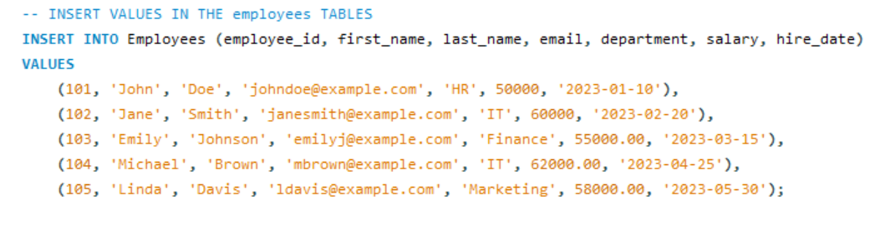

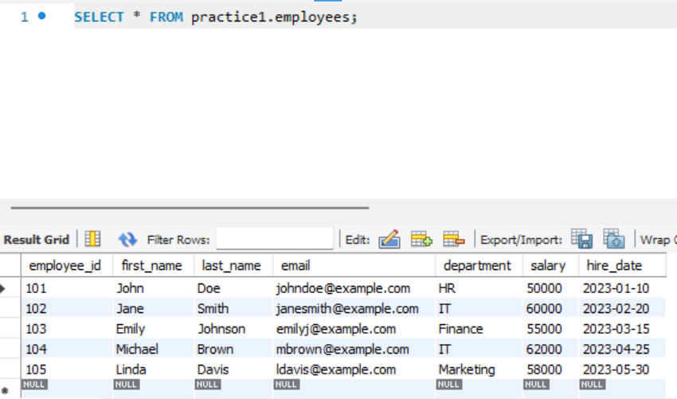

2. UPDATE the salary of all employees in the 'IT' department by 10%.

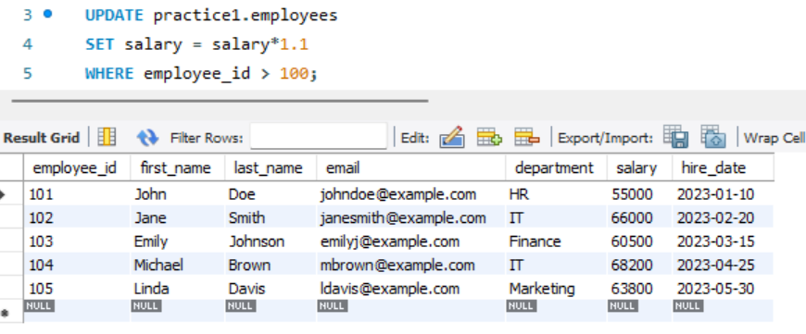

3. DELETE the employee record where employee_id = 101.

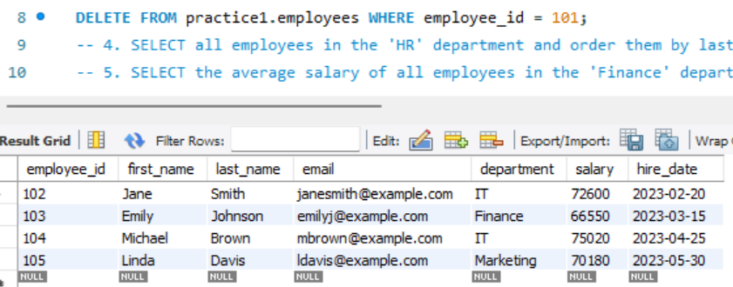

4. SELECT all employees in the 'HR' department and order them by last_name in

ascending order.

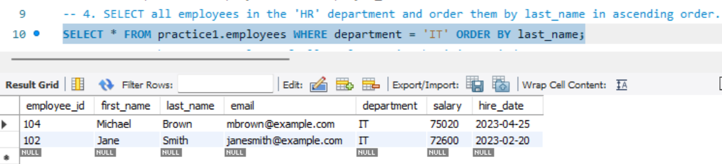

5. SELECT the average salary of all employees in the 'Finance' department.

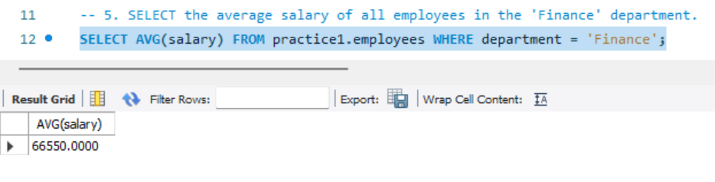

6. CREATE a new table named departments with two columns: department_name VARCHAR (Primary Key) and manager_id INT.

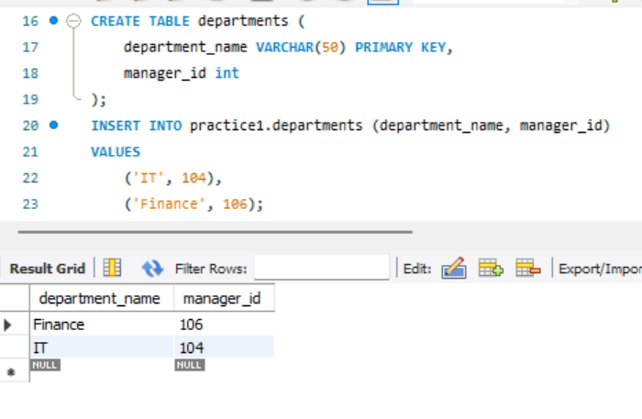

7. ALTER the employees table to add a new column named hire_date of type DATE.

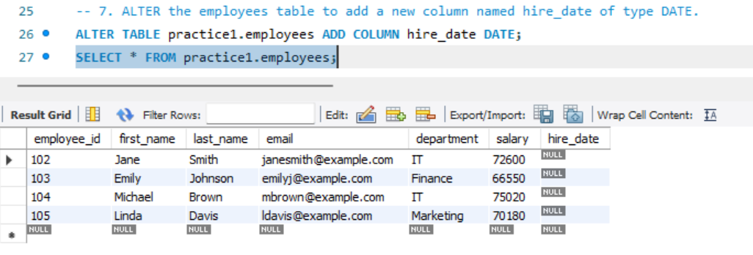

8. DROP the departments table.

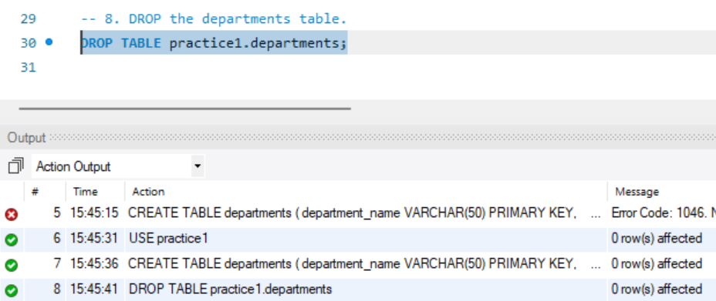

9. Write a transaction that INSERTS two new employees into the employees

table and then ROLLBACK the transaction.

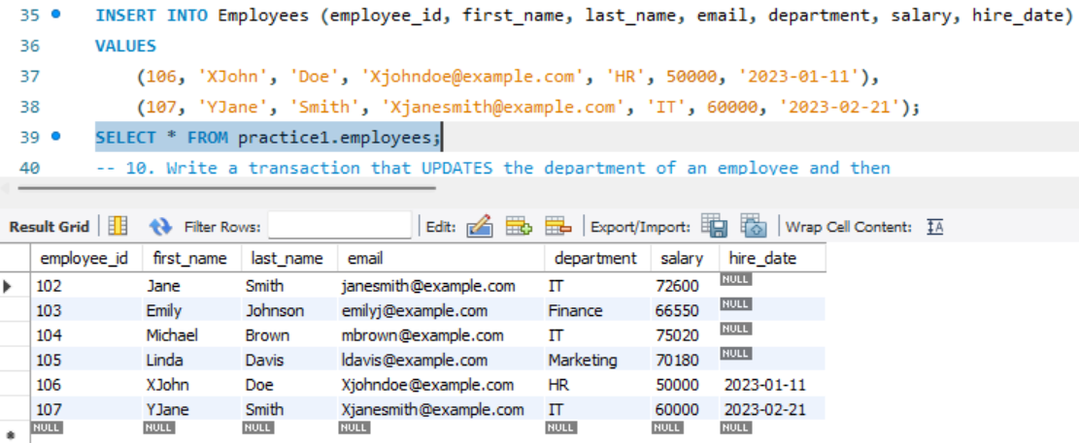

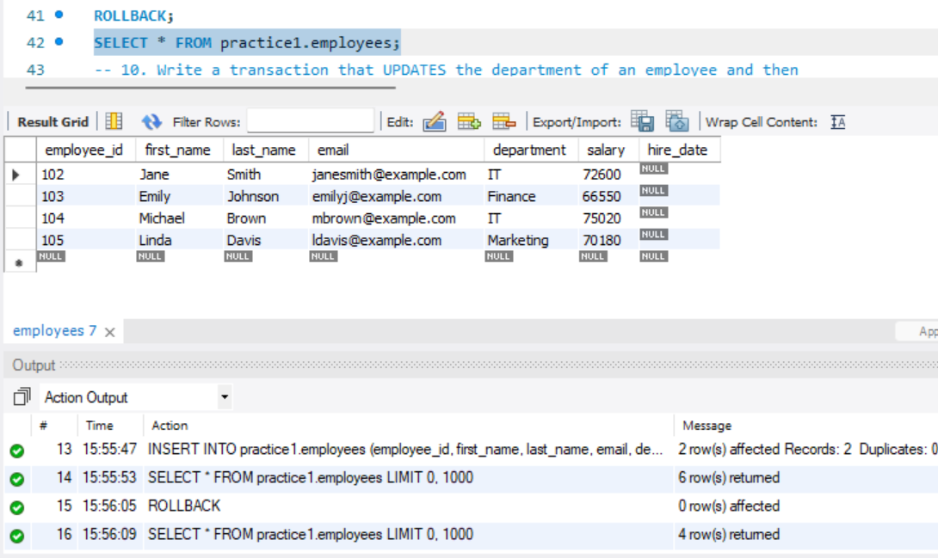

10. Write a transaction that UPDATES the department of an employee and then

COMMIT the transaction.

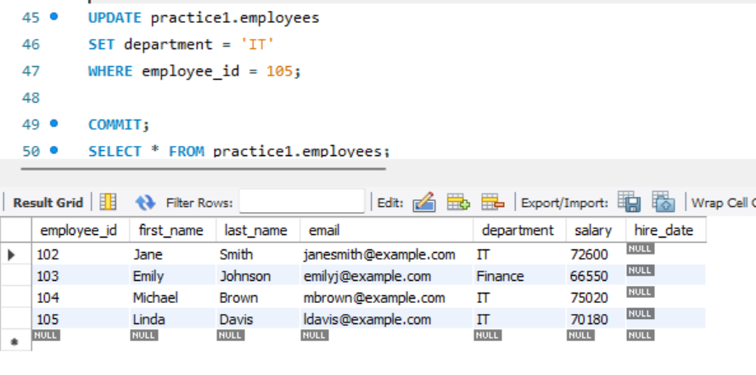

2.

1. INSERT a new product into the products table with the following details:

product_id = 201, name = 'Bluetooth Headphones', category = 'Electronics',

price = 89.99, stock_quantity = 150, supplier_id = 2.

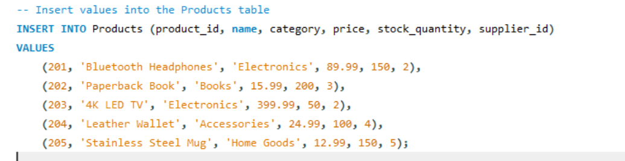

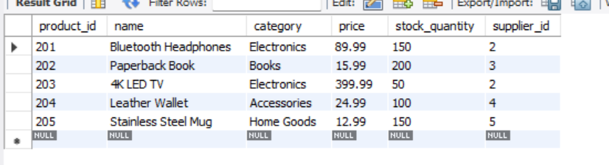

2. UPDATE the stock_quantity by adding 50 units for all products in the 'Books'

Category.

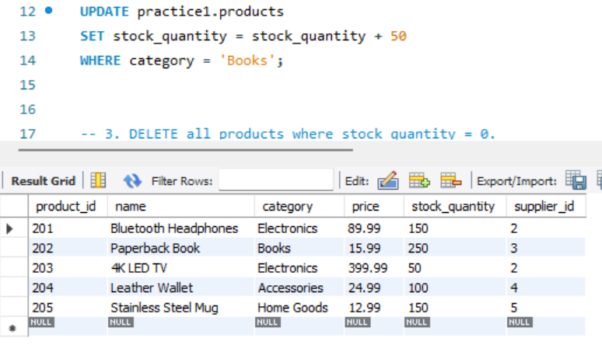

3. DELETE all products where stock_quantity = 0.

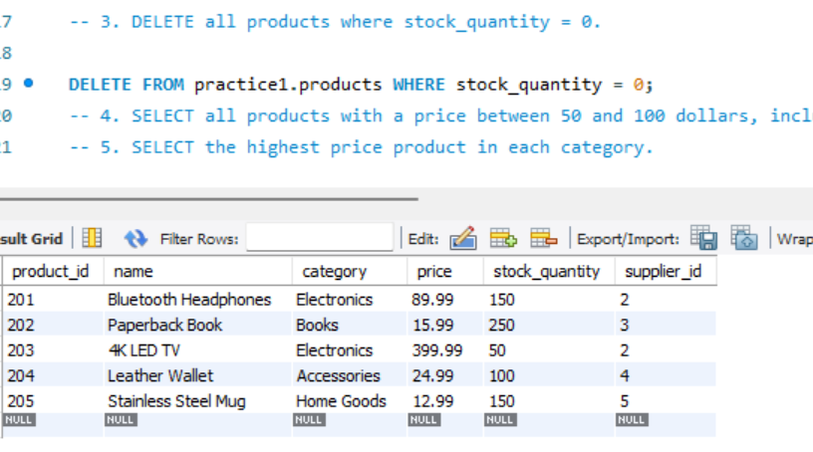

4. SELECT all products with a price between 50 and 100 dollars, inclusive.

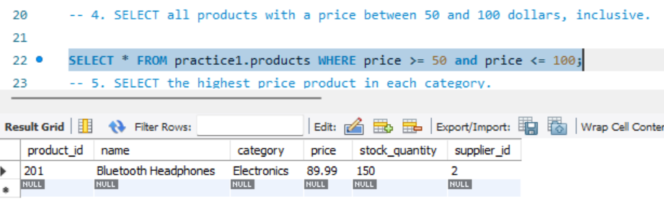

5. SELECT the highest price product in each category.

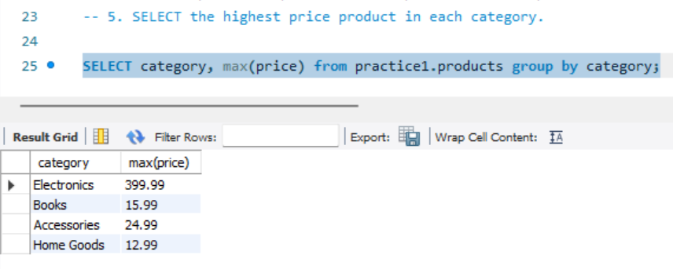

6. CREATE a new table named suppliers with three columns: supplier_id INT

(Primary Key), name VARCHAR, and email VARCHAR.

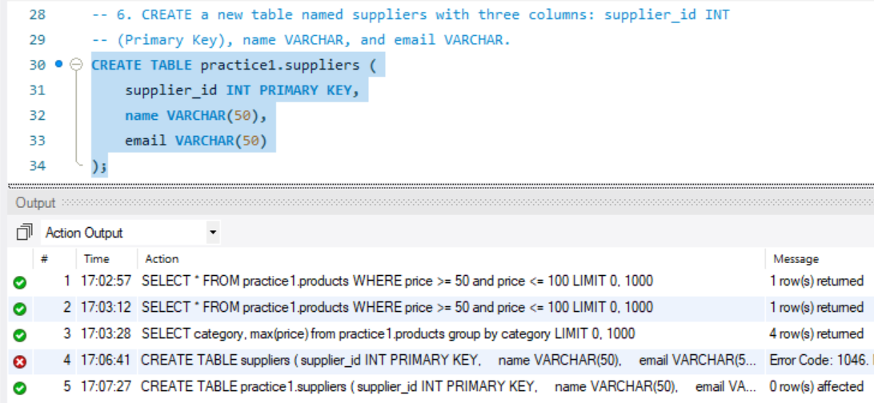

7. ALTER the products table to add a new column named description of type

TEXT.

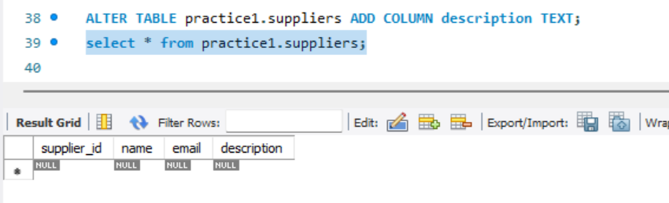

8. DROP the table named suppliers.

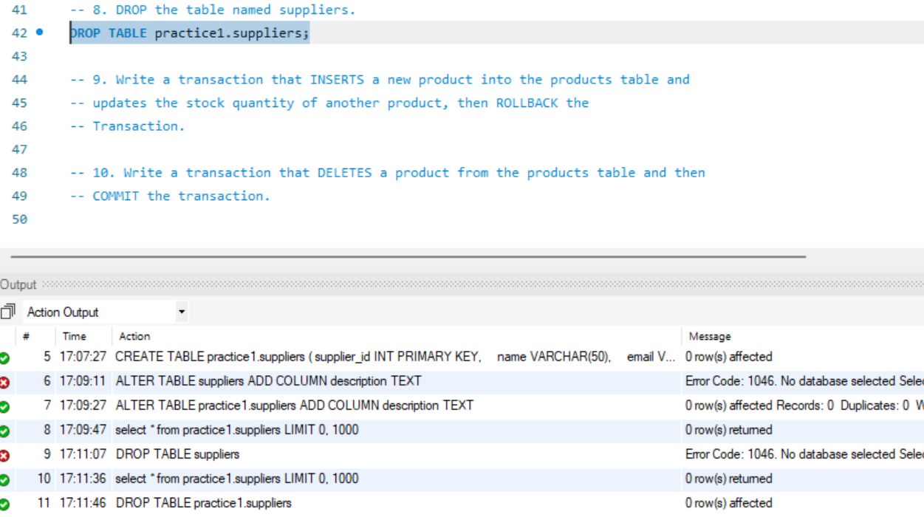

9. Write a transaction that INSERTS a new product into the products table and

updates the stock quantity of another product, then ROLLBACK the

Transaction.

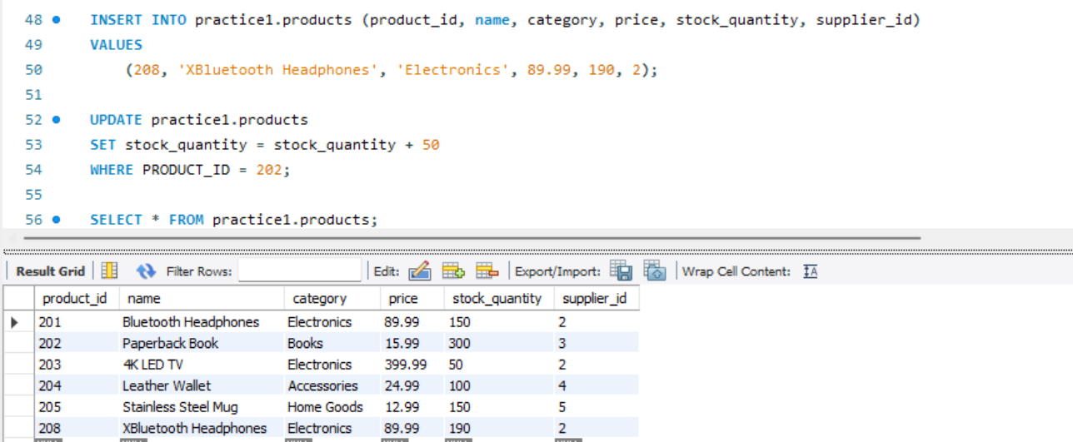

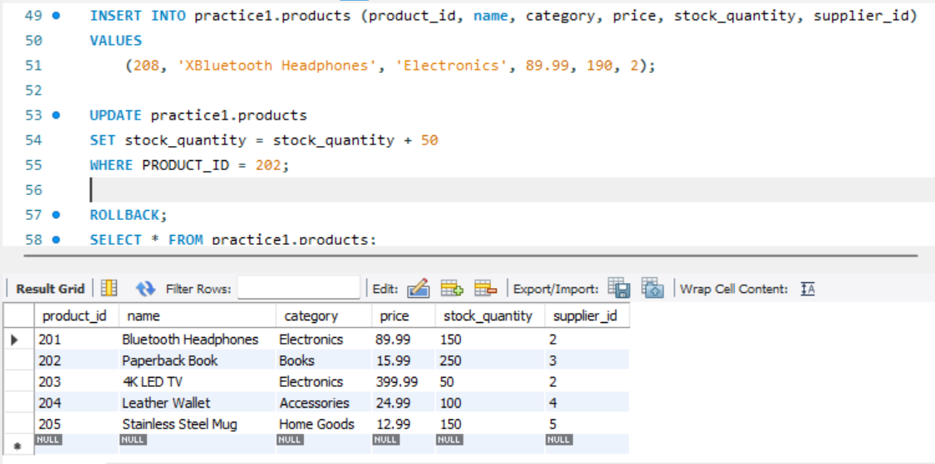

10. Write a transaction that DELETES a product from the products table and then

COMMIT the transaction.

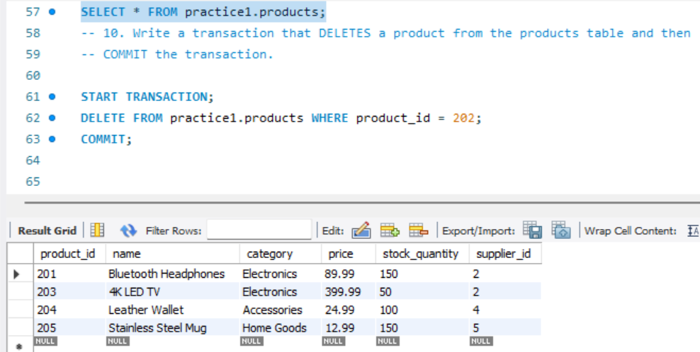

3.

1. INSERT a new customer into the customers table with the following details:

customer_id = 301, first_name = 'Alice', last_name = 'Johnson', email =

'alice.johnson@example.com', address = '123 Maple Street', city = 'Springfield',

country = 'USA'.

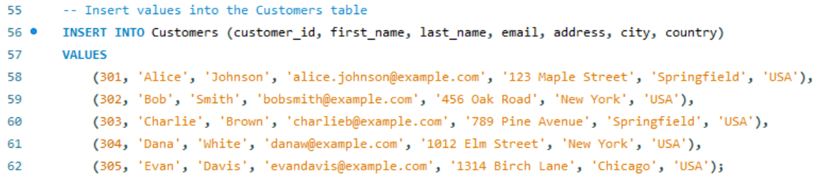

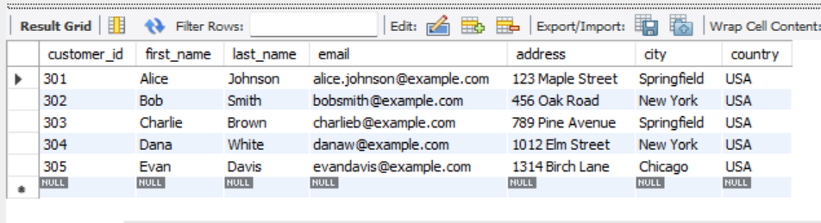

2. UPDATE the email address for the customer with customer_id = 301 to

'[alice.j@example.com](mailto:alice.j@example.com)'.

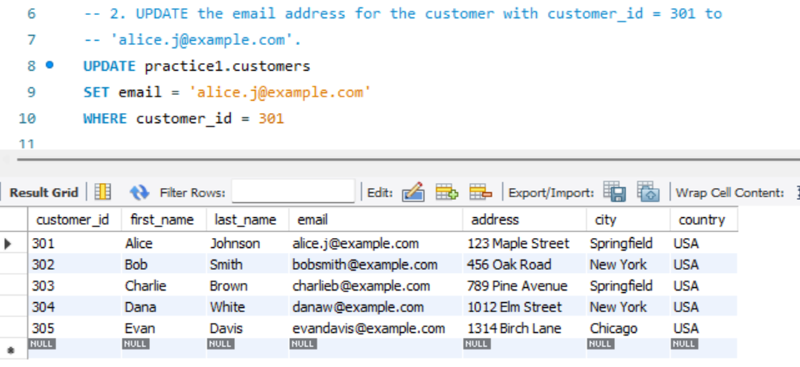

3. DELETE the customer record for any customer who resides in the country

'Neverland'.

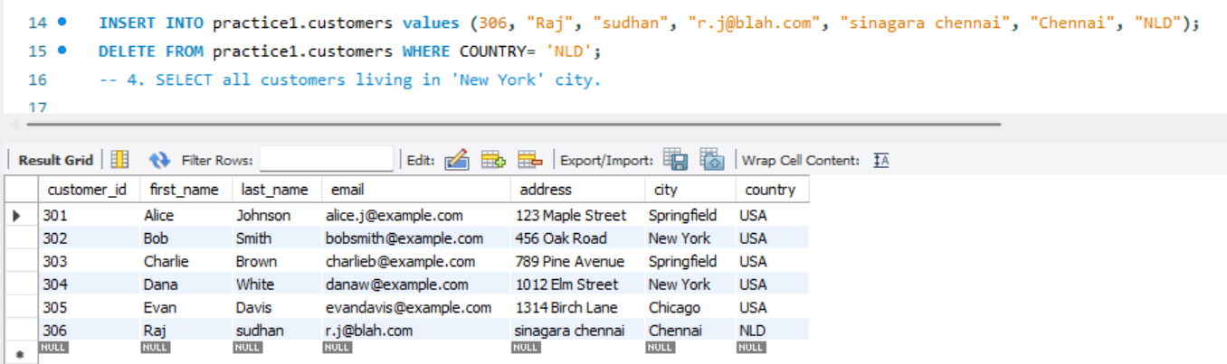

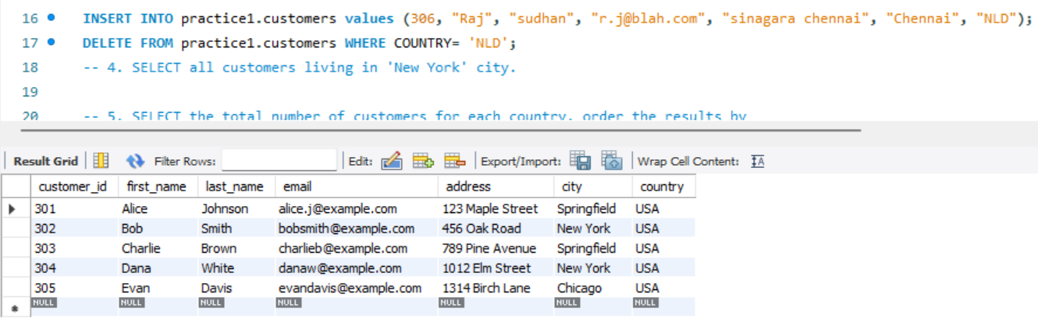

4. SELECT all customers living in 'New York' city.

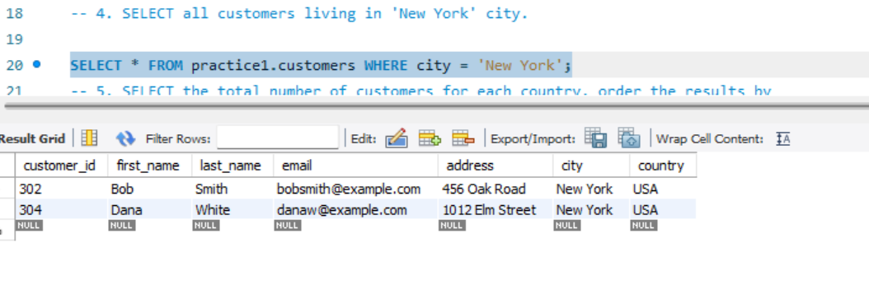

5. SELECT the total number of customers for each country, order the results by

the total number of customers descending.

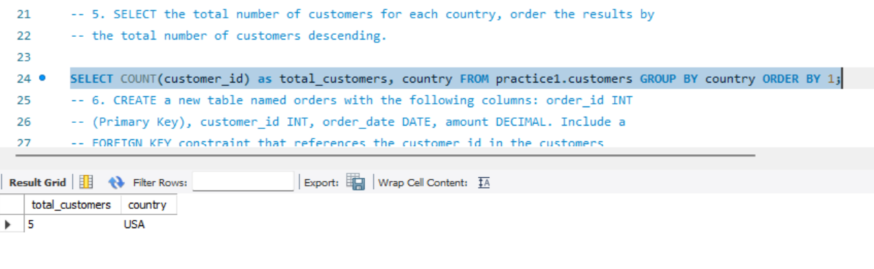

6. CREATE a new table named orders with the following columns: order_id INT

(Primary Key), customer_id INT, order_date DATE, amount DECIMAL. Include a

FOREIGN KEY constraint that references the customer_id in the customers

Table.

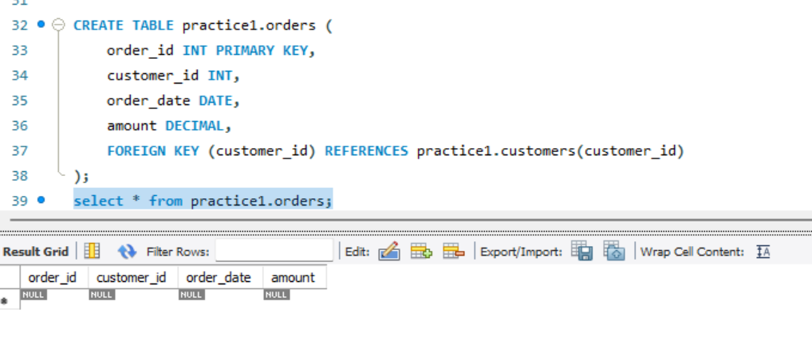

7. ALTER the customers table to add a new column named phone_number of

type VARCHAR.

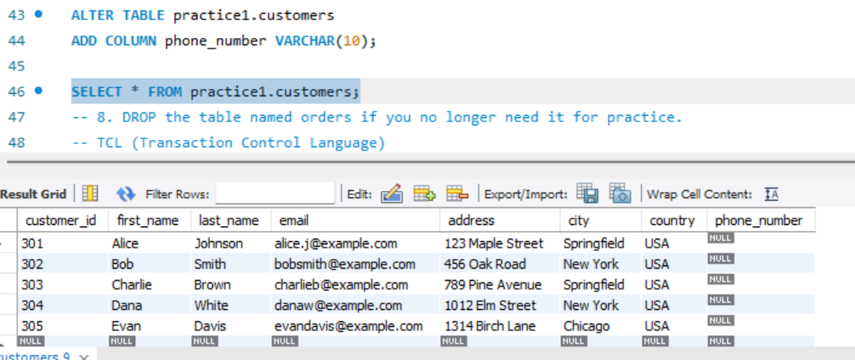

8. DROP the table named orders if you no longer need it for practice.

TCL (Transaction Control Language)

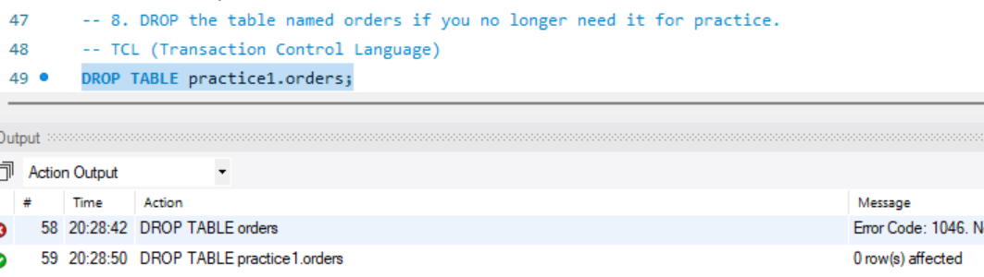

9. Write a transaction that INSERTS a new customer into the customers table and

a new order into the orders table for that customer, then ROLLBACK the

transaction as if detecting an error in the order details.

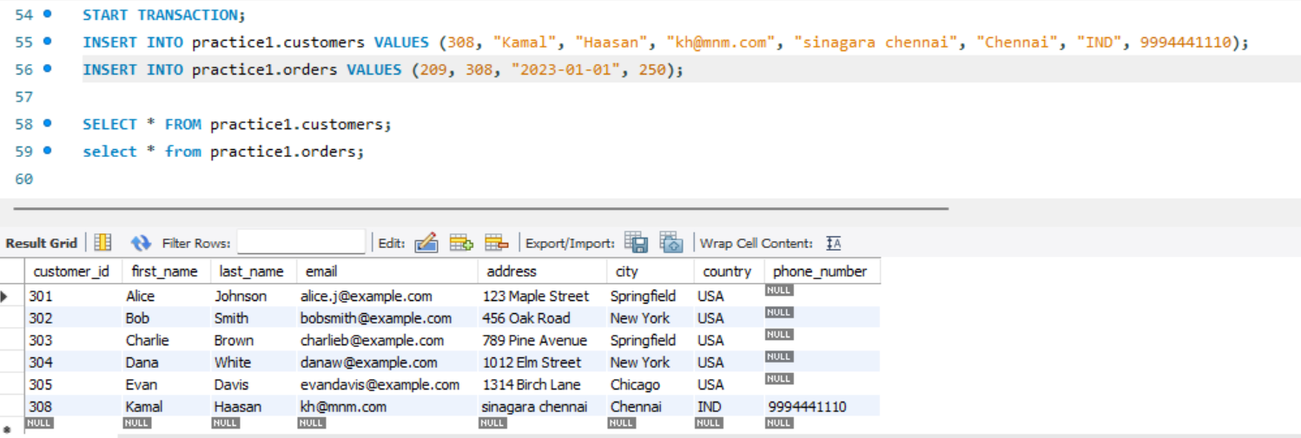

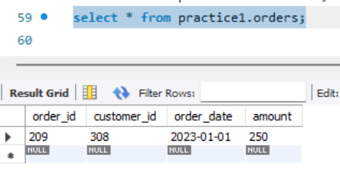

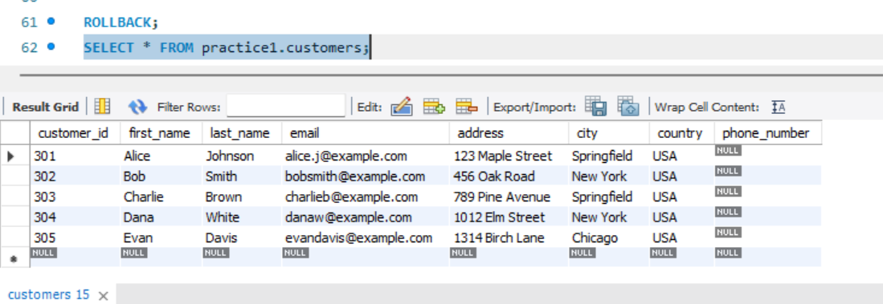

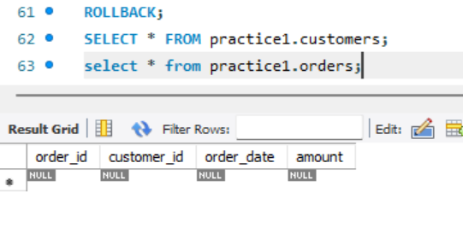

10. Write a transaction that UPDATES the address of a customer and DELETES a

customer with no orders, then COMMIT the transaction to finalize the

changes.

